[[](https://www.safaribooksonline.com/library/publisher/addison-wesley-professional/)](https://www.safaribooksonline.com/library/publisher/addison-wesley-professional/)[Git Essentials LiveLessons](https://www.safaribooksonline.com/library/view/git-essentials-livelessons/9780134655284/):

Setting Git Configuration:

Rahul.Dhalla@VERIMATRIX-24 MINGW32 ~

$ git config --global user.name “Rahul Dhalla”

Rahul.Dhalla@VERIMATRIX-24 MINGW32 ~

$ git config --global user.email rahuldhalla786@gmail.com

Rahul.Dhalla@VERIMATRIX-24 MINGW32 ~

$ git config --global color.ui "auto"

Rahul.Dhalla@VERIMATRIX-24 MINGW32 ~

$ git config --global core.editor "'C:\Program Files\Sublime Text 3\sublime_text.exe' -w"

For this we have to setup Path Environment Variable:

Whnever you set any custom Editor you have to do bcoz when you type name its gonna search in default environment varibles.

Rahul.Dhalla@VERIMATRIX-24 MINGW32 ~

$ git config --list

Output of below command:

user.name=“Rahul

user.email=rahuldhalla786@gmail.com

color.ui=auto

core.editor='C:\Program Files\Sublime Text 3\sublime_text.exe' -w

**Lesson 2 :Understanding and Using Git:**

1. So typically when we start working with Git,

it's good practice to have a folder

in your home directory called Git.

So let's create that folder

1. Now that we have a folder called Git

we can put all of our Git-related projects in it.

Rahul.Dhalla@VERIMATRIX-24 MINGW32 ~

$ cd Documents/

Rahul.Dhalla@VERIMATRIX-24 MINGW32 ~/Documents

$ mkdir git

Rahul.Dhalla@VERIMATRIX-24 MINGW32 ~/Documents

$ ls | grep "git"

git/

Rahul.Dhalla@VERIMATRIX-24 MINGW32 ~/Documents

$ cd git/

Rahul.Dhalla@VERIMATRIX-24 MINGW32 ~/Documents/git

$ mkdir git_lesson

Rahul.Dhalla@VERIMATRIX-24 MINGW32 ~/Documents/git

$ cd git_lesson/

**There are two ways in which we can create git repositories.**

**1.One is folder that already has content we want to track**

**2.Other is folder that we starting from scratch( so here is folder git_lesson we want to make it scratch)**

**Now we want to git track git_lesson folder (so every subsequent folder,file will be tracked by git). By running a command called git init and make sure don’t run this command in subsequent folders later on in furture**

**This gets into more complicated “GIT workflow” called gitsubtrees and git submodules that is out of scope from this lesson.**

**So assi home directory ch ek directory bnayi git then further ek directory bnayi jisnu (assi repo kehnde assi folder nu repo banan lyyi us folder de aandar jake git init kita and as empty repo create kitti )**

Rahul.Dhalla@VERIMATRIX-24 MINGW32 ~/Documents/git/git_lesson

$ git init

Initialized empty Git repository in C:/Users/Rahul.Dhalla.IND-DEL/Documents/git/git_lesson/.git/

**The folder that you are in.**

**1.ls naal kuj nahi dikhega**

**2. but you see hidden files by ls –a**

**See hidden files**

**We see** .git (hidden folder is created ) and this folder contains all the version control information that git will be using)

.Command You used regularly is called **git status**

**And it gives you status of the repository in which you are in**

Rahul.Dhalla@VERIMATRIX-24 MINGW32 ~/Documents/git/git_lesson (master)

$ ls -a

./ ../ .git/

Rahul.Dhalla@VERIMATRIX-24 MINGW32 ~/Documents/git/git_lesson (master)

$ git status

On branch master

No commits yet

nothing to commit (create/copy files and use "git add" to track)

that’s how you create first git repository.

3.Track changes(add,commit,log: what is master)

What is branch master

The way git works is way similar to any program that you worked with saved file except in this case git calls these saved files commit

C1->c2->c3.

So we can go from one commit to another

Similar to say one file state to another

Note: when you saved the files and creates the commit it creates the graph that represent your entire save history.

By default this graph has a name and that name is called master.

Conclusion:

As we create files,commits and save the file over and over and that we want to tracked and we will create this graph and graph name by default is called master

Right now our folder is empty there is nothing here so lets first create a file.Typically whenever you create a file you must know its Readme File so people know what is in this folder

Using Nano but you can also use sublime ,atom, notepad++

……………………………………………………………………………………………

After creating file we see status by running git status command

…Now we see that we are still on branch master and we havn’t made any save that git know about.so its going to know our first initial commit and new file git never seen its going to called untracked files and in my case it is “red file”

1.Between one commit to another there is another state called

Staging area where we put the files that we want to commited into

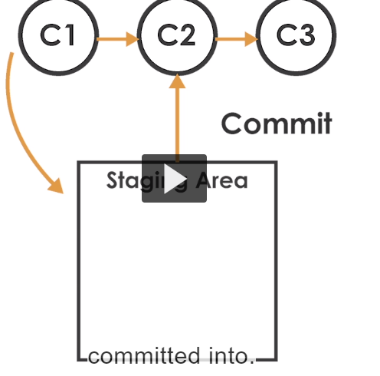and process is to add the files into staging area and once the files been staged we can then commit them.

Two commands that we are going to use that is add and Commit

1.Add the file through git add README.md

2. See git status and we are still on branch master and still performing initial commit

3.We know this file in “staging area” because “changes is to be commited” and now in green we have new file called ReadMe.md that’s in the staging area

4.Now run the commit “git commit ”to save and describe message to the people what you did.

5.After file save we quit.

Rahul.Dhalla@VERIMATRIX-24 MINGW32 ~/Documents/git/git_lesson (master)

$ git commit

[master (root-commit) 3c2fc1e] Initial Commit with README.md file.

1 file changed, 1 insertion(+)

create mode 100644 README.md

**I file changed ok but one insertion means I enter one line a readme file.without enter ok**

**.6 .Run git status we see on branch master**

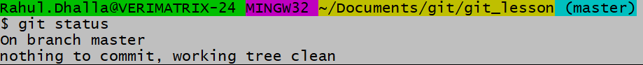

**It means everything you have done git track and there is nothing new to report.**

**7.how I see this just entered git log command.**

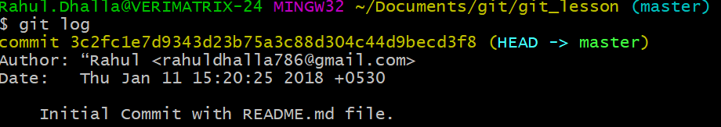

**It describes what you saved and We see commit id: which is unique for every commit.**

**But you can turn any folder into Git repo**

**8. After changing the file we get same message when we are on branch master.**

**Again master is the series of commit’s that we were making and that series of commites is by default has a name called master.**

**Changes not stages for commit**

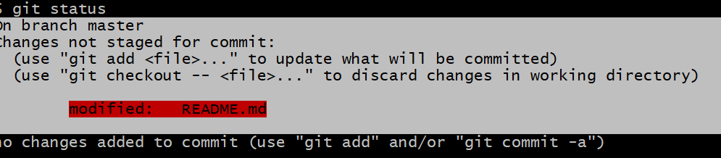

**This means git ne file dekhi hoyi pehle but file has changed and git giving you clue what we are doing and says git add to updated**

**For one line Message you can use this command:**

**Git commit –m “hi THIS IS MU COIMIT”**

**I CHANGED ONLY ONE FILE is readme and insert one line**

**9. Generally we need to see one liner message so**

**We write “git log - -oneline”” command**

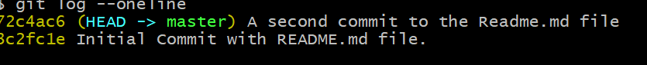

**We see in reverse chronological order.**

**1.Lets see git diff:**

**1.Change the file with message and go on**

**2.Run git diff to see difference between last known state and current state.**

**3.Simple is we see that two forms of Readme file one is a form (original file ) another is b form(changed file).we see green text that is new file changes as compared to previous file.so keep in mind about differences or new things that I added**

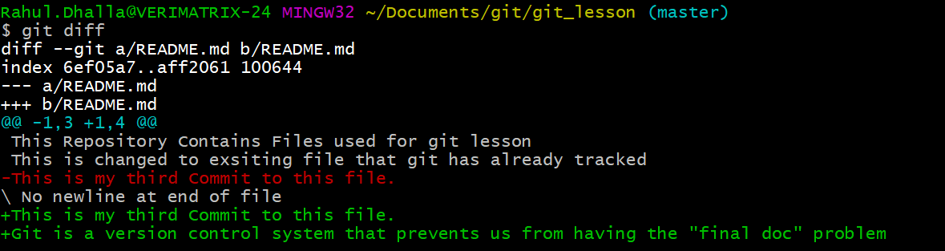

**Another way to add :**

**1.One is git add “Filename”**

**2. Another way is to add everything is through period(.)**

**Now red file is in staging area and changes it color ready to commited**

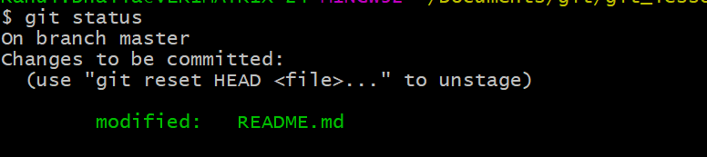**.**

**Scenario: Suppose we change something in file now we don’t know what change it is and we add in the staging area and I run git diff what changes but git diff didn’t return anything the reason is file is in staging area and git know about the file so we cannot see any difference but what if I want to see the difference.**

**So there is special command is to see the difference between staged file and last known commit.**

**git diff --staged**

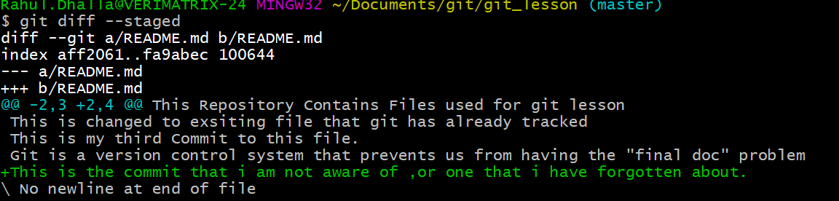 **and run the last command (git commit –m ‘done’)**

**……………………………………………………………………………………………………**

**Suppose you look at different commited of the file**

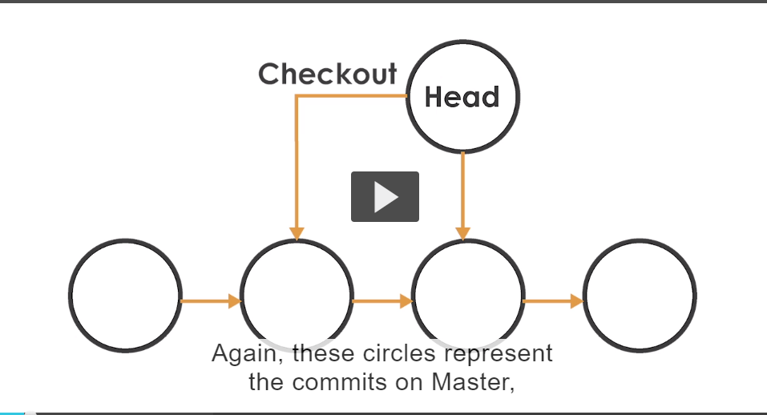

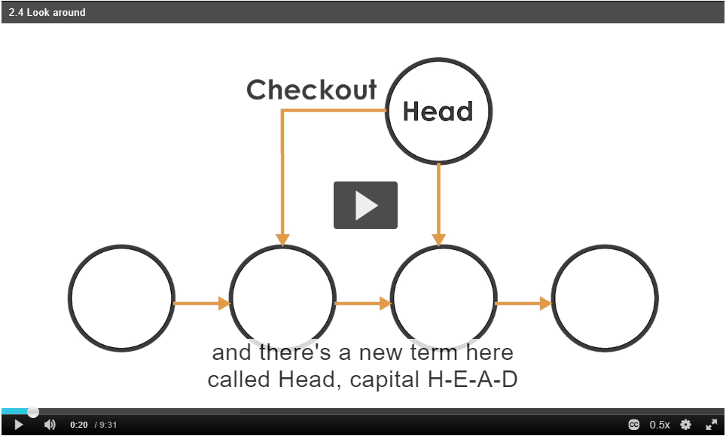

**New term called Head refers to the current state that you are looking at that is current snapshot of the folder that you are looking at.**

**So we can use git diff Head~1 to look the differences between current commited state of file or folder to the previous commit**

**Meaning :git diff Head~1 and if we want difference between 2 commit before.that means 1 and 3 ch difference**

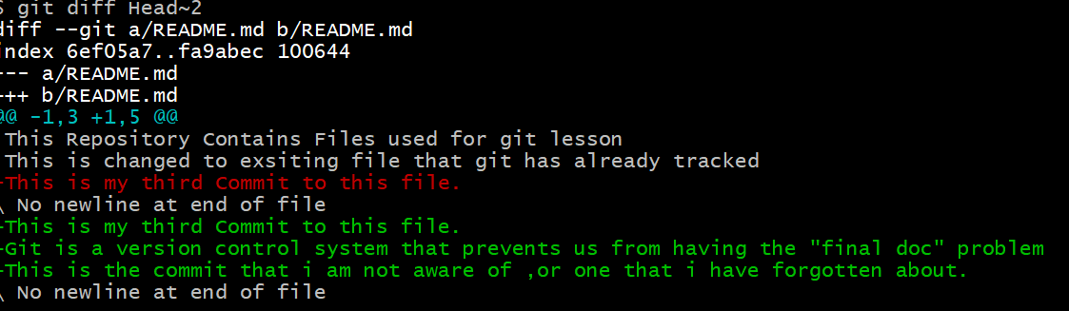

**Our current state and two stated behind.**

**3 states and we use git diff Head~2 means two commit shd k eek 3 and 2nd vala shad ke first and third commit naal difference .**

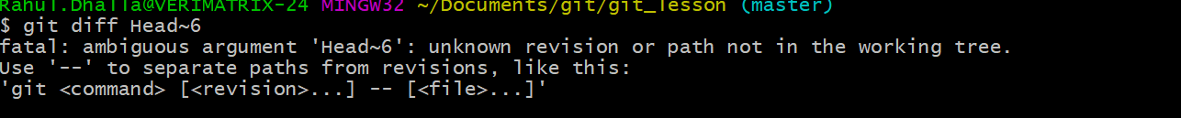

**Out of commits we get errors.**

**Series of letters and numbers know as ther commit hash.**

**Instead of counting 1,2,3,4..**

**So Instead of do git diff Head~3 we can do this thing with the help of commit hash.**

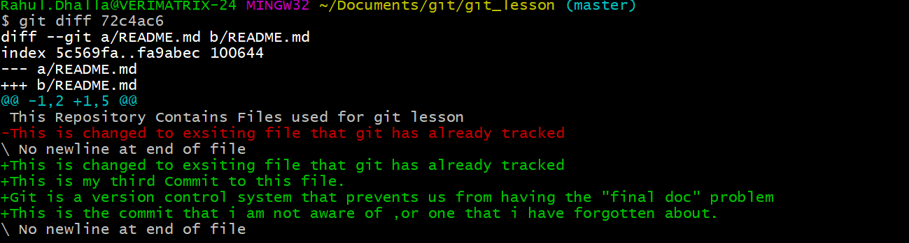

**I used seven characters string instead of long sring.**

**Jido tussi jaada commit karde ho then you can se less : to scroll up and down and use q to quit and prompt back to terminal**

**………………….**

**After we look into differences we actually want to “revert back to previous state”**

**Git diff head~1 and last line is commited I actually want to undo**

**…….**

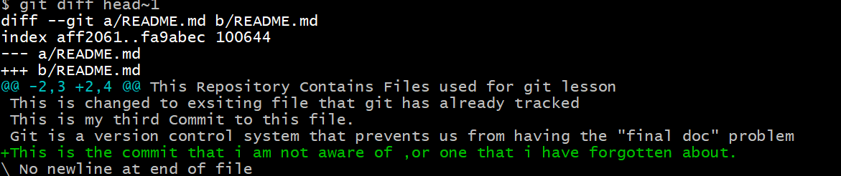

**So undo the change**

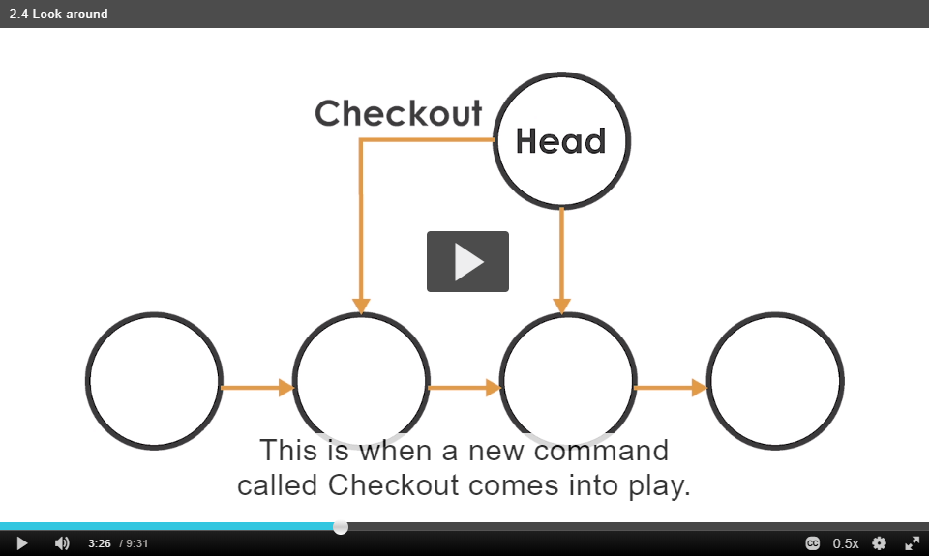

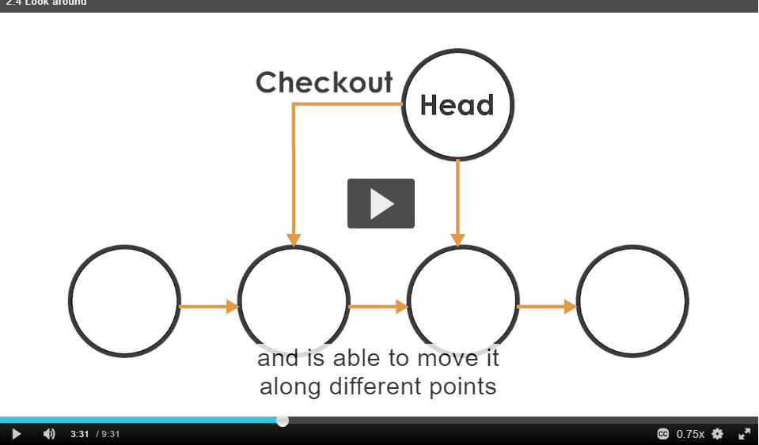

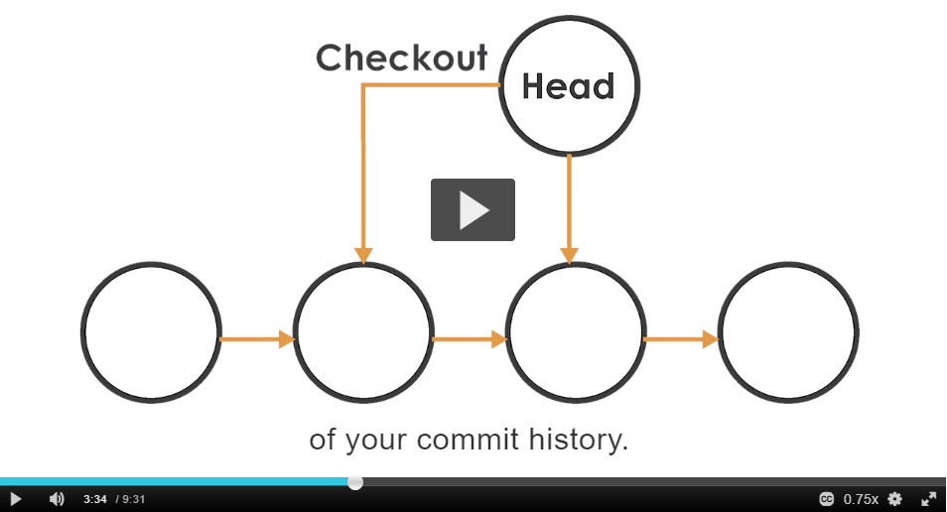

**In this case we use checkout to checkout the previous state of file.**



**We see that last line is no longer there**

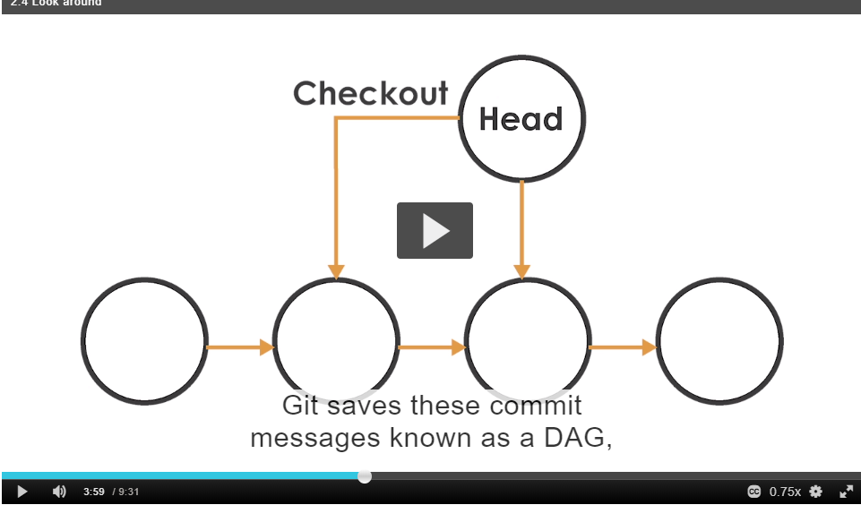

**Git saves these commit messages known as a DAG or directed acyclic graph meaning that there are no**

Directed meaning we can go from one commit to another.

They are directed hence these arrows and its acyclic meaning that cyclic is not allowed in this graph and meaning this is graph representations of all the commits.

what we just did we revert a file back to previous state but because this is acyclic graph there is not actually arrow turns back to this state.

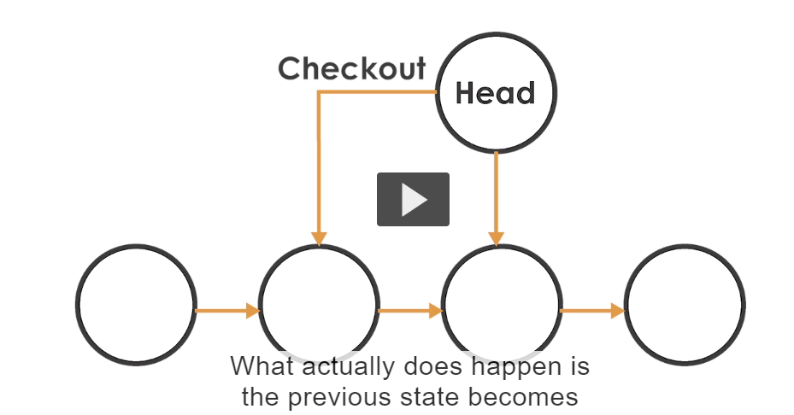

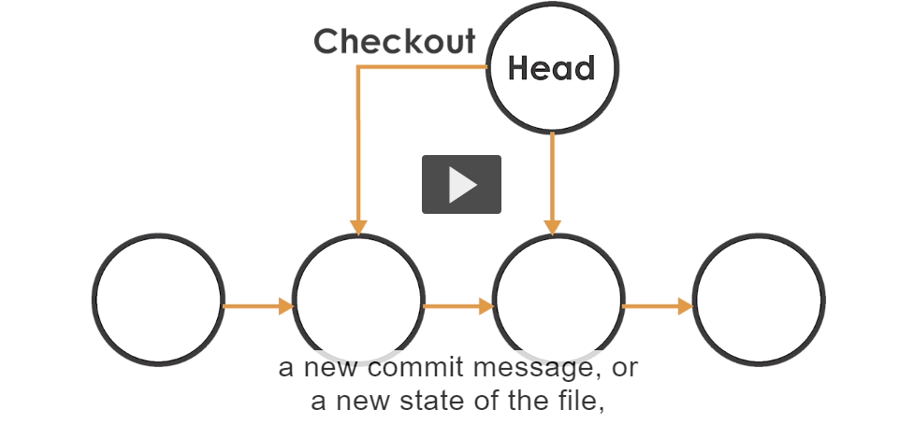**and we see that**

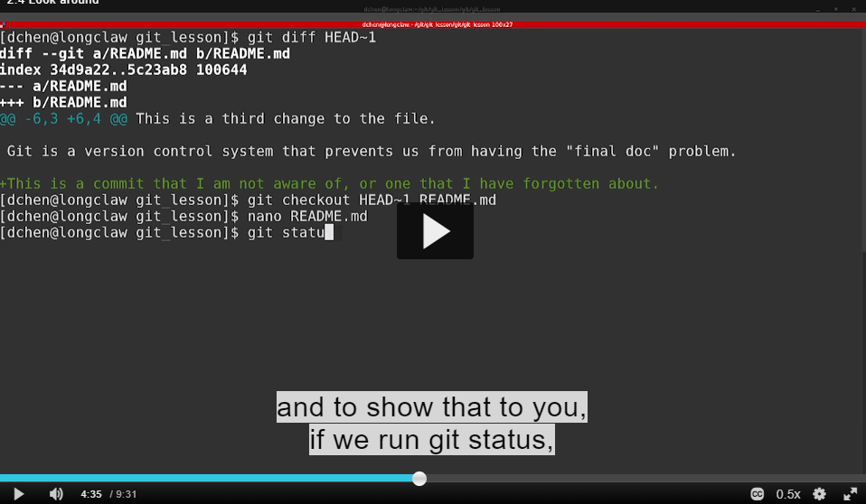

**Its actually change in file wapis previous state ch nahi gya nya commit message or nyi file di state change kitti va**

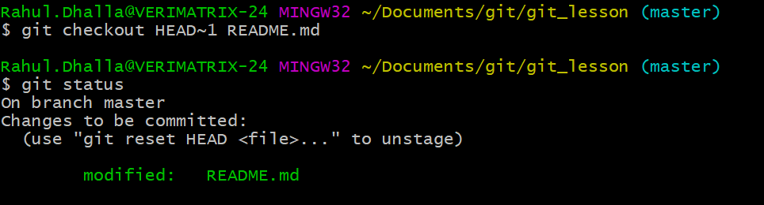

**Now look git diff –staged**

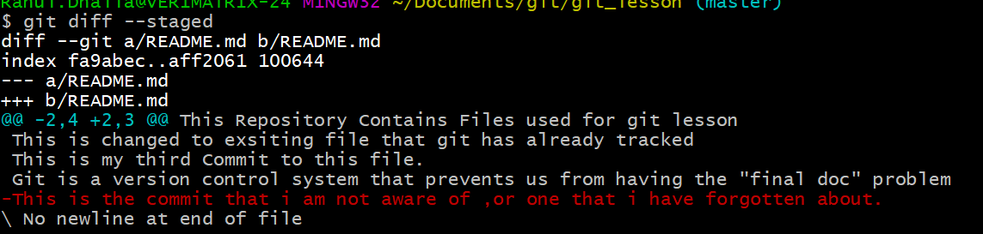

**Last commit and es toh previous commit ch difference for readme file assi fourth commit vale changes liyande ne es cha and current snapshot sada fifth si means latest us di readme vale changes dekhe bus. Now line in red colour will be deleted.what git actually changes is deleted the line for us**

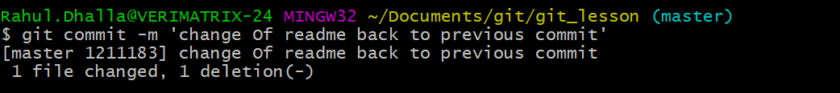

**Even I change the file to previous state**

**But its actually a new change ( so means acyclic meachnism is used)**

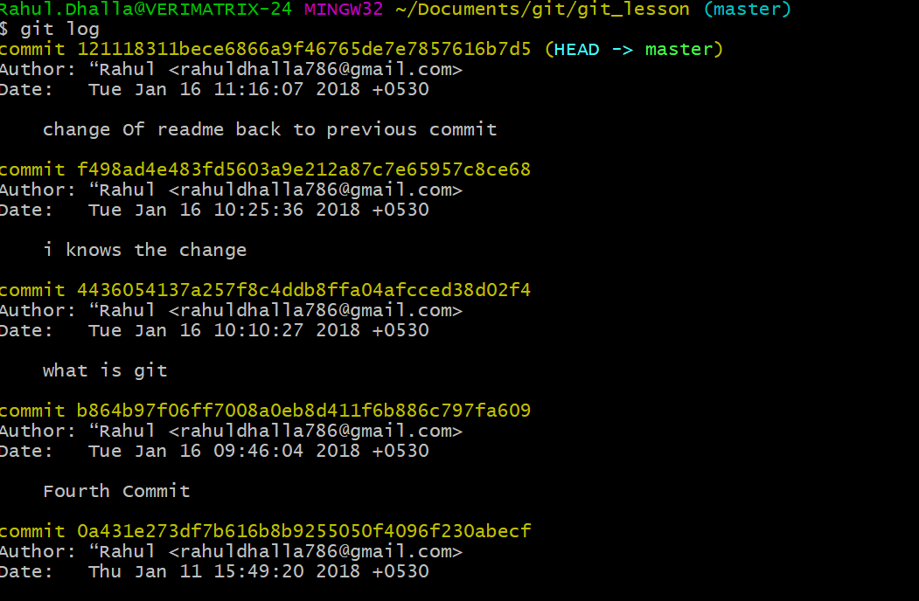

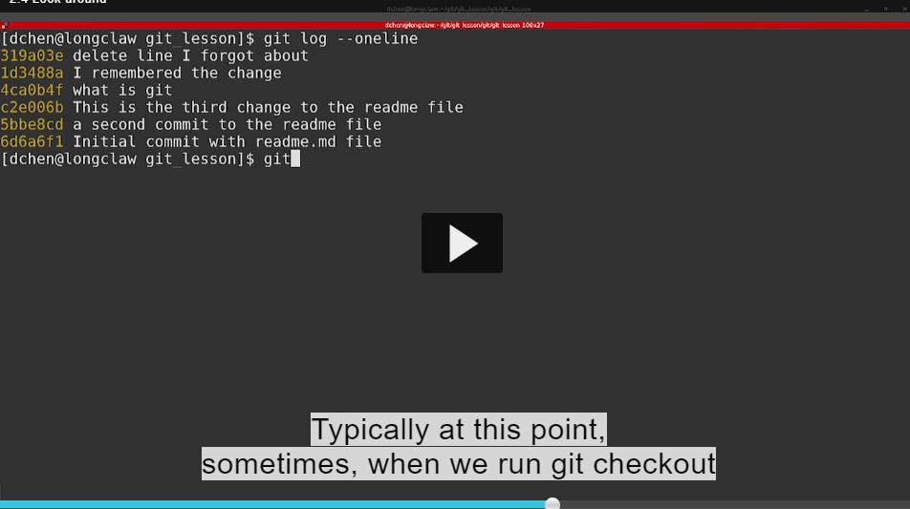

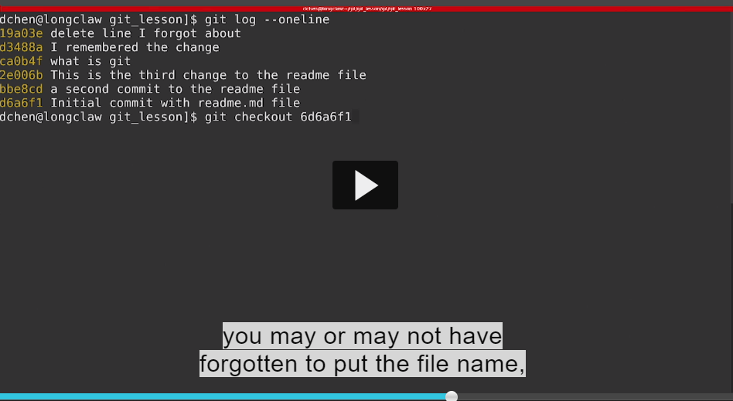

**If you do that what known to you is**

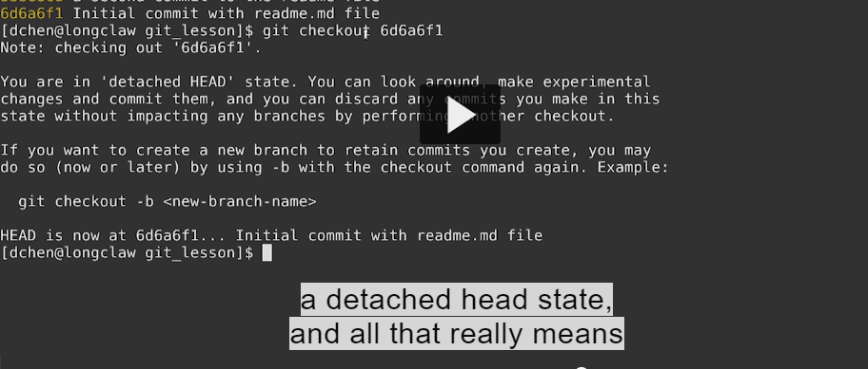

**Is all that means in our graph representations head has been moved**

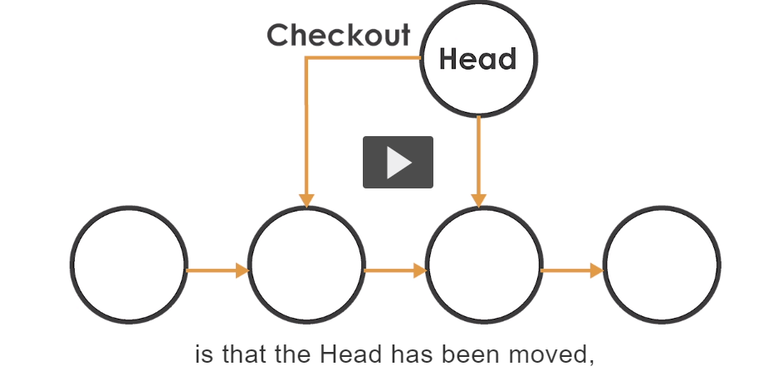

**Its really looking into master and its not attached anywhere**

**For this time we explain in over git branches , for now back to latest commit is by as so getout of this state and if run git checkout master. What will it do it puts our back to last state that we were in**

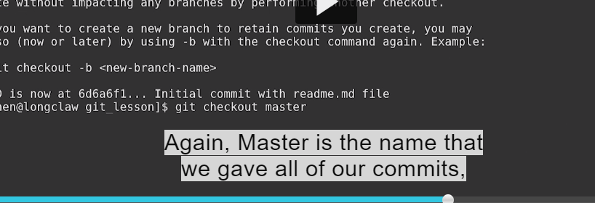

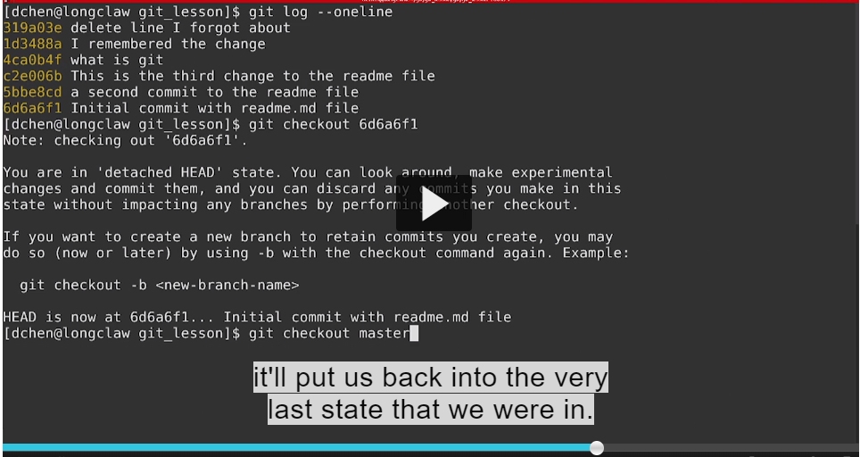

**When I run git log see head is in detached state**

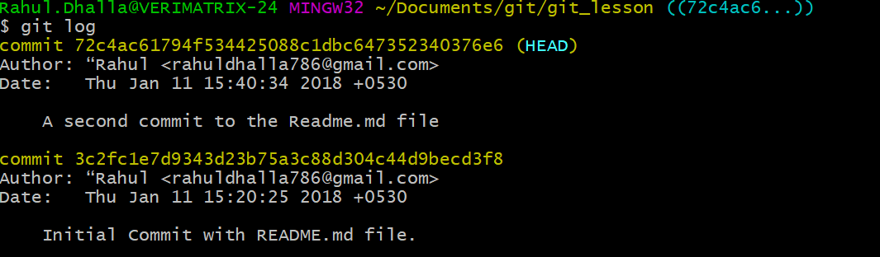

**But after checkout master we back to very last state**

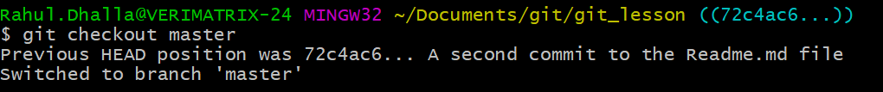

**Git status naal eh dekho detached hega and master de naal nahi hega**

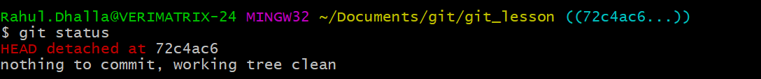

**Git status and we see are we on branch master**

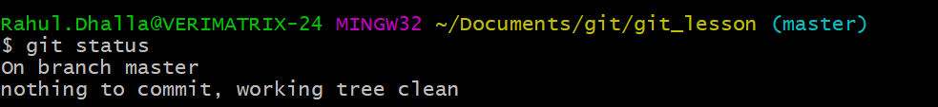

**Scenario where we accidentlly deletes a file.**

**So right now I have file readme.md if accidently deleted then .**



**So run git status**

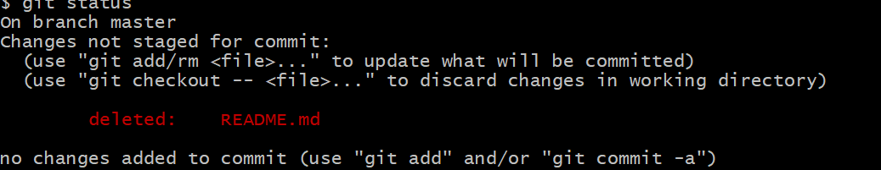

**Git recognizes that file is deleted**

**There is a way to actually undelete this file.**

**Commit krke delete krlo new commit bnalo or we can use checkout to undelete this file.**

**If we want to revert back to the last state we can checkout with Master.**

**Git checkout master README.md(filename).**

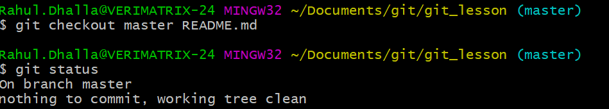

**ls and you can see we undeleted the file.and run git diff we find nothing bcoz file was in last state exactly same as before**

**just as before we move to file position by head and commit hash now we move back to revert file back as through head and commit hash.**

**Again if we revert the file git doesn,t actually point to this file in the history.**

**What I really does make a change to a new file.**

**Git checkout head~1 README.md**

**But what I want to actually unstage this change git tells us**

**We can run the command called**

**Git reset HEAD <filename to unstage>**

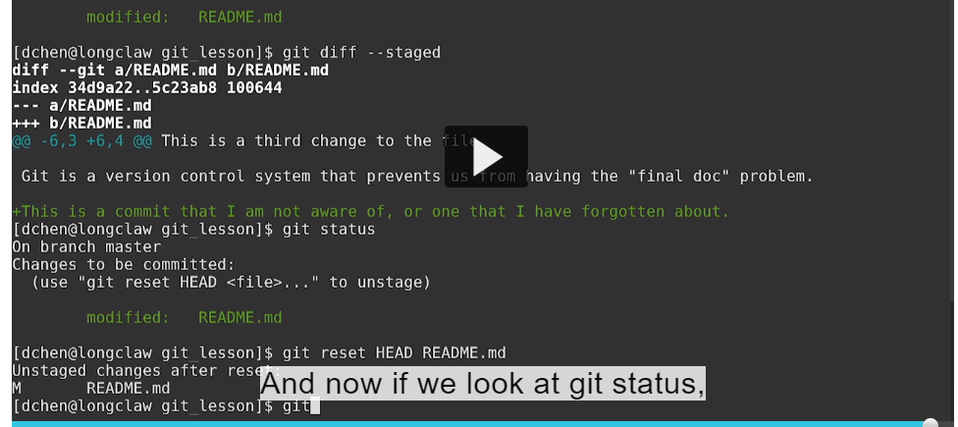

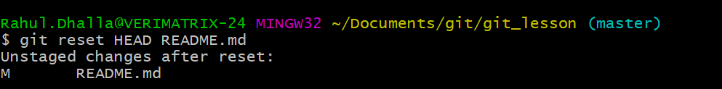**.**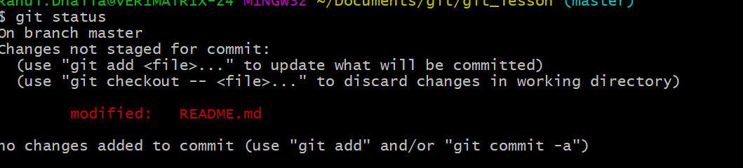

**Unstage file.**

**So this is a change not stages for commit.**

**Undo the changes:**

**I change the file but whatever the reason I saved the file**

**I don’t want to add file so how I undoing is**

**Something previous commit that something we want to**

**There is panic button called git reset dash dash hard**

**Git reset - - hard it will turn the entire repository back to the last commited state**

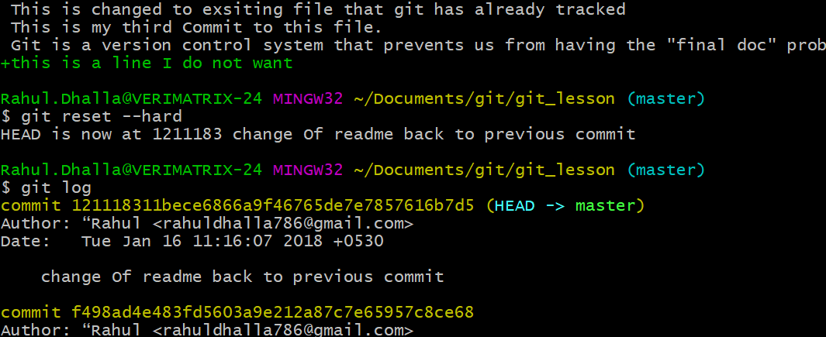

**And see last line in the file no longer exists.**

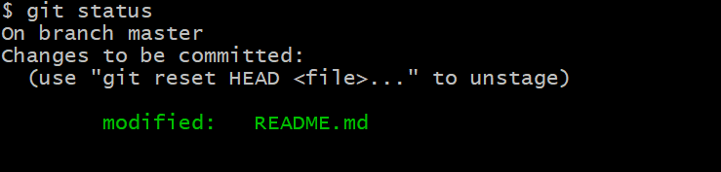

**See git reset HEAD to unstage**

**1.we don’t want this file to be staged or just check the difference with the stage .use diff –staged and run git reset HEAD**

**And the file no longer vaialble in staged area**

**2.we checkout head~1 README.MD but after I want my last commit we use git reset –hard or git checkout commit hash filename**

**Git checkout 12121323 README.md.**

**#######“Ignore things in git”**

**……………………………………………………………………………………………………..**

**1.mkdir src for source files and docs for documentation related files or manuscript for your paper you are writing and data folder for processing.**

**2. run git status and it says empty it bcoz is git found folder which is empty then it cannot track it is**

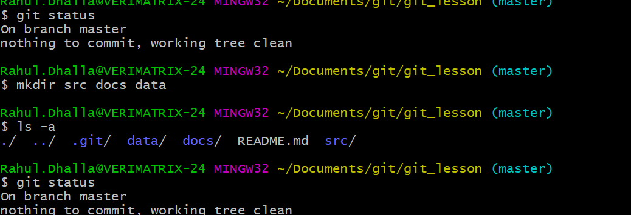

**1.One way is to create is readme file in each folder and describe each folder .**

**2. Another way is mostly people deal with this is to create “.gitkeep hidden file”.so whenever people open the folder they don’t see anything but git tracked that folder.**

**So lets create .gitkeep file in each of the folders.**

**Create output folder and hidden file.**

**Now use git add .(period to add files at once )**

**So everyfile in subfolder will get added into staging area**

**All 4 .gitkeep files added into staging area**

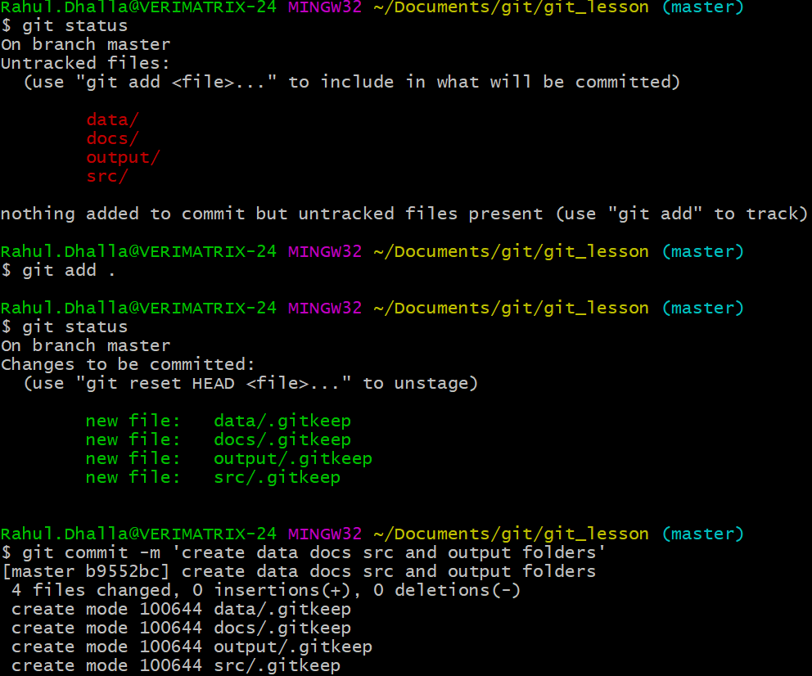

**1.ehne ki kitta ek file noble .txt ditti pdflster nu usne files generate krti 3 but main esny ignore krna chhauhnda taki kdi vi chahva ,main file create kr skda va so main esnu nahi rkhna chahuhnda git esnu dekhe.**

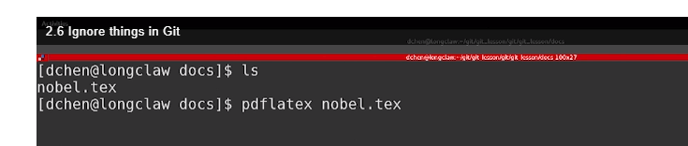

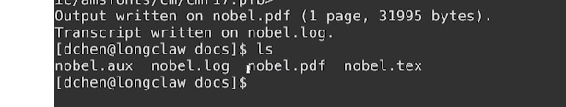

**You have file that generate files why u add these generate files.**

**So need of render or generated files to be tracked.**

**So what we need is when we type git status we get orginal message on branch master and working directory is clean.**

**How we accomplish that we create a known as “.gitignore “file.**

**Typically “ .gitignore file” is created at the root directory of repo meaning the place where you typed “git init”.**

**“.gitignore file” is special file know by git and everything matches or pattern is ignore by git.**

**Meaning if we run git status those files are not showing up as new file.**

**So we commit this file like add and commit**

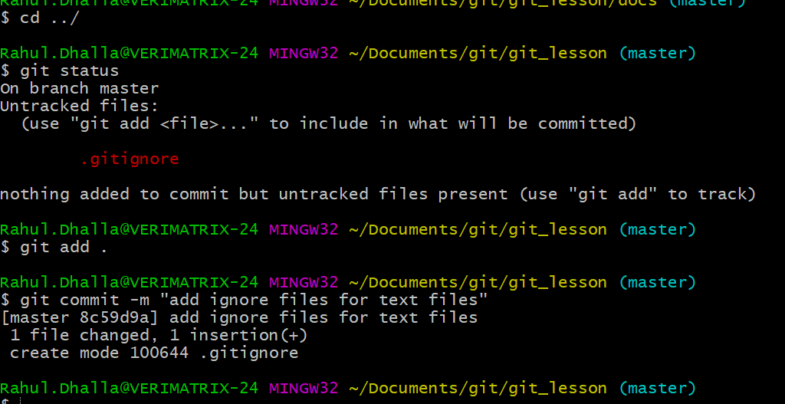

**2.assi pattern naal vi ignore kar skde instead of specifying pattern name.**

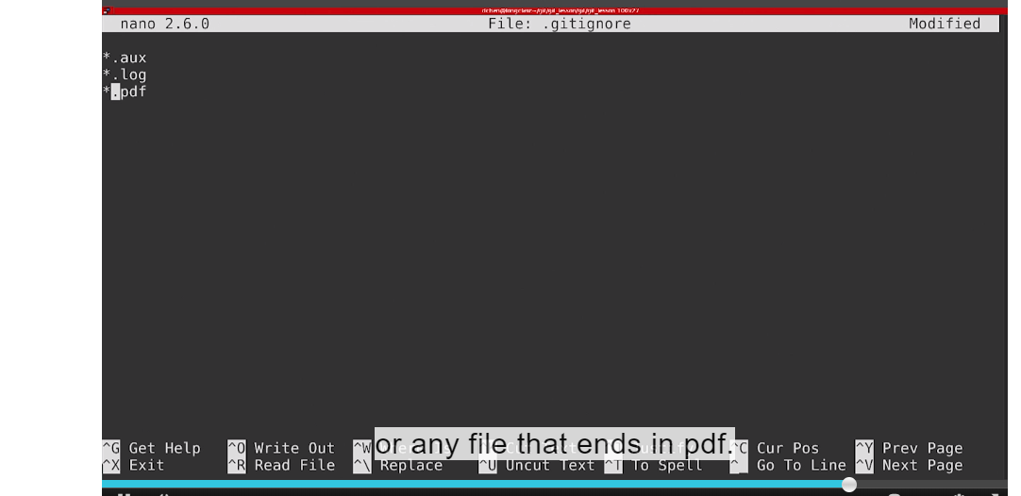

**If you forcefully added this file then see what happens**

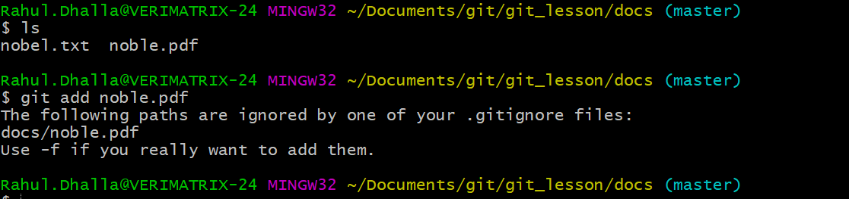

**Agar add krna va taki ignore na hove –f use kro**

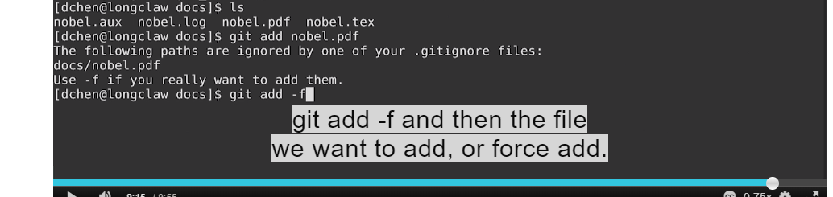

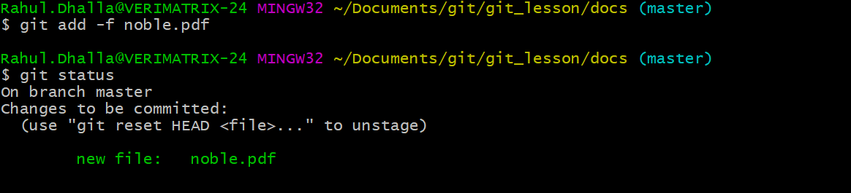

**Now commit and see branch master and working dir is clean and file is forcefully added.**

**Lesson 3: Remotes and Branches**

1.Understand what github is and how it is used.

2.compare with other similar services gitlab and bitbucket.

3.From there I will tell you how can we use these online services as Remote so we can do pull and push the code using remote with https.

4.Remote with ssh(typing username and password is tedious so we also tell you how to setup ssh keys.

5.How to make changes in both location(UTILIZE SELF COLLABORATION

6.USE github for project management.

7.introduces branches and pull requests in git and github

8.extend our branches to see gitflow workflow and finally I show you graphical interfaces to make git easier to use.

By the end of the lesson you should be fully independent git user.

1.Understand what github is and how it is used:

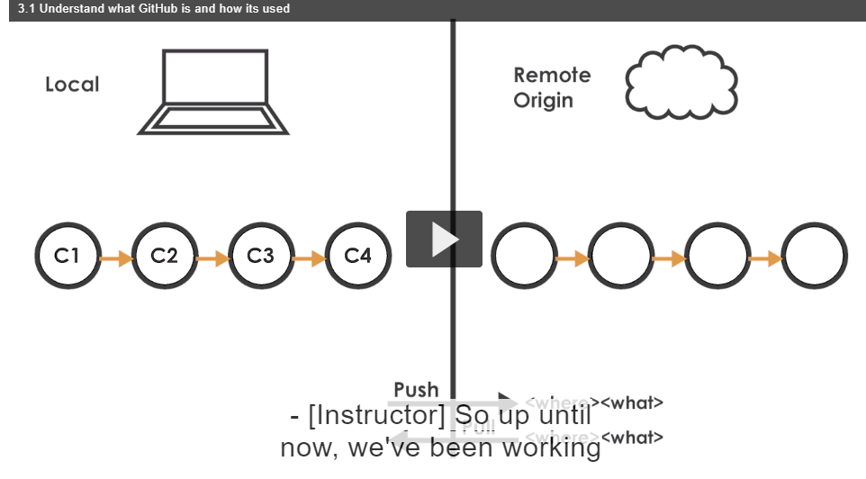

1.Hun tak assi commit kr rhe si local computer te

2.you can think git as backup system for your local computer but as backup system this still is not good enough

3.computer loose all work ,hard disk crash.

4.Now we are going to know about remotes.

you can think remote as folder or place that is not where you type git initially.

5.The most common remote is internet service or some cloud service

A very popular one is known as github.

6.Github is a cloud service that stores all your git information that you had on your computer

7.It is unlimited as long it is open source and public available.

8. With github you actually use as your own project management software.

9.you can have issue which is very good way to document code bugs, things you have to do in project.

10.you can have pull requests which small bits of changes that you required and finally you need you can also have wiki where you store various bits of information related to particular project

11.git allows us to create unlimited no of repostiories.

12.create username on github .

2. **Use remote with https:**

1. A remote is any location where you **didn’t type git init** .In this example we are going to use github service as “remote” and **what github** is it takes all of the commits and essentially makes a mirror copy of it.

3. Now we will have pretty much backup system.

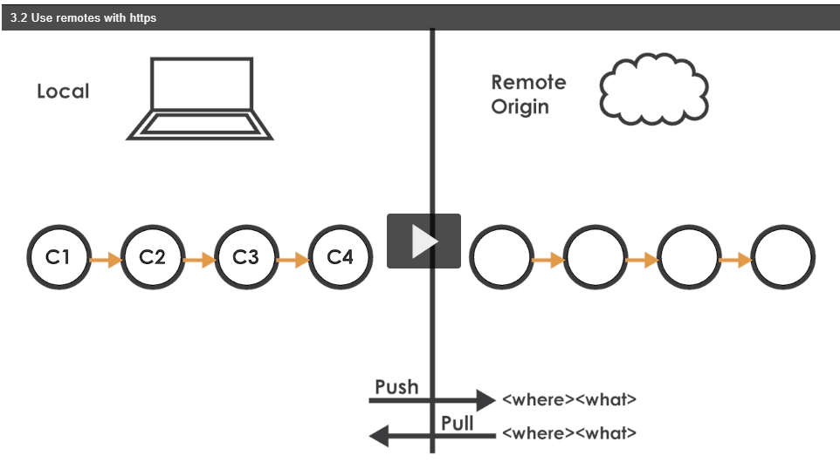

Where you have all your work that is tracked on your local computer as well mirror copy on github

4.The way we interact with local computer to the Remote is through pushing code to the remote and we want code bring it back down to the computer we pull code down

5.

we can have many remotes meaning you can take your local code on computer and save into multiple locations but by default your primary location has a name called origin and that just convention that you will see through various git documentation and tutorials online.

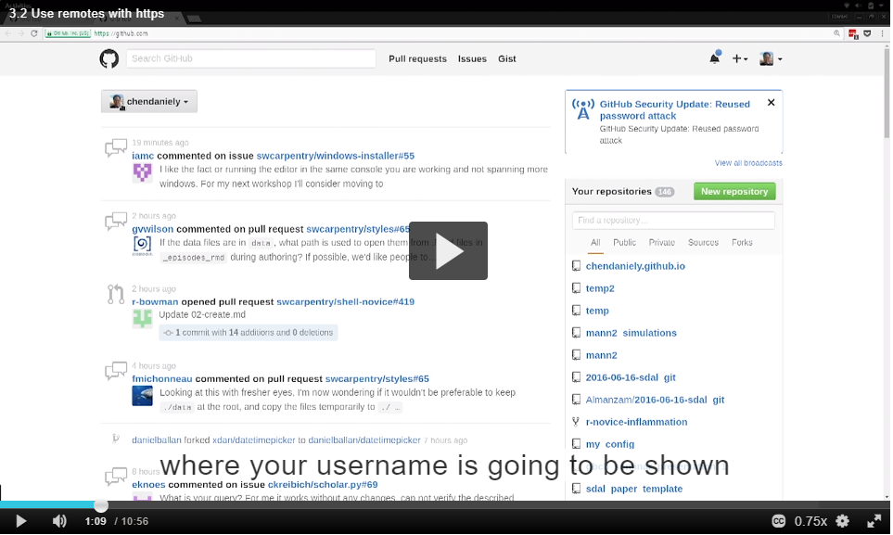

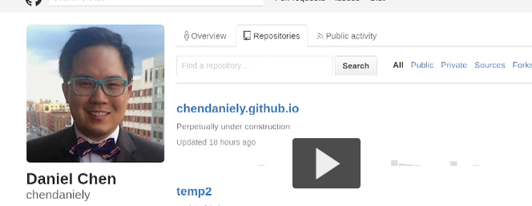

He is looking into

Overview ,

Repositories,

Public Activity.

Time to create New Repository: 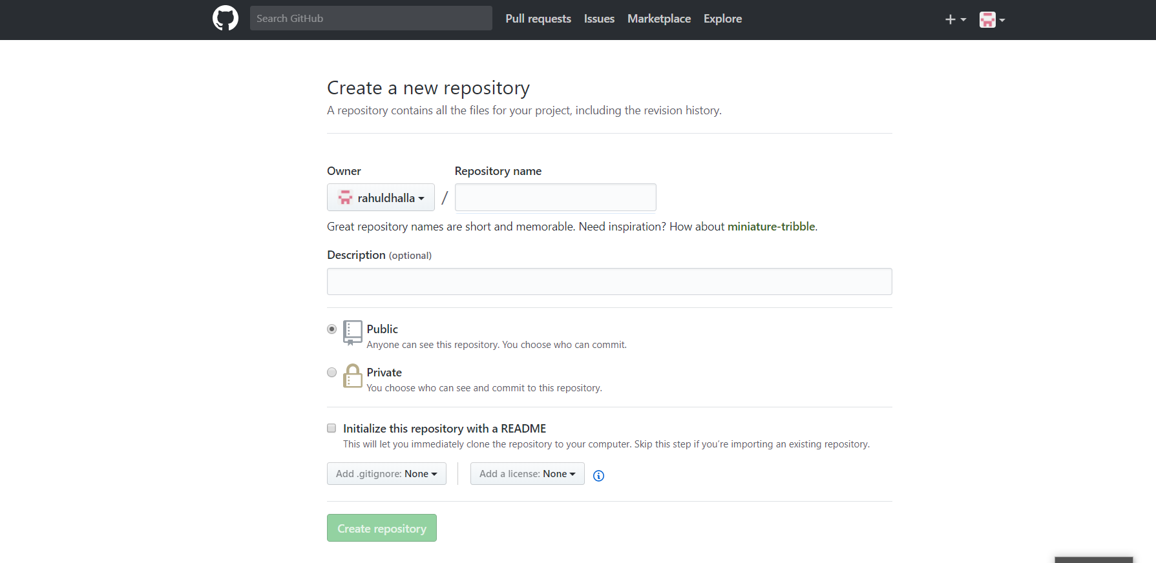

1.Repo name create karega agar tussi download kroge then git_lesson folder tuhade new computer,old computer,te create hovega.this is the folder name tht will be created.

Public: anyone can see this repository

Private:only particular people can see

Github: unlimited amount of public rep

Bitbucket: unlimted amount of private repo

License: are telling people how they can use your code

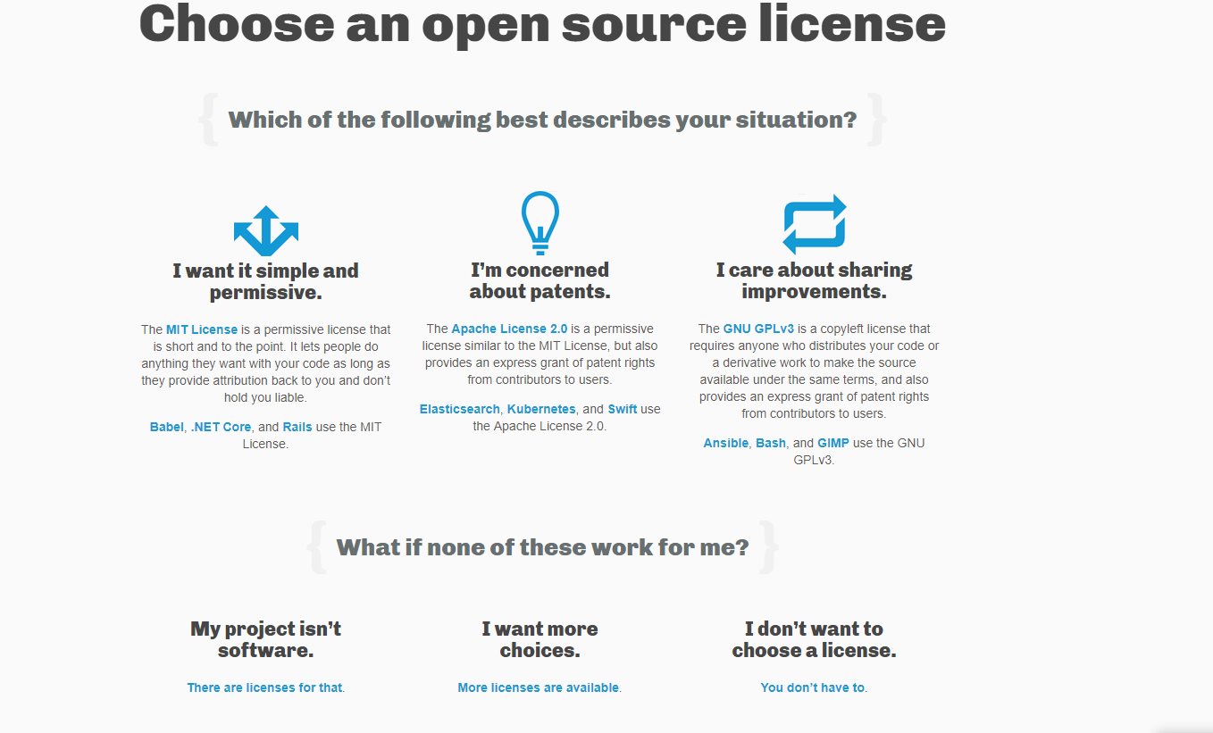

If someone wants to use my code as long as also pay me for using the it will be great this is fall under **MIT license**

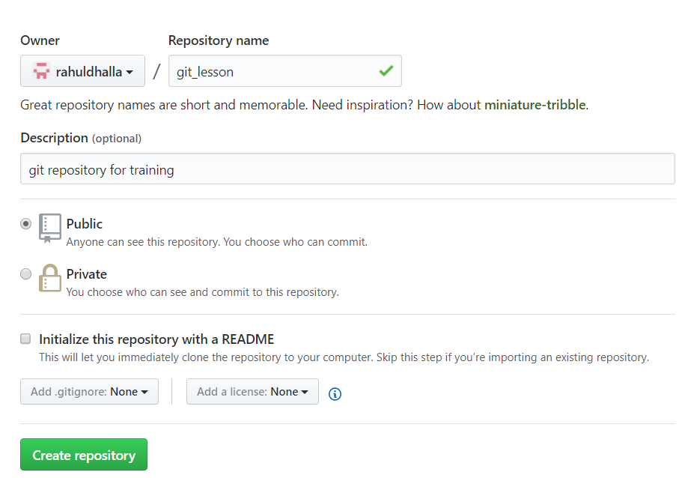

Nor I need readme file,.gitignore and License file

When you click create repository

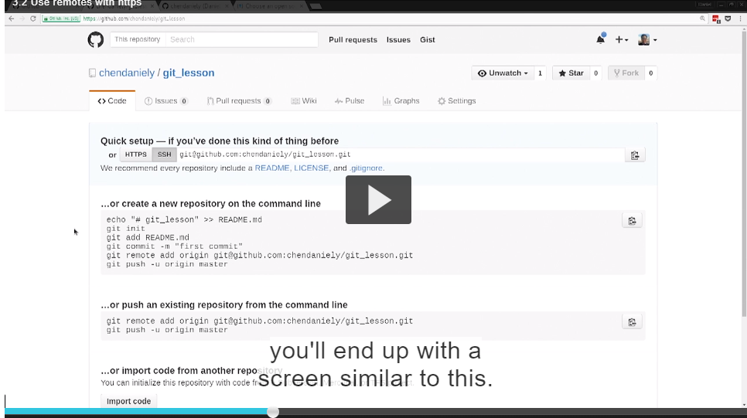

We will start off with HTTPS.

Everytime you use HTTPS and Provide github with username and password later on we use how to use ssh where you authenticated with github where you don’t provide username and password.

When you create completey empty git repository you have two different paths;

1.you can create an new repository on the command line and bring it to github

2. you can move Push an existing repository on the command line

3.we already done

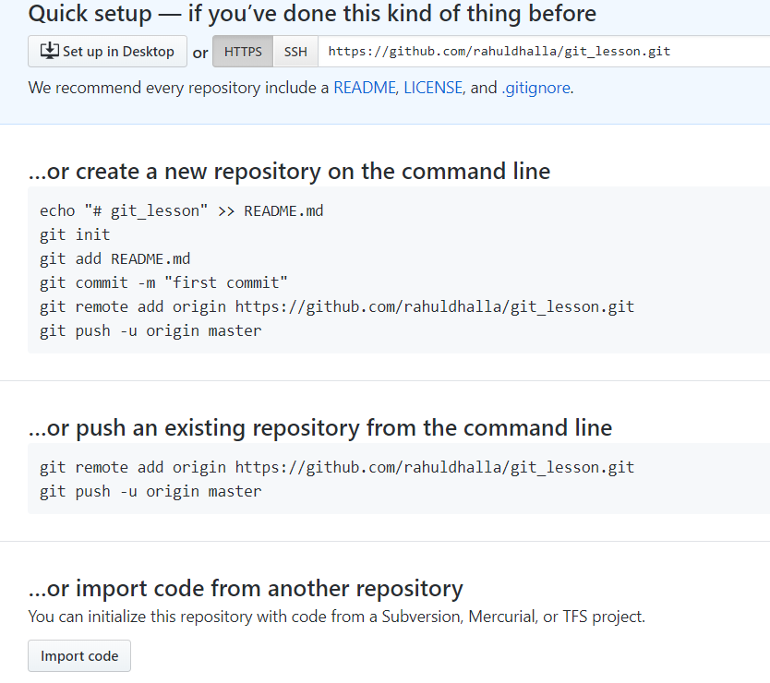

First 3 lines except two lines

Git remote add origin followed by url

Git push –u origin master and

**The other option is to push an exsiting repo from the command line and we see the exact two lines above**

Since we already created repo on local computer

We really just run the last two lines

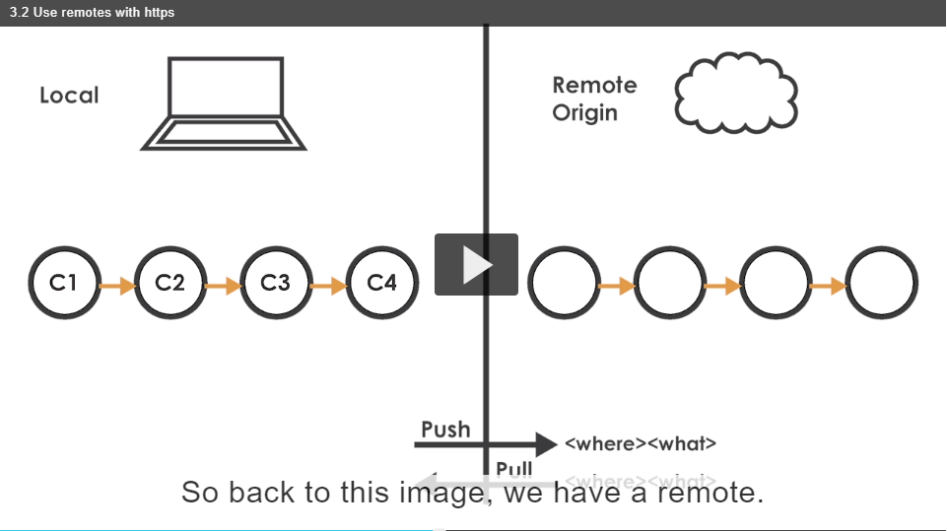

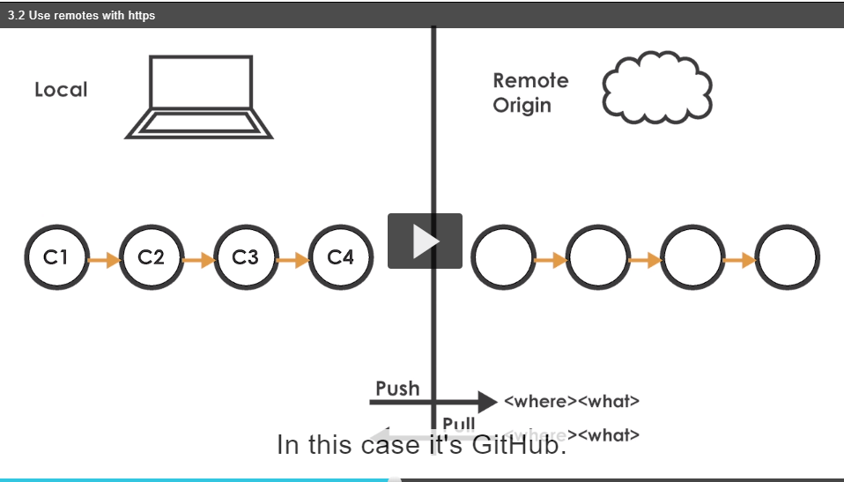

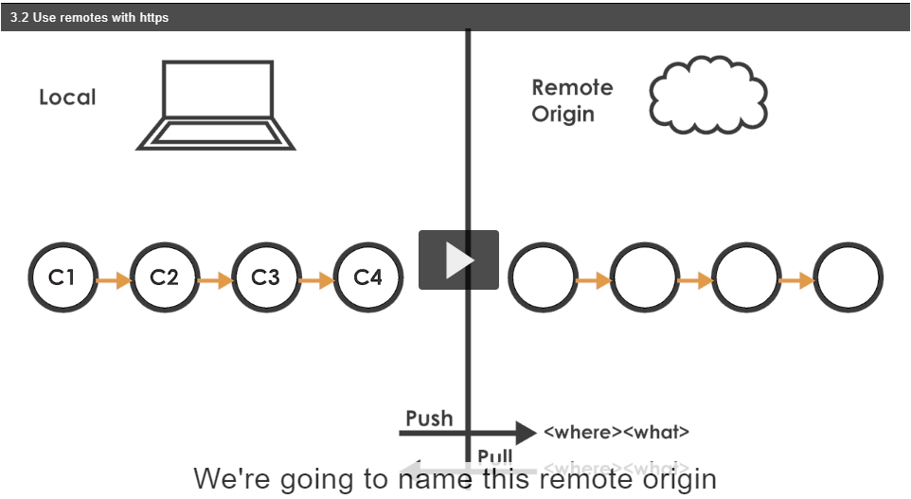

And we gonna take over local code and push it to origin and the syntax for pushing and pulling is where in this case the where…. is origin and the what ….is this master set of the commits

Before we add our remote makes sure we select “https’’ button and click this buton to copy in our clipboard.

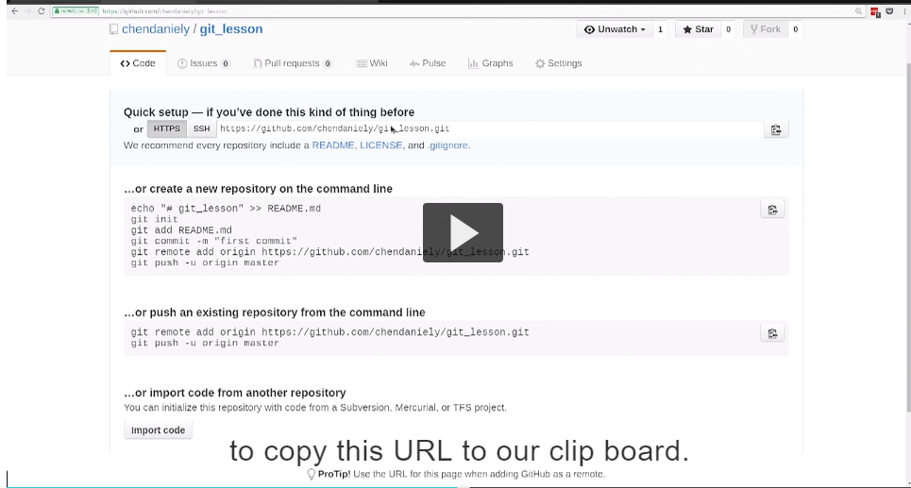

Back to compute and run command

Git remote since we were working remotes

We were going to be adding remote

The name of remote is origin

And origin is now shortcut for that url



If we hit enter nothing will show up but if we run’’ git remote -v ‘’



We can see that two lines show up

Both of them are named origin

Because that what we named it and that we have url that we provided

There is two bcoz there is **fetch url and push url**

For the most part they are always going to be same

That means you can get code from one place and actually push or save it another palace

But for most part you really leave this two alone.

Again by convention the name we given to the main remote is titled with “’origin’’ I could have easily named this pizza and it would been exactly the same.

So that now that we have our remote we can run over push command saying we were gonna take the repo of our local computer and we were gonna push into out remote.

1.so we run the command git push.

if we remember github page there was a actually flag called –u but I don’t typically use it

2. -u stands for upstream what it does is setting a default so that in future you **type git push it will automatically use origin and master as a default.**

“git push -u origin master

**”**

**Agar eh karde ta default set hojhu**

**.**

**I personally like to be more explicit when I working with git**

**1.more explicit slower your work and less chances of mistake**

**Git push has syntax where you want to push to and in our case is its origin and the what which in this case is master is which refers to the series of commits that we have working on .**

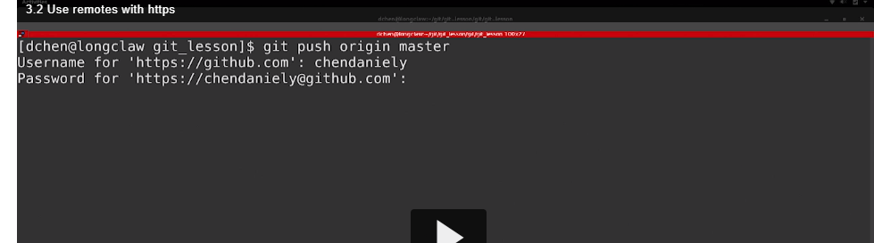

**If you typed username and password correctly**

**You will see a series of dumped lines into your screen**

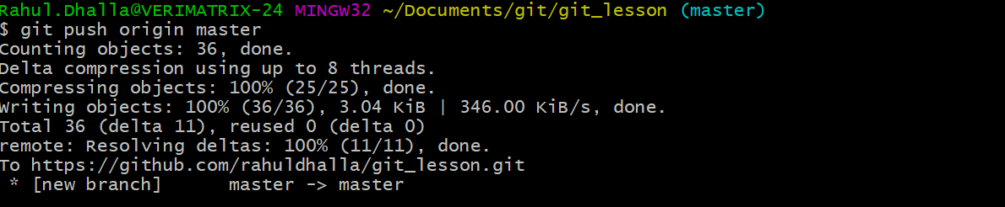

**Essentially whats going to happen is assi ek folder bnaya si .git oh compressed hojanda and send krditta shipped to github or shipped off to the remote that we specifying.**

**People wonder github store a new version everytime we make commit but what git actually is store a individual differences between files.**

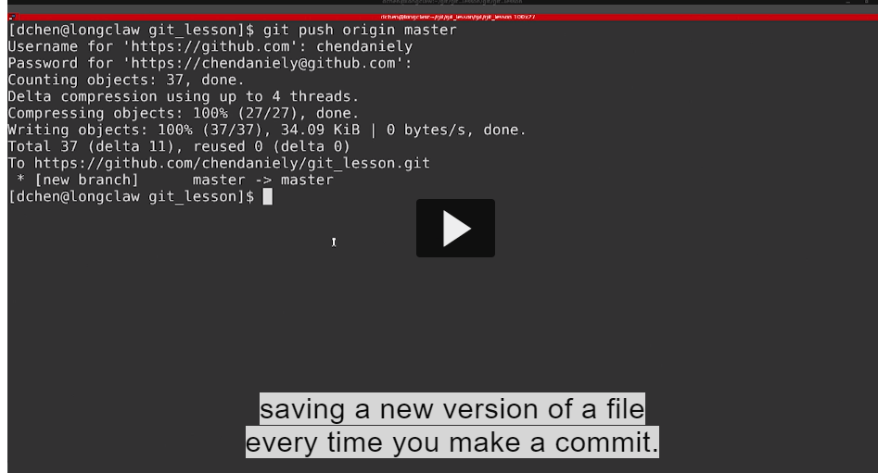

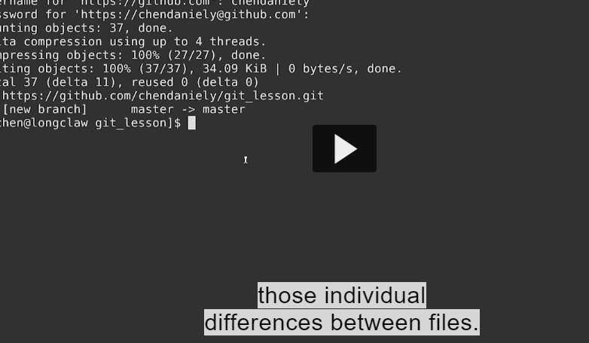



**Not that much extra space is used when using git**

**The only time is actually new files gets copied**

**If it git can’t resolve a difference between file**



Where you actually can’t show

Agar excel or word files ch git diff nahi kad paunda then us time te copy of that file rakh lend ava keep in mind.

This is why end up people like version control system like git

Start to work in plain text files

In our case the plain text files were the readme.md files we are created

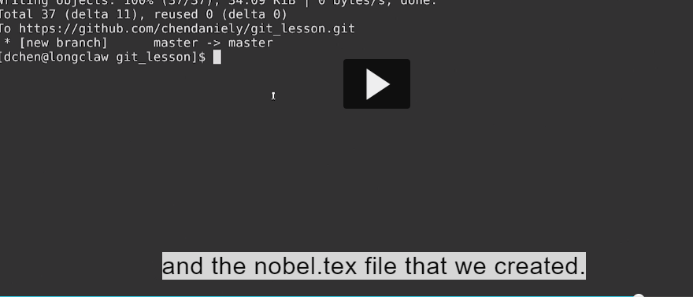



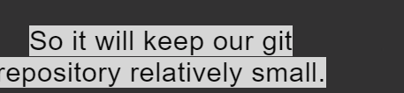



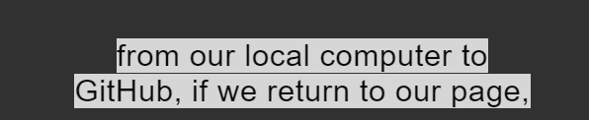

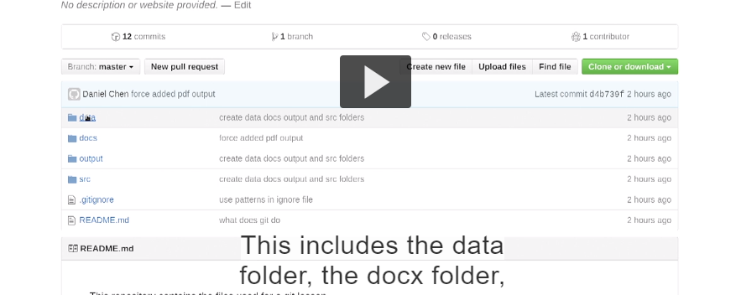

**Readme.md actually render on page of online service readme show karega ki hega**

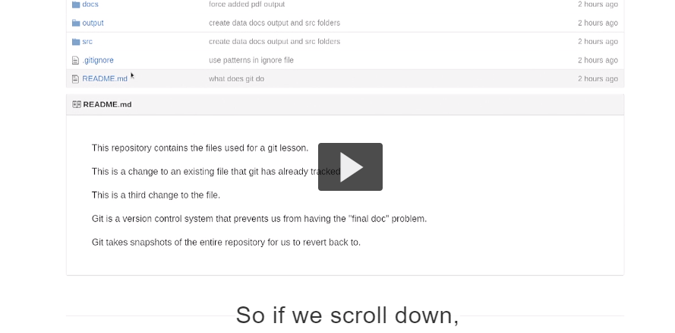

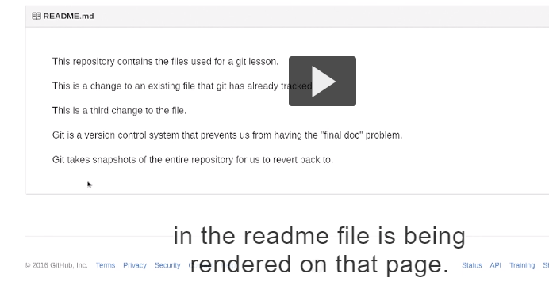

**Rendered on that page**

**Jehre vi loki aange mere page te vekh skdi kis karn repo hegi**

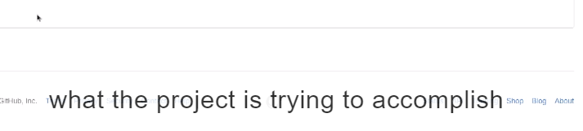

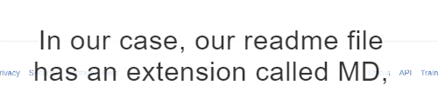







**In our case we really don’t us mark down features.**

**This is something you can explore to make your initial repository page.**

**A lot more readable to users you will see that .gitkeep in various folders.**

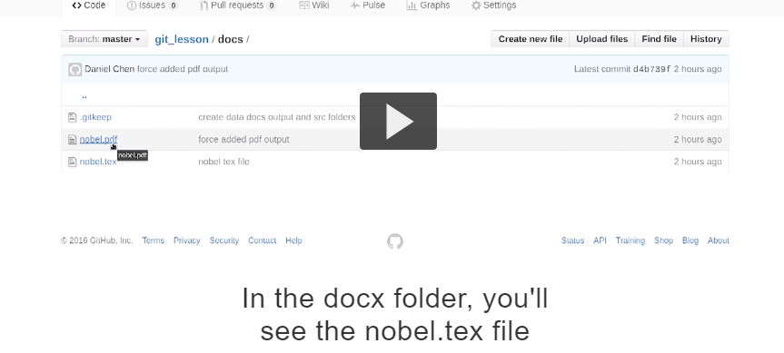

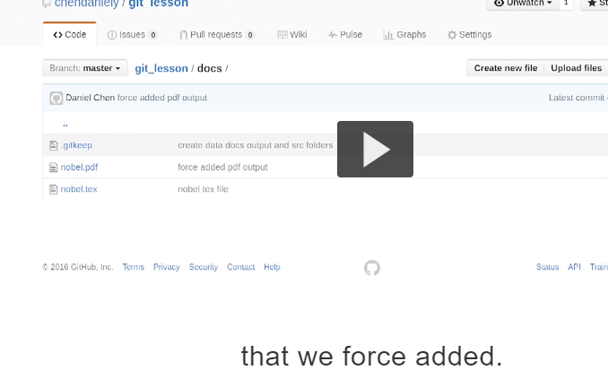

**Pdf file we force added**

**1.Use Remotes with SSH:**

1. [Instructor] So now I'm going to show you

how you can use SSH with GitHub.

First if you haven't done so, you need to generate

an SSH key on your computer.

So if we go back to our terminal,

if we go to the .ssh folder in your home directory,

if this folder does not exist, you can create one.

Now to generate an SSH key,we run the ssh-keygen command..

Ek jagah hundi os ch jithe .ssh hidden directory milegi but eh root toh milegndi esnu cd ~ means root then loonk inside

1. 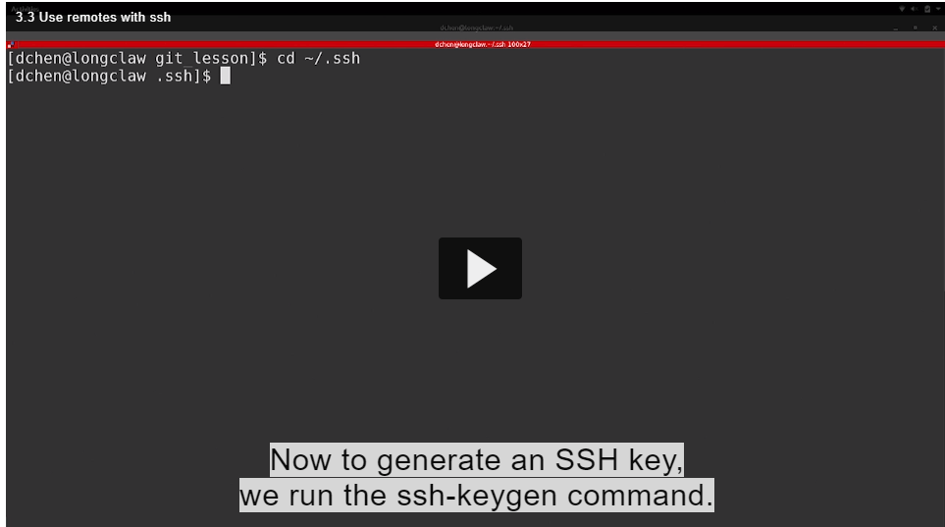
2. By default we private ssh key,id_rsa
3. 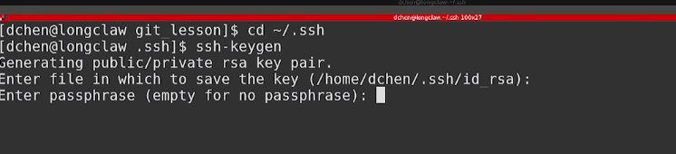

You may or may not provide a passphrase password but I don’t.

And press enter

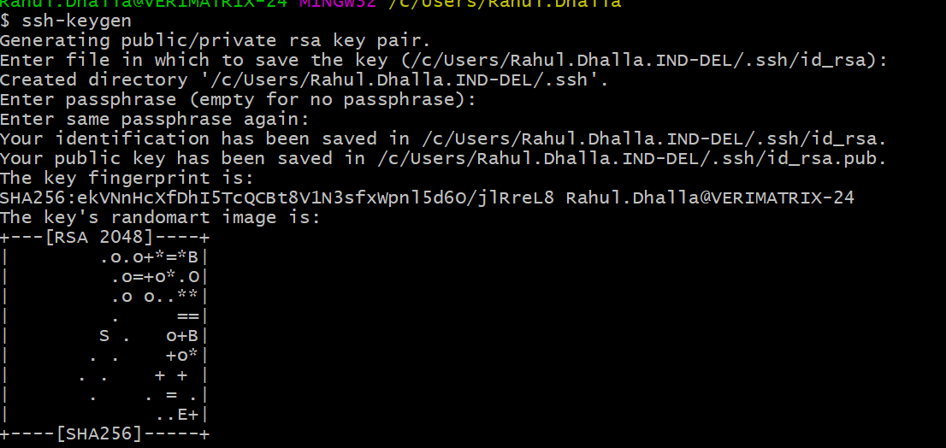

When your generated key you will see something like

Now if I look at our folder .ssh

You will see that there is id_rsa file and id_rsa public key file

The pub is for public

What you want to do is copy the contents of the public file

On to clipboard so we tell github this is our publick key

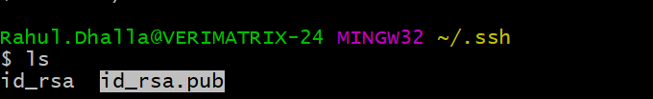

1. one way you can do that is open the public key in a text editor

We need to copy the public key and one way is to view it through cat command



Cat is dumping everything and now what we do is to copy everything from file and we go back to github page in our top right corner we go to setting and under the ssh and gpg keys.

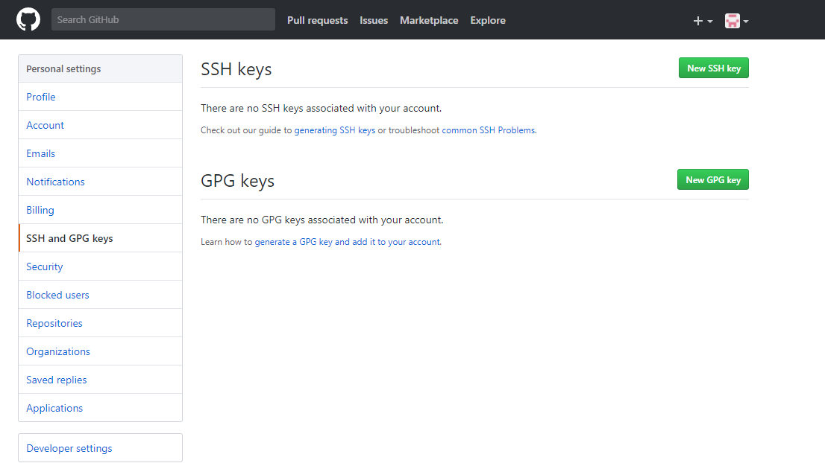

We can add a new ssh key

Here I can give the title I give it the name of computer we are working on for the key that is where it is paste

You know that everything worked correctly begins with ssh.rsa

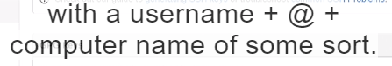

When you done you add the ssh key.

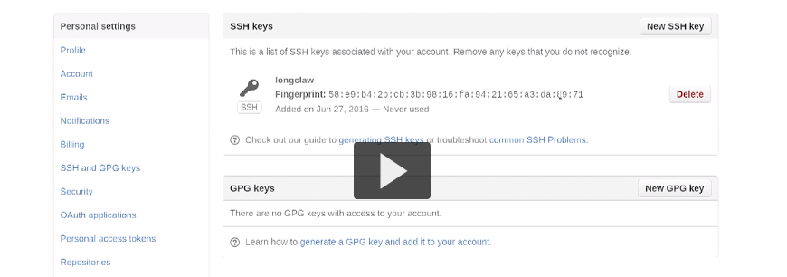

When we add ssh key and go back to repository page and instead of using https link.

We can now use the ssh link

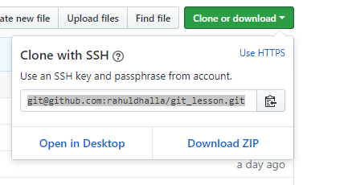

Ssh copy into clipboard and when we click https and ssh we see link is changing



Now back to our git_lesson repo and follow the last two lines of the page

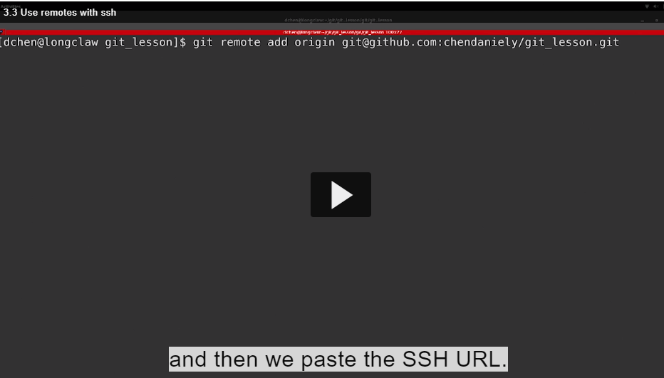

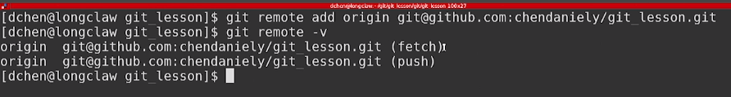

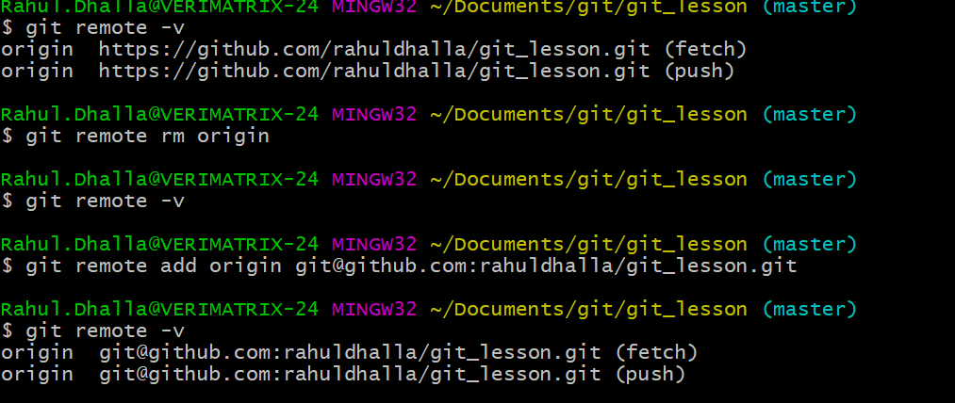

Now we have the ssh key setup on github

Ist first time you are conncetiong to github it asks you want to continue connecting type yes

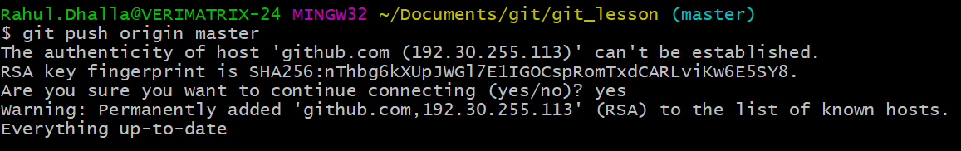

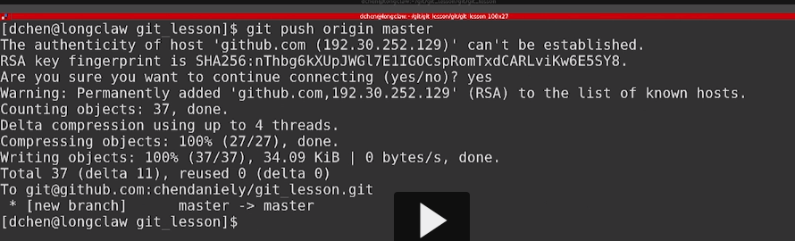

./git folder compressed and sent to github

Benefit of ssh key is you no longer type username and password

Everytime you want to make connection.

3. Utilize Self Collaboration:

- Now that we have our code on github,

I'm going to be showing you how

you can use the code on your local computer

and constantly interface it with github.

I'm gonna start this example by

creating a program that we can execute.

I'm going to move into the SRC folder,

and I'm going to use Nano to write a quick Python script.

1.ehne ek python script bnayi src ch ek func jehra square krda .

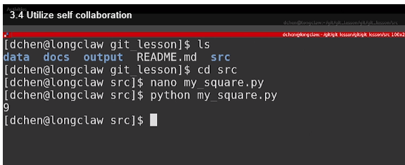

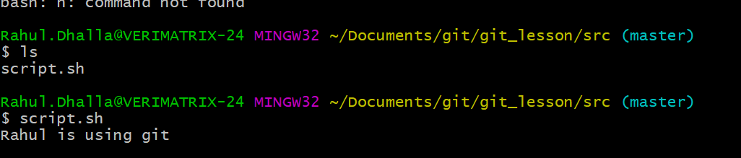

If we look at something git status.Main same ek shell script bnali.

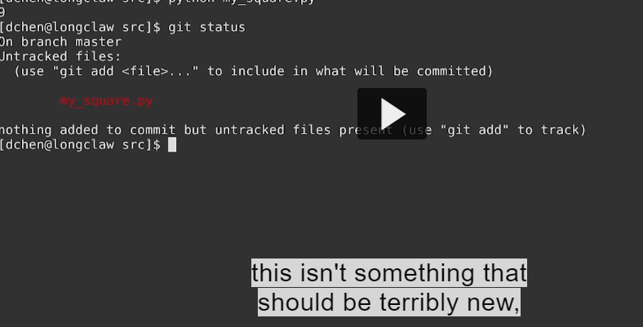

We can add this file to staging area and commit this file

We can go back to github ui and see in src folder there is nothing actually shows up here

Bcoz we only change to the local computer.

We now have explicity push our code into github

1.so we run git push and it takes two arguments

A)First argument is where we want to push and what in this case is its master

When that’s done we can go to back github

If you look at git hub you will see that there are three buttons.

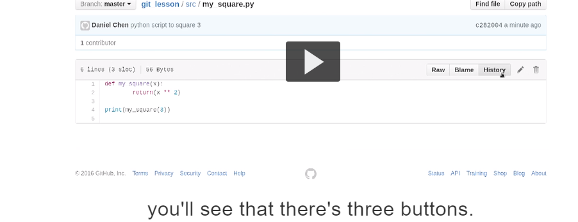

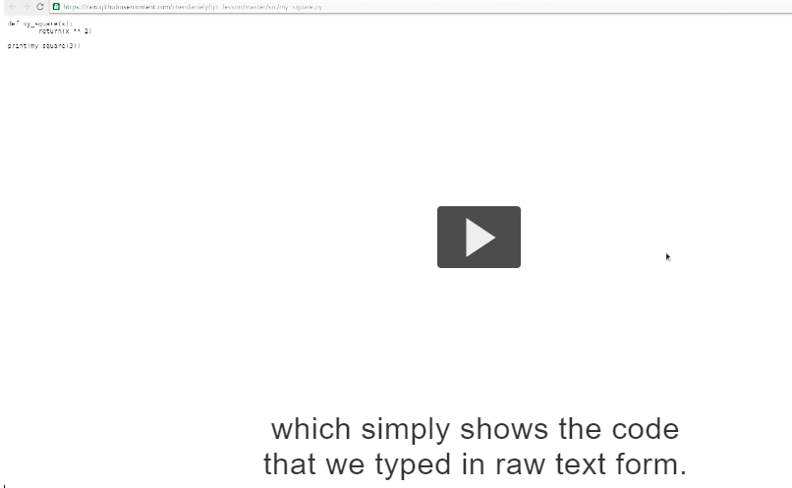

If you want to download the file right click on “raw” then save link as and file is downloaded .

2.There is blame button which is good at when you are collaborating with other people bcoz it will show you who wrote what line of code and when



3.History Button: which is just like a git log when we type git log in the command line but this is the log for particular file

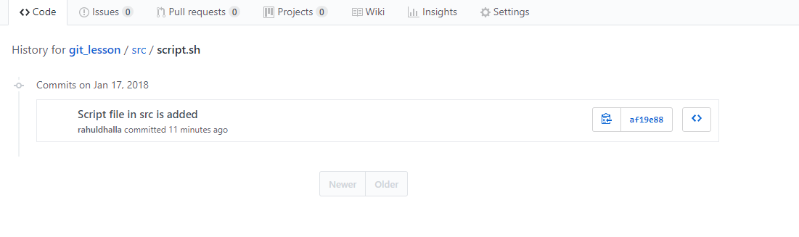

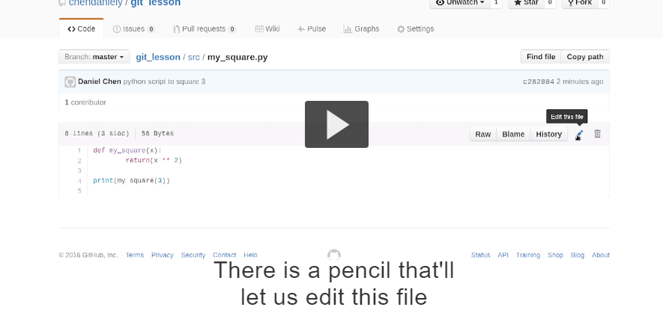

In github text editor

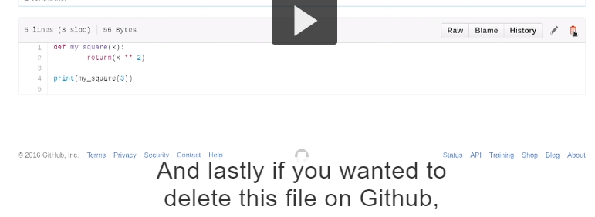

Now we have script we change it on github interface and bring back to local computer.

Eh ohdo krde jido tuhade kolo local computer da access na hove and you want to make a change .so this way you can make a change to the online interface.to quickly make a change to your code

To make the change we use the pencil.

Since we are using git every change needs to be commit.

Meaning we have to write a message with it

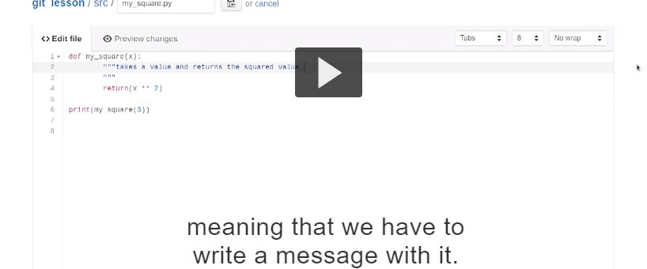

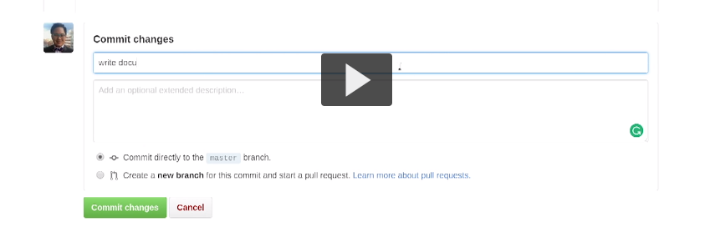

Top box is single line and below is for long messages

After typing both messages we are finally done

1.commit directly on the master branch which is what we have been doing through command prompt and we can commit our changes.

Now look at our history.

You see there are two commits.

2.so we made a change in our remote in this case github and if we want to back to our local computer we have to run the pull command.

Pull command is exactly the same command as push command

Where:origin

What: master

After run

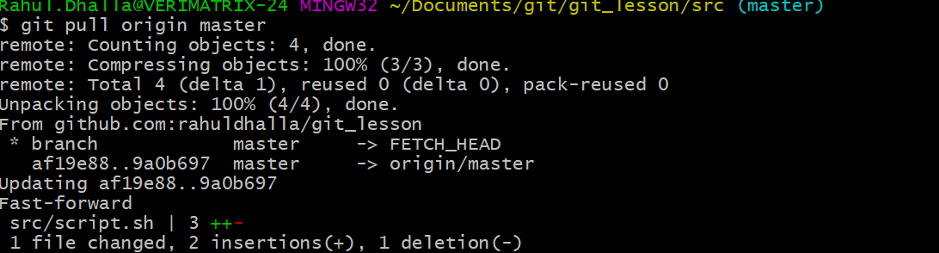

You are gonna see a line call fast forwarded and which simply means we are taking our current local state and updating all our commits that’s happening on our remote and the next file we change in on remote

If multiple files are changed then we see multiple files are there

++ means adding and –deleting and see the file locally you will find its gonna changed.

I am gonna show what would happen if you would change a file local on computer and github essentially at the same time.

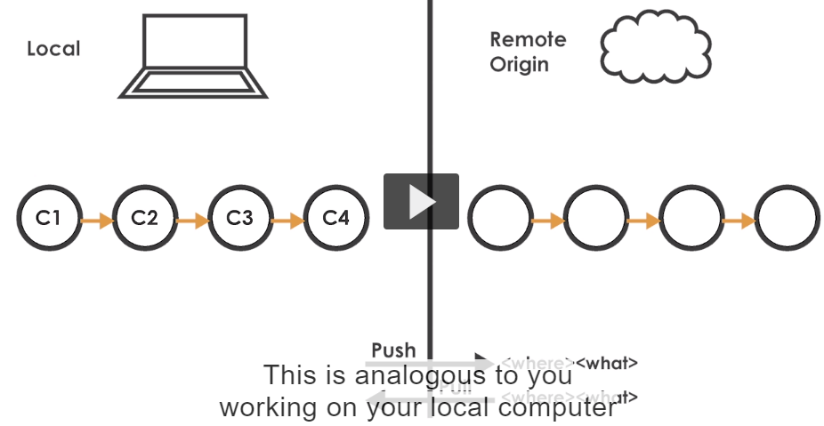

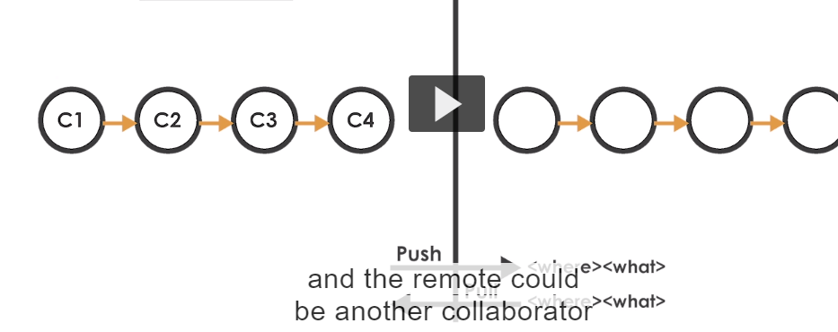

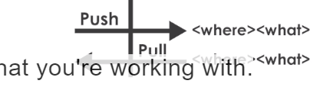

Git allows any number of parties to work on same files or multiple files all at the same time independently of one antoher

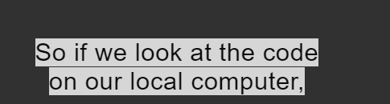

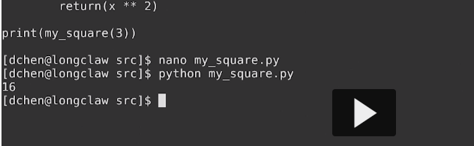changed.

Before edit let change the file same time. i am gonna use the pencil at the edit time. I add new message and change it and save it.

So if we were going to push our changes you see such kind of message

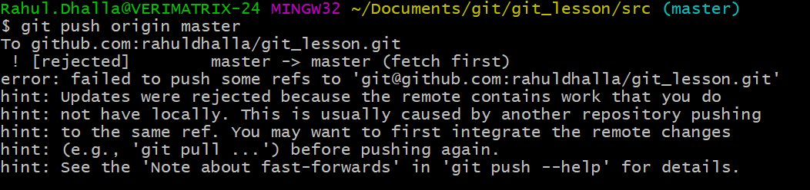

Your push is rejected but git is actually pretty good trying to help what going on



And we don’t have a that change on our local computer

Eh scenario hega tussi apni local te kuj change kitta siddha push kr rhe ho error

1.Pehla pull karo changes merge akro then push karo .

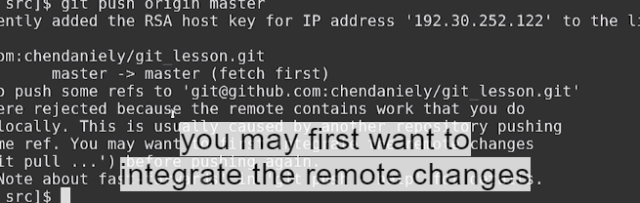





**Git pull origin master bcoz this is a new change that we are making and git is going to create commit message for us this is very your text editor and you don’t have to change any of this**

You can simly save and exit the file.

And you see same message done here when you run pull message originally

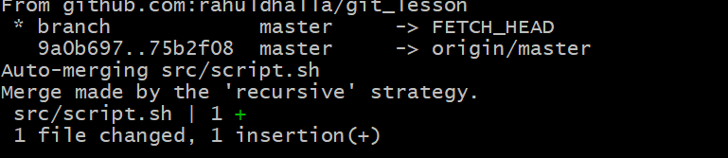

Line we are talking about auto mere as git is smart enough.

Means mere changes ch pull vale changes add karte ok done

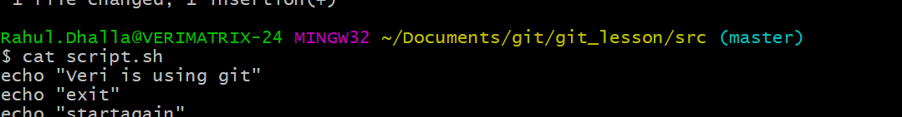

Git ki krda local and github de changes merge krdinda means dono changes vikhange okay.

If we look at the log

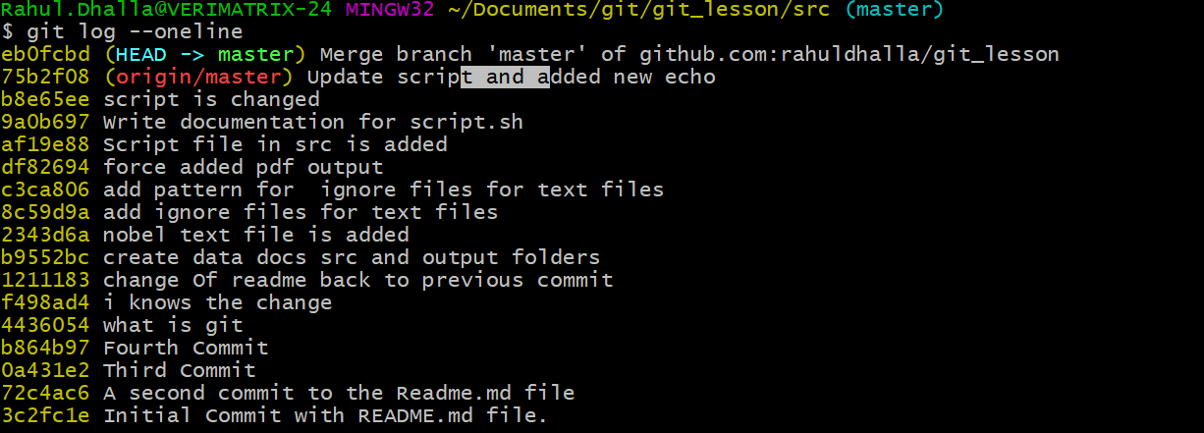

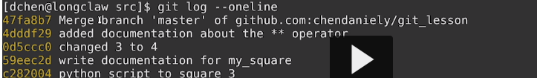

I am getting error on pushing now we push again

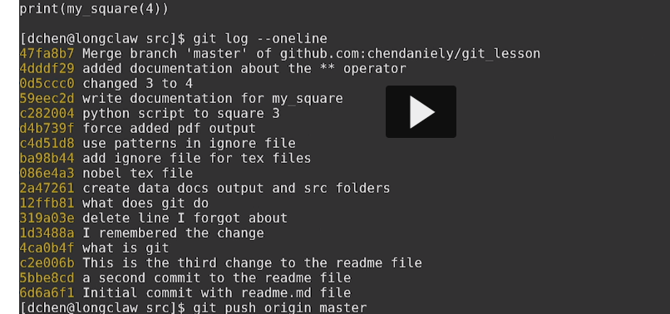

Push our code and return to github

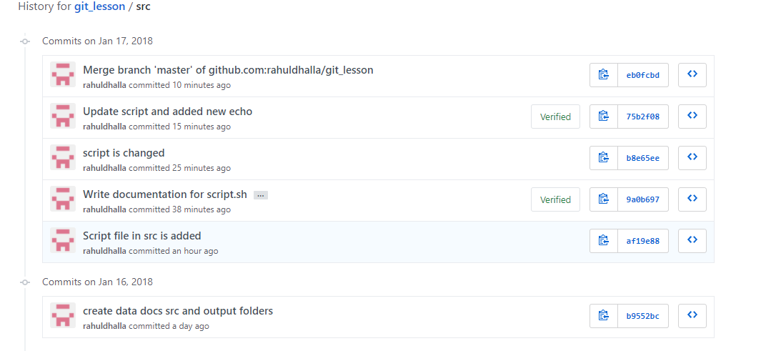

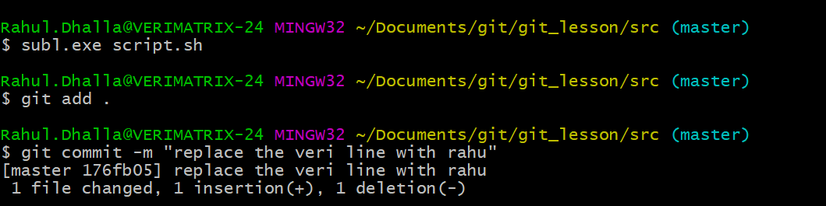

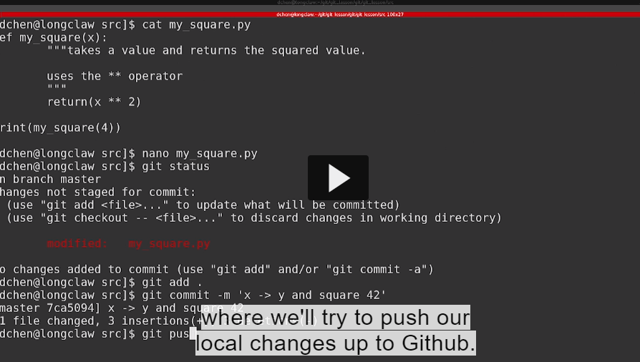

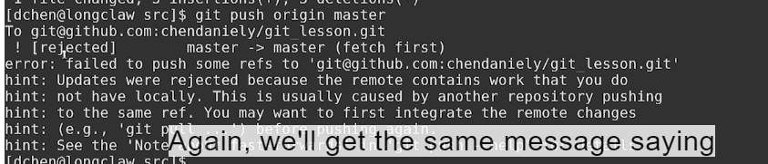

Github da version sade computer naal match nahi kar riha so esliye

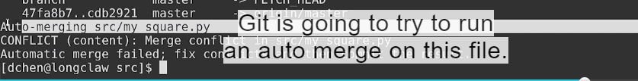

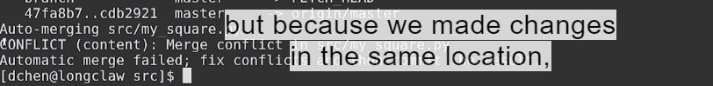

Git is doesn’t know how it incorporately these messages.so it going to tell you there is an conflict then there is merge conflict.

Different jagah te oh khud kardinda va okay keep in mind.

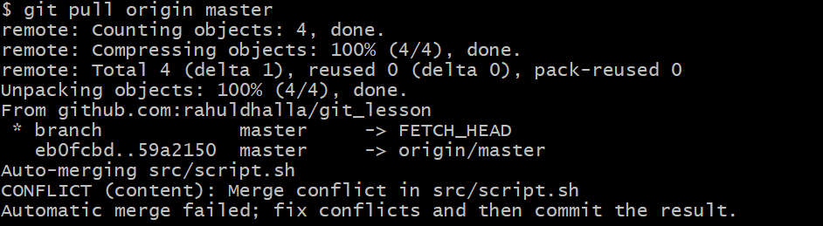

If you open the file and you will see that git changes the file in which we see conflicts are

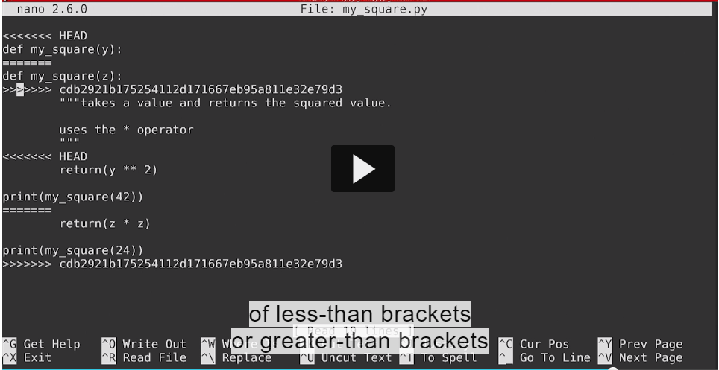

Less than brackets or greater than brackets

Location where conflicts occurs is separatd by equal sign

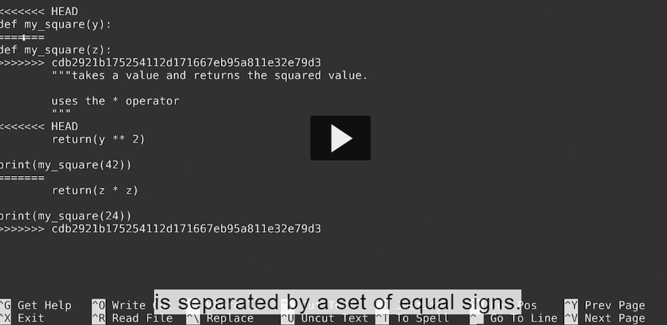

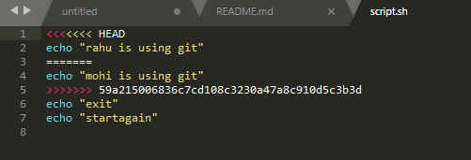

You see **head** which is the version of your local computer and **commit hash** refers to the version of github or our remote

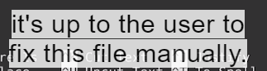

So I am going keep the version on my local computer and individualy delete the file and manually fix the file

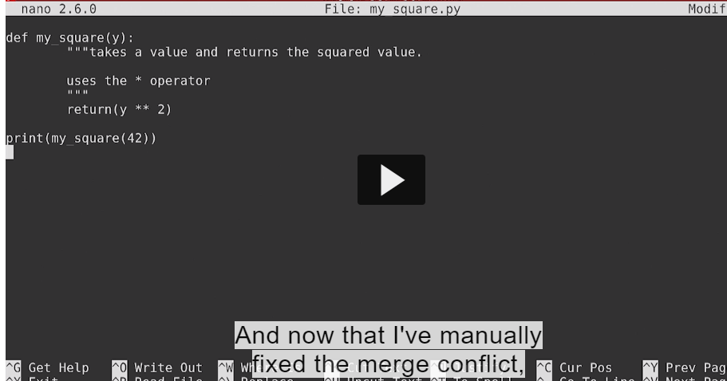

Save the file

Git status and we are on unmerge paths and we need to fix the conflict and run git commit or git merge –abort .

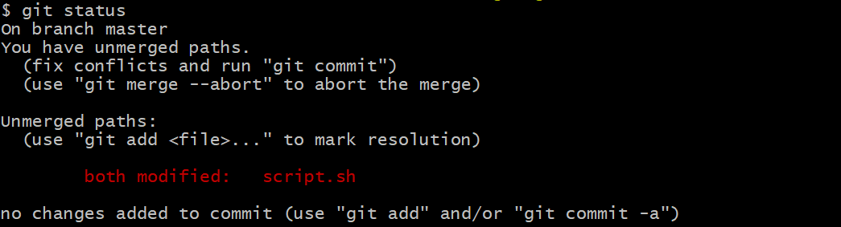

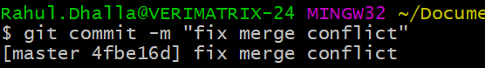

**Now run git push origin master ad return to github**

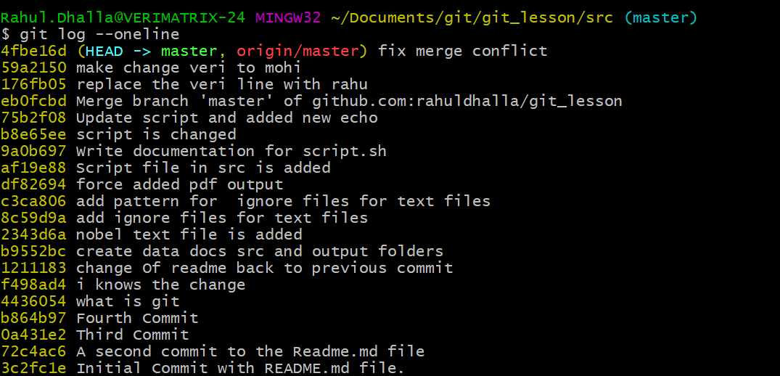

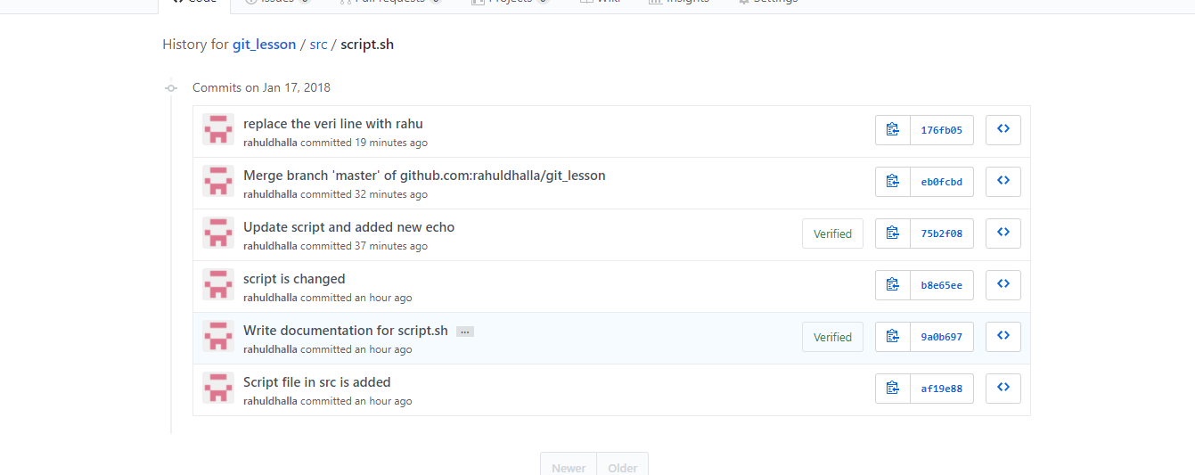

#**Use Git For Project Management:**

Transcript

- One of the main reasons why GitHub

has be come so popular is the fact

that it promotes for social coding.

The same features also exist

on other git hosting services such as

Bitbucket and GitLab where you have

an Issues tab and the ability to create a wiki.

The issues tab allows you or other people

collaborating with you to write messages

on what needs to be performed, any potential bugs,

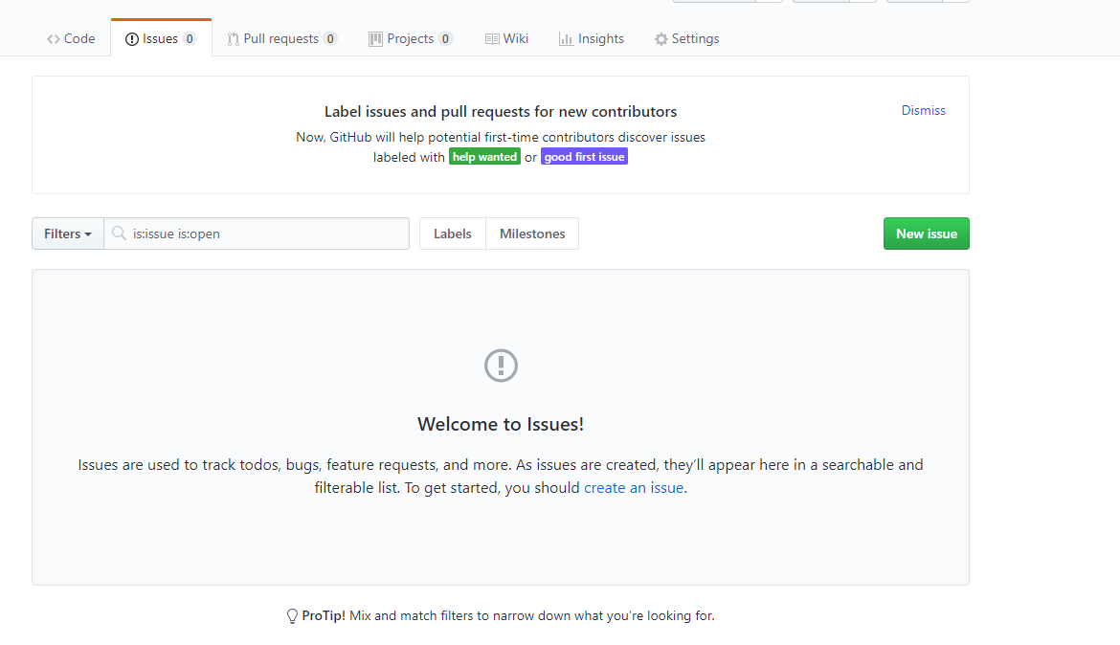

Its also good place to store any meeting notes about your what projects needs to do.

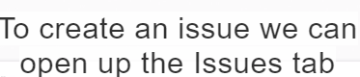and click new issue

Write title and comment for issue Again this can be useful for bug reporting, taking notes and what you need to do in project.

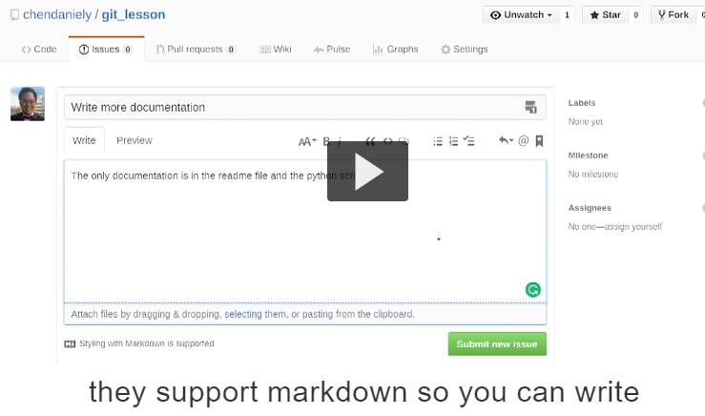

Italic ,bold and even add code snippets



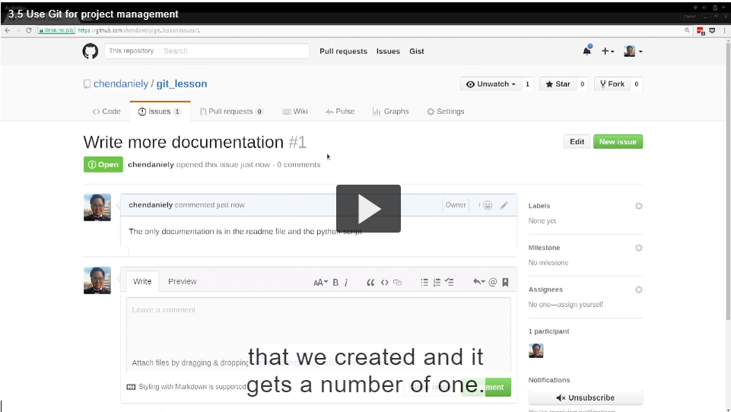

Chronological order

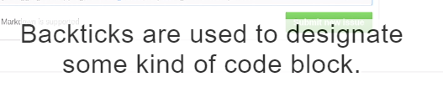

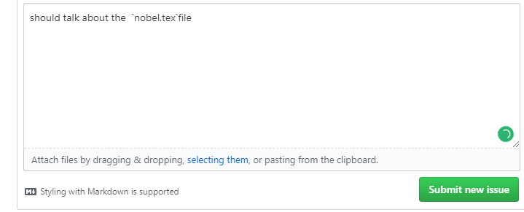

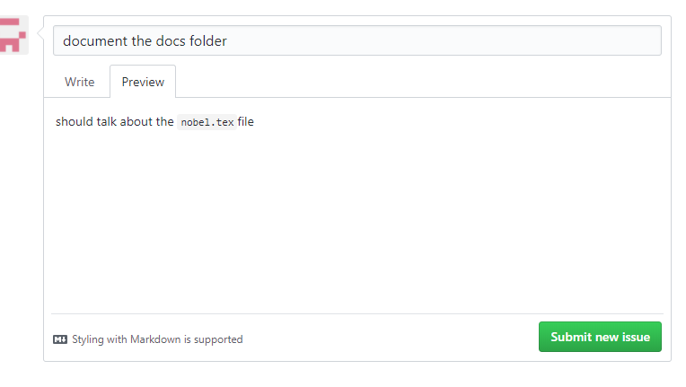

To highlight nobel.tex file

Since issues are numbered we can actually refered to by number

In github and other we can reference back to the issue by #1,#2,#3

And see preview you will see the number gets into hyperlink and we can click on.

So reference back to original issue.

Its good for any conversation or thoughts within the project.

**Another github project management tools github provide us is**

**a)Labels: you will see that in many open source projects**

there could be thousand of hundred of open issues and for someone who is the maintainer of this project just to make it sense to all they can label them so

they can quickly filter issues have the same problem

for e.g issues refers to the bugs in the code .

Jehre issues de labels ditte hoye assi use kar skde but je estra da issue jehra assi bnya but oh custom bnana then create new issue.

Now we created this label

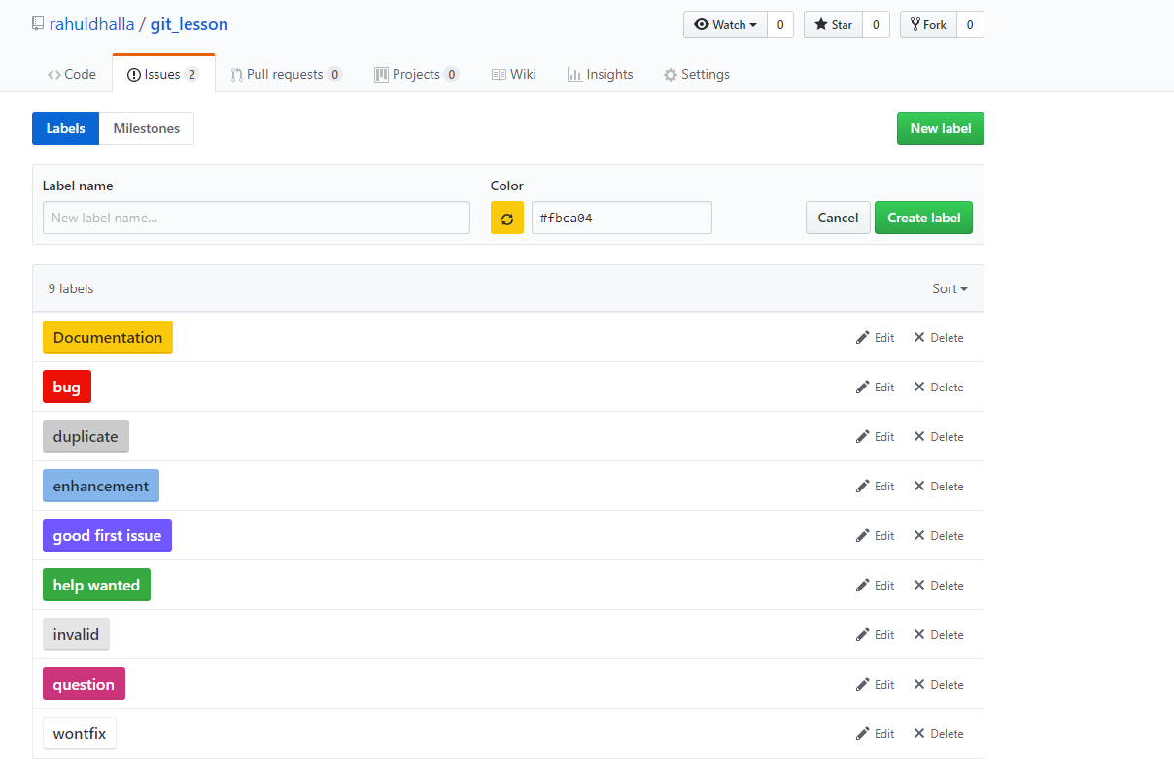

We can back to issues tab and we can assign them.

1. open the issue and on the side we click on labels

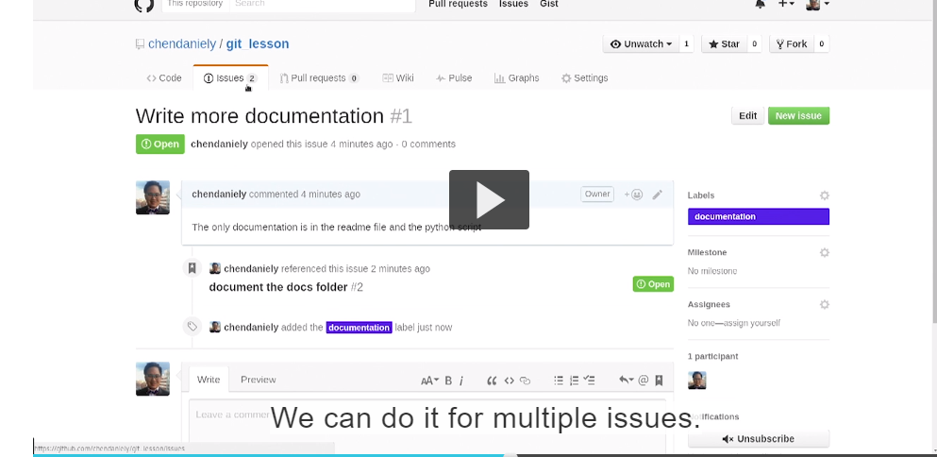

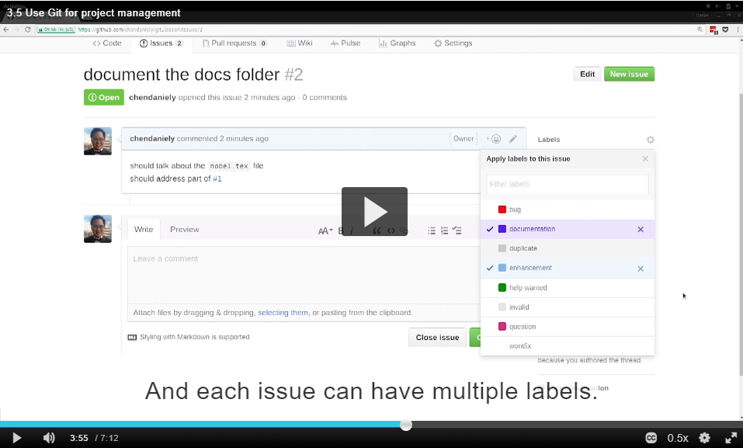

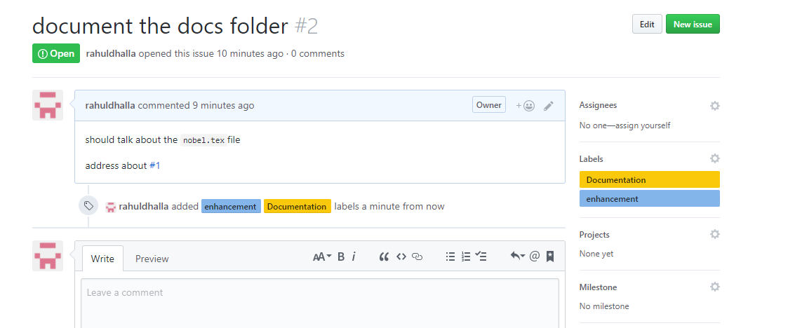

Main chahunda bus enhancement vale lable naal issues vikhan then label te click karo bus.

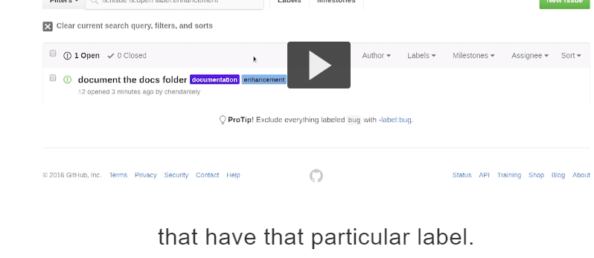

**Another way is to use github services is through is grouping issues together into milestones.**

**1.To create a milestone we will click on the issues tab in the milestone panel.**

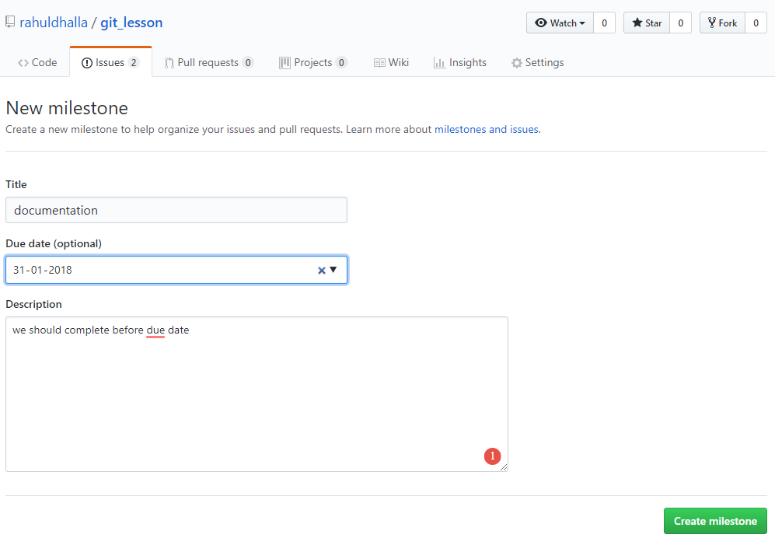

**We can go to issues tab and assigned issue to a particular milestone**

**.**

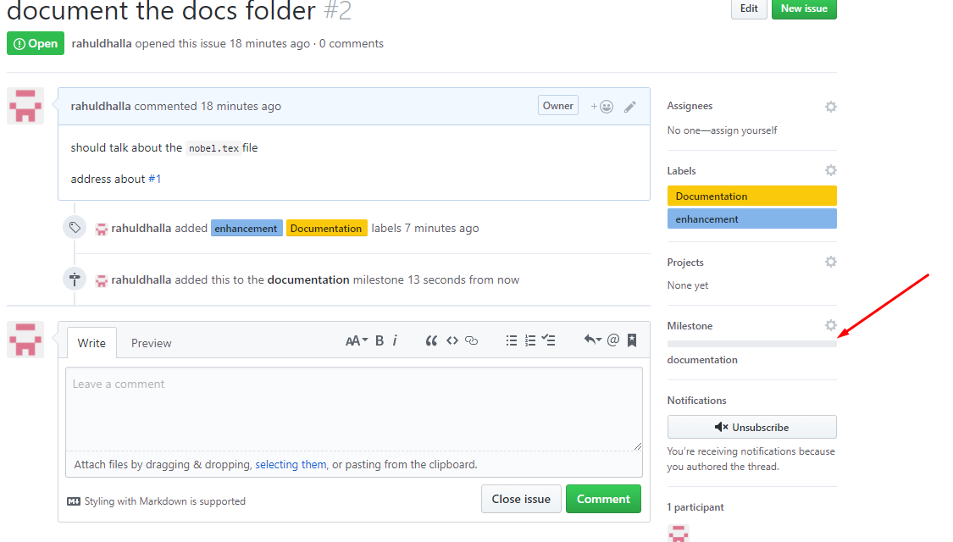

I am going to create empty issue to show what happens when you finished parts of milestone

we close the issue means issue no longer relevant or it has been solved

Jido assi koi issue milestone ch hove and assi close krdiye then progress bar fill hojandi va

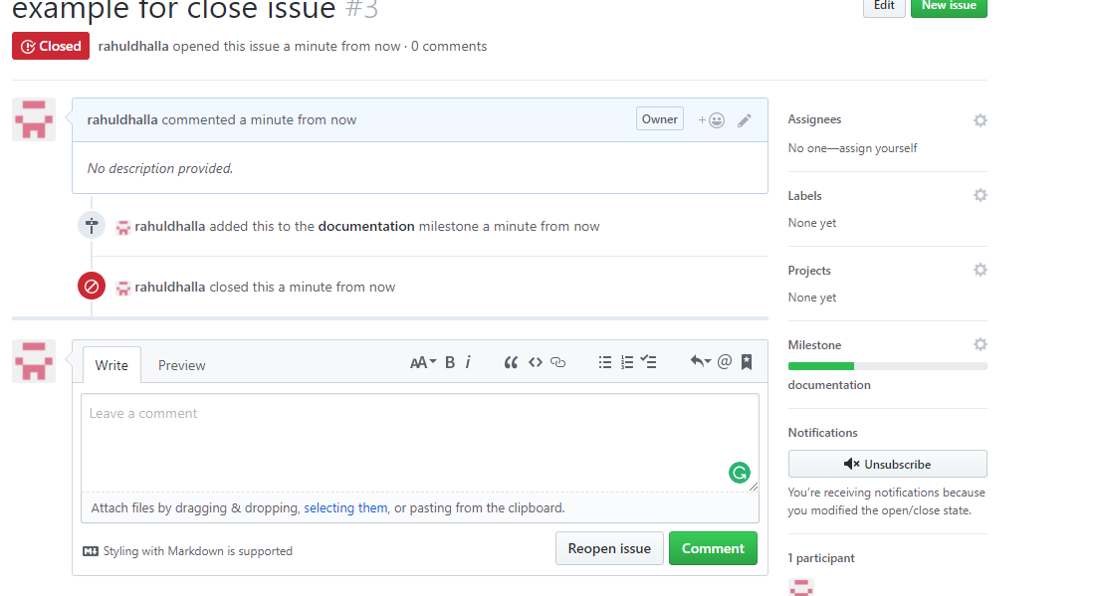

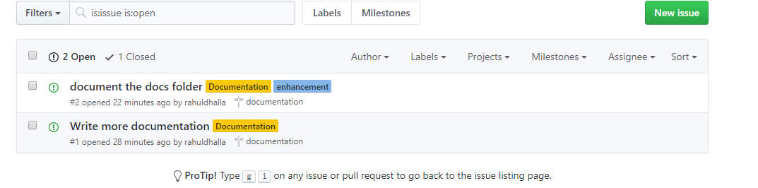.

**Another good project management tool github is a wiki:**

**Wiki is good for curating knowledge** that could be relevant to project and you are working in git and everything will change have a ,message associated with it.

1.Initial homepage message is already populated for you and choose to save the page.

2.As you see you are work with wiki

3.create multiple pages or edit the page

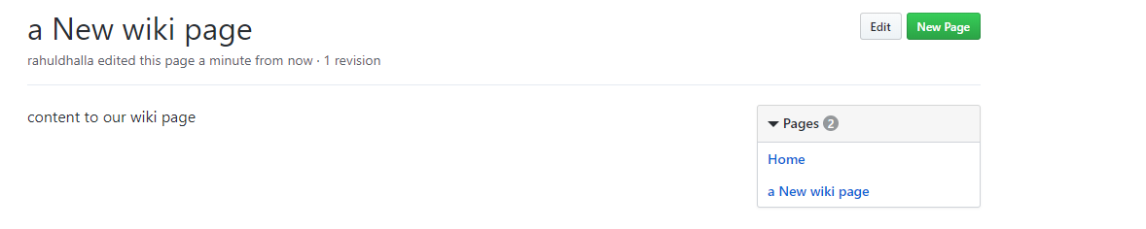

So with wiki we slowly build our project.

**Next: use branches on your own**

Transcript

- So far, we've been making our commits

on the master branch.

Now I'm gonna show you how we can create more branches.

When we start working with more complicated workflows,

we want to make sure that we always have a state

that's always good.

For example, when we are working with code,

we want to make sure that the master branch points

to a state that the code can execute without problems.

But when we're developing,

we still want to make our commits as we're testing our code.

So here you can see that we have a master branch.

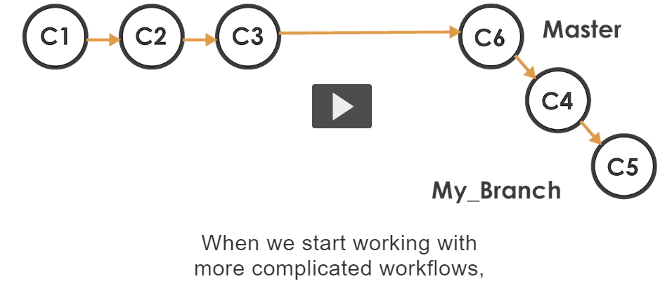

**What we can do is to create another branch**

**So second branch contains series of commits for the work that we are prototying but we can always fall back to the master branch.**

**So back in our terminal we can create a branch using the git branch command.**

1. **Git branch takes a parameter:in this case we give the name of the branch we want just like how master is the default name given to our first branch we can name anything we want .now we created the branch**
2. **We can see what branches are available using the –a flag for branch**
3. **Git branch –a**

**“*” indicates that what branch we are means we are on branch master and below is the list of any of the branches we have created.**

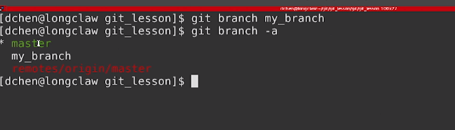

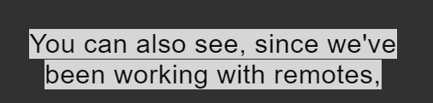

**Is github and we also see**

**the branch that is on github as well that is.so just how checkout was able to bring your head back in history for us .**

**so we can use same command checkout to go from one branch to another.**

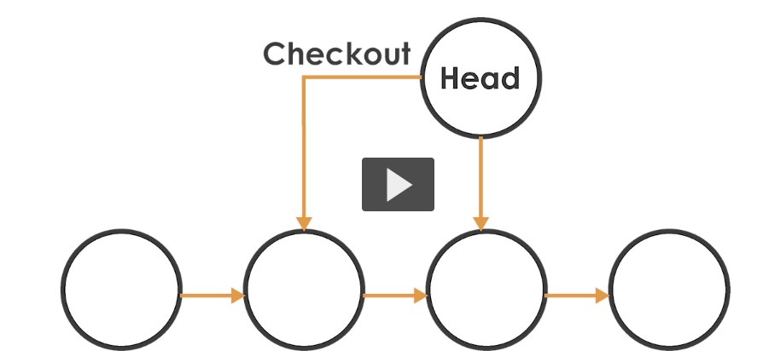

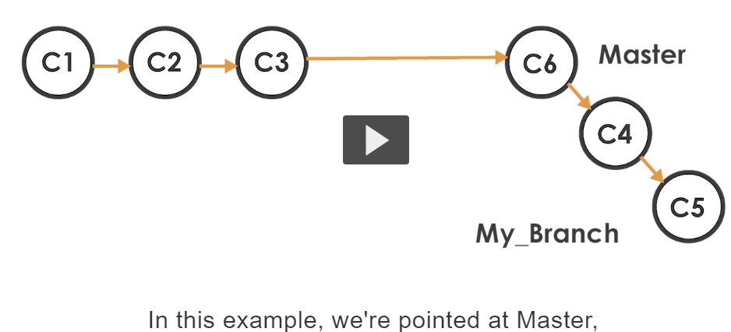

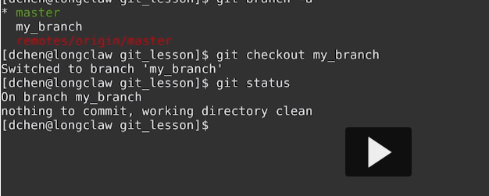

**Instead on branch master we are on branch ‘my_branch’**

**If we list all the branches.**

**Git branch –a**

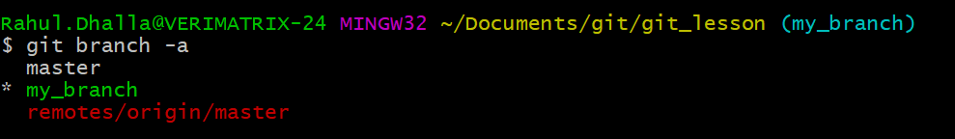

**2.Another way we can create branches using git checkout command**

**We can pass the –b for branch flag and just like git branch we can give the branch name .**

**Git checkout –b <branchname>**

**What it do is it creates a branch and moves to the branch all in one go**

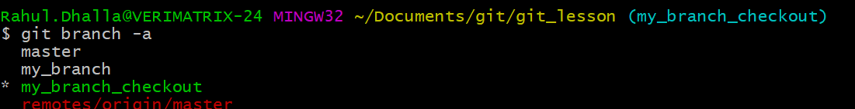

**To delete the branch we use the the “–d flag” for branch**



**If you try to delete a branch that you are still on that branch. It won’t let you**

**.**

**So move to master then delete it .**

**So you can see we successfully deleted branches. Ok**

**……………………………………………………………………………………………………………………..**

**Lets make a branch form master**

**Git checkout –b my_branch and make a commit to this branch.**

**Change the script and do add and commit.**

**Only diff is we are on on my_branch**

**As we see changes are there so we now move to another branch “master”**

**Now if we looked at the contents of the file.**

**We see changes are no longer here**

**Sanu hamesh branch de log dikhange keep in mind.**

**What actually I do is used when working with muliptle branches to view git log with flags**

**We using –all it will help us to see all commits**

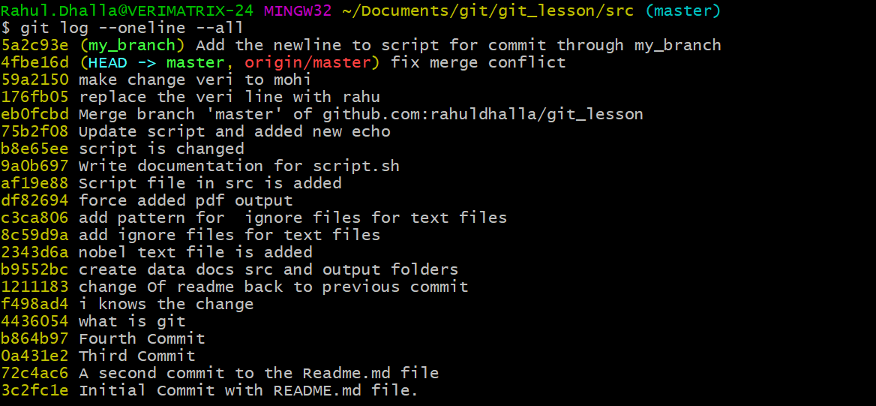 **main branch master te si phir vi sare commit vekh lavve**

**So we are still getting commits from other branches when we use all the flag**

**However this view is still confusing and doesn’t show which commits are associated with with branch. So I like to add other few flags as well**

**Decorate: I like to add decorate flag so we can see which branches are there**

**Graph: graph flag just to get the view of our log and now you see log is now decorated with various branches and head is pointed to.**

**Currently I checked out with master branch so head is now on master branch**

**And since we have been working with remotes we have a remote named called origin that points to github and the master branch is labeled as well**

**Additionally the my_branch where we commit it also has own commit.**

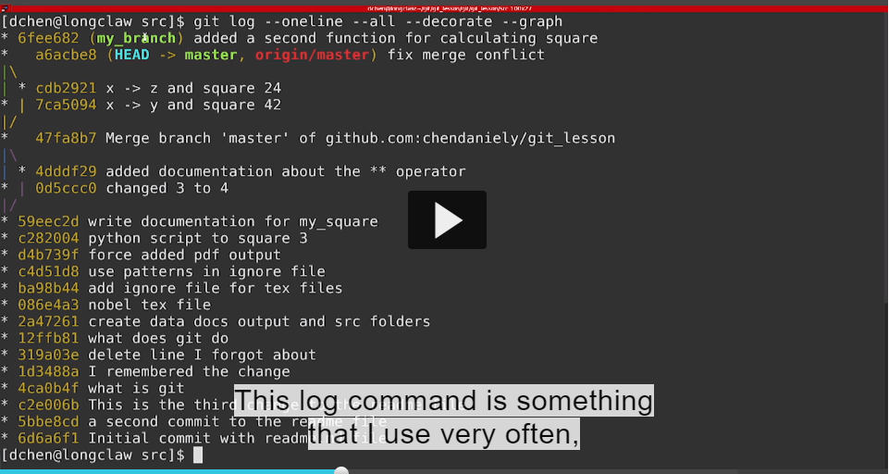

**Vaise jis branch te hovange used commit vkhayega jehre dusri de us de branch naal vkhavagea samjag gya jive (my_branch)**

**And it is something you should about aliasing into shortcut just becox of its lots of character to type.**

**Secenario: agar main chahta hu dusri branch ke changes apni master branch main leke aane means incorporated changes then we have to do is merging branch**

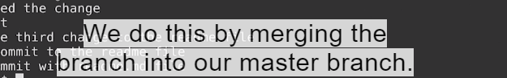

**The way we can merge one branch to the another we first have to go into the branch that we want to incorporate changes into(jis ch changes liyanna chahuhnda va )**

**1.git status**

**2.i’m currently on branch master**



**What I do is to take the changes of my_branch incorporte into the master branch**

**We can accomplish this by using the merge command.**

**Git merge and the branch that we want to merge into.**

**You can see that the output looks very similar to when we run git pull when working with remotes**

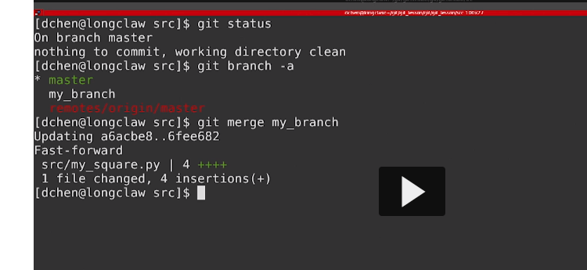

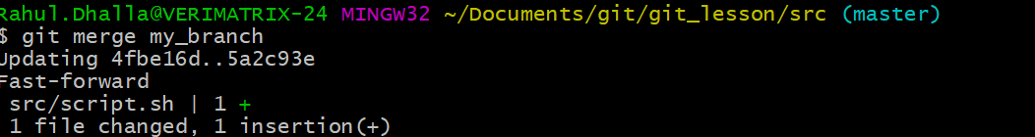

**It will show all the files that were changed and number of files that were changed in that file.**

**You can see the changes incorporated in our master branch**

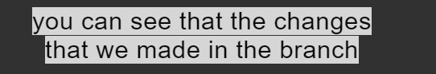

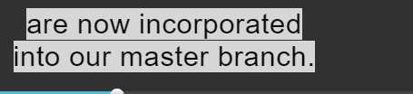

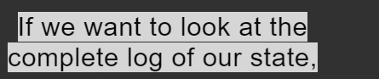

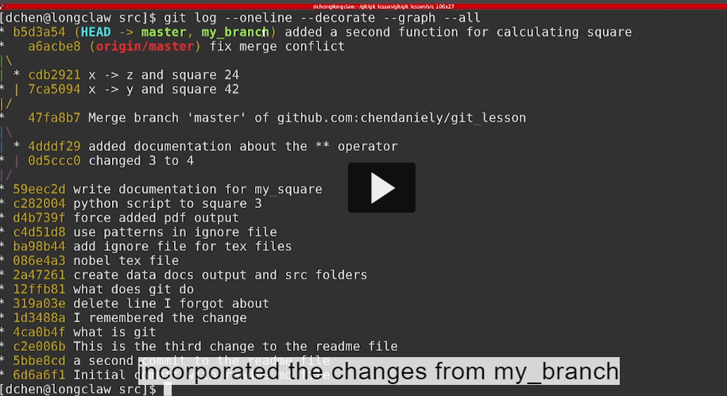

**You can see master and my_branch is on same branch**

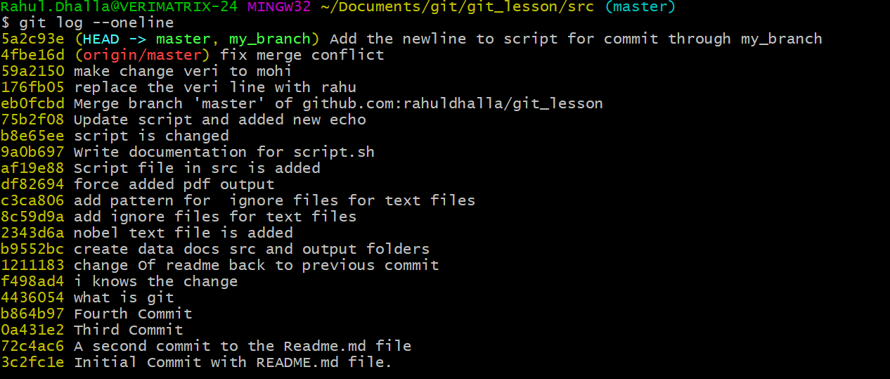

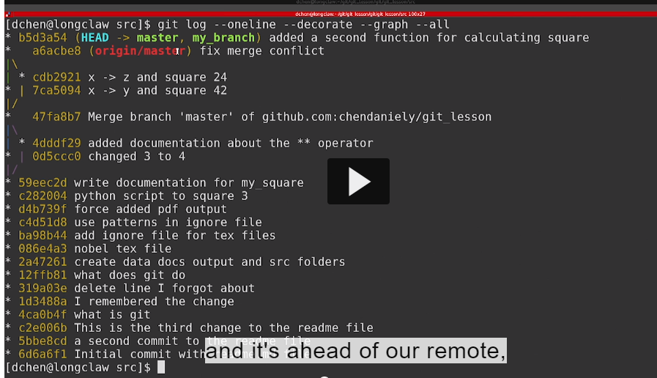

**Master branch is ahead of remote .ek step agge hegi va in that case its origin points to github and master branch there or we can do as before we use the push pull system to sync our local changes to the remote and you see in github interface file now has our changes.**

**If we want the main page the button called commits and just like the history button on an individual file shows you history on a single file the commit button show you the entire log.**

**Here we see latest commit in chronological order.**

1. **If we want to click on commit hash and github will render a different view of the file that pertaining to commit**
2. 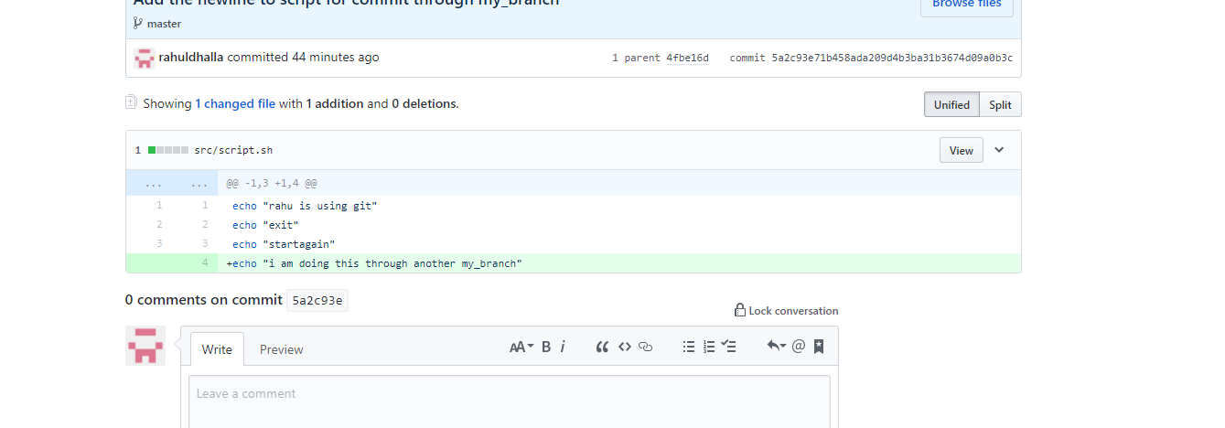
3. **Showing green is am adding this file in this commit**

**…………………………………………………………………………………………..**

**Just now I am creating the branch and merge it locally into master into .**

**the computer**

**you can also submit the branch to github and have github do merging for you**

**this is what know as pull request.**

**Run git log decorate command to see everything going on**

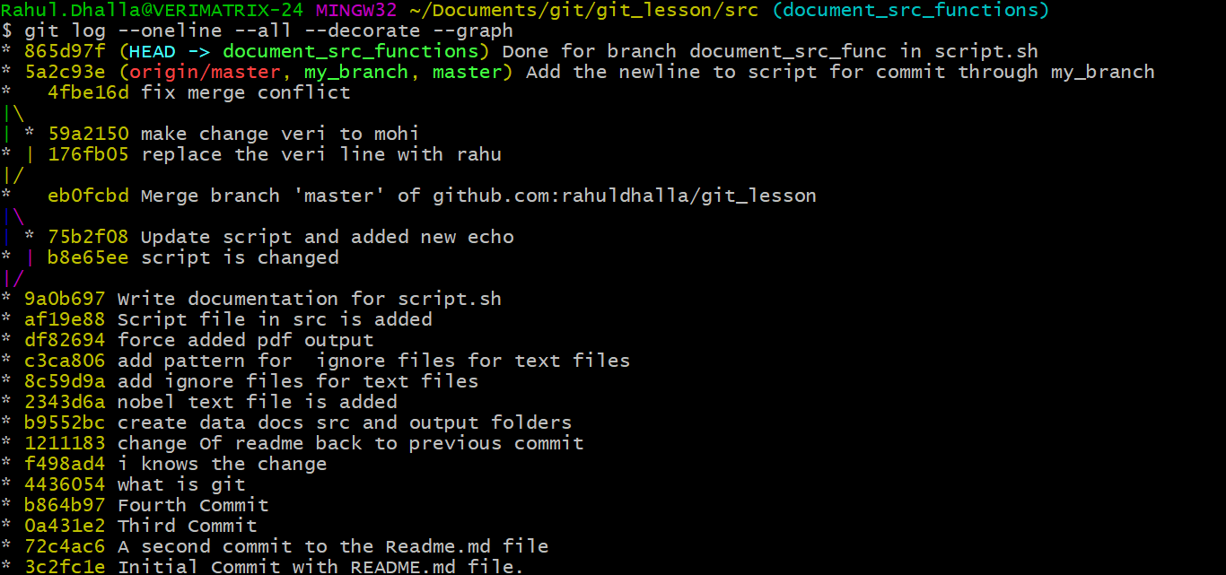

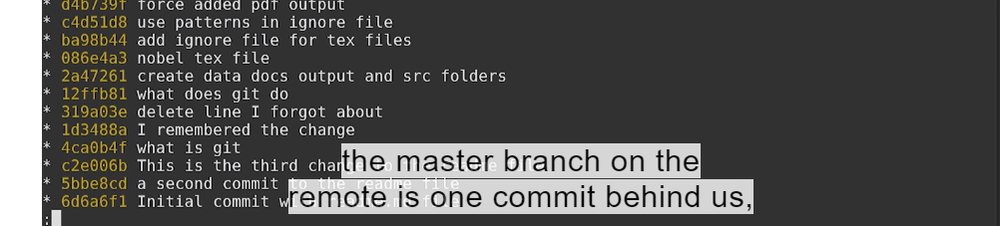

**Head is pointed to the branch jithe assi hege va okay. And as well behind one for local master from current branch**



**Both branches are on same**

**Hun assi git push krlggeaa remote te**

**Where is origin points to github and up until now we are now using master**

**The what in this case use of master .we can use the branch that we are currently in .when that’s don’t we**

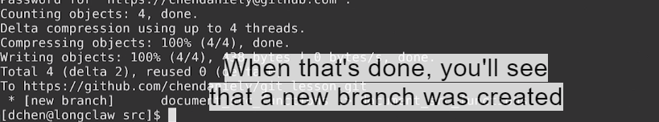



**Where the branch on our local computer**

**Is now branch on our remote if we go back to github interface**

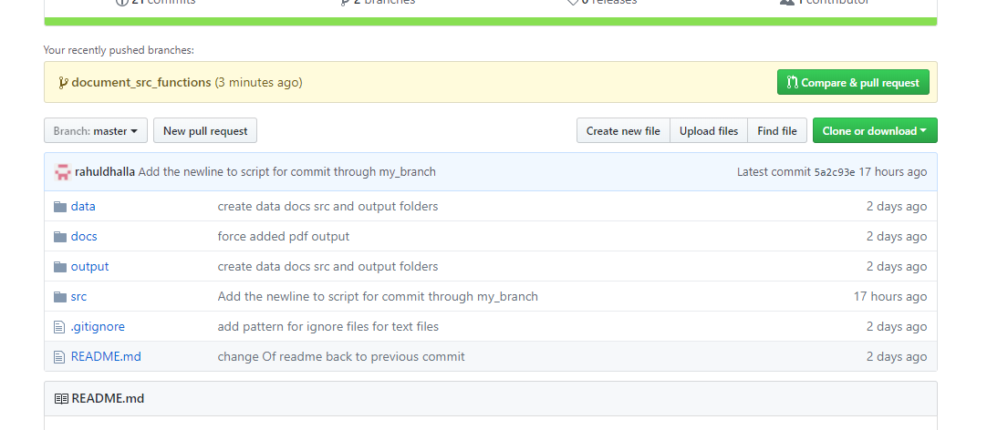

**That says compare and pull request.**

**1.if you don’t see this button you can also view this in branches panel**

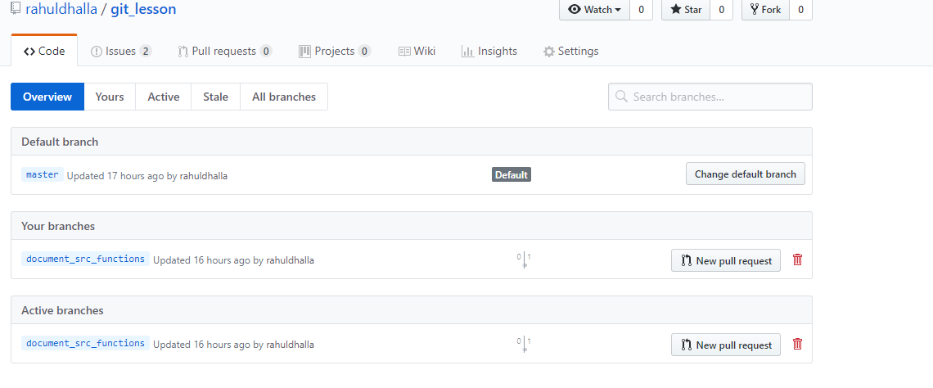

**You will see this is master branch on github and also see document_src_functions on github**

**Again there is new ability to click a new pull request.**

**Whether you use new pull request button or green button on main page**

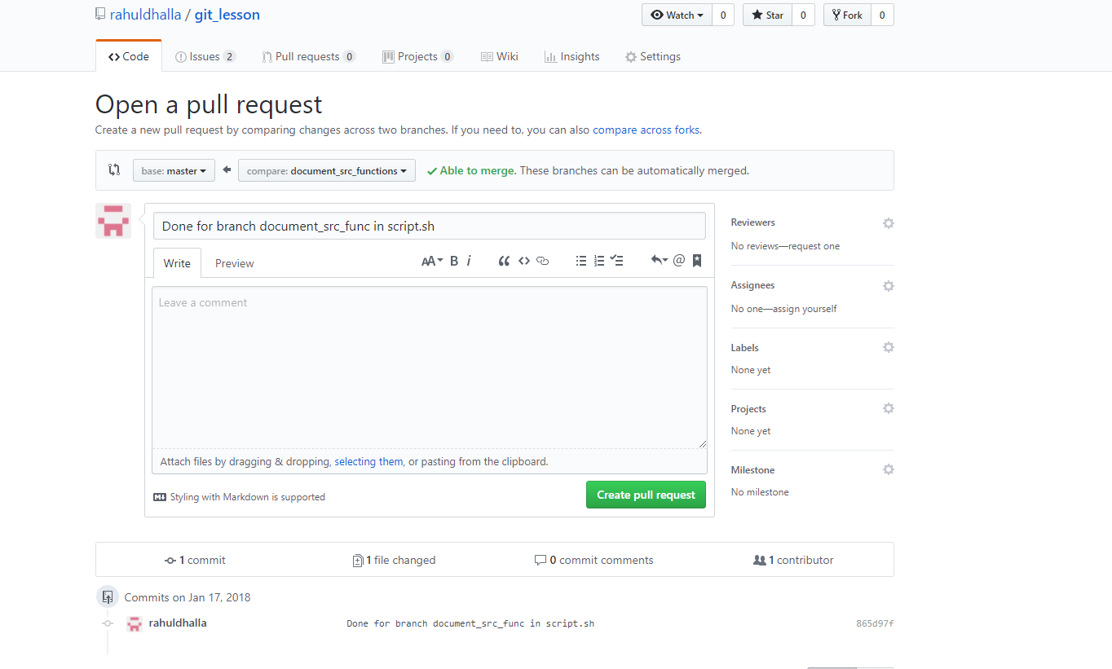

**Base is :master branch**

**Compare is :document_src_functions**

**Just how we see the merge function on terminal.**

**Assi ki krlgegge github toh merge kr lgge a document_src_functions de changes to master branch .**

**So everything needs commit so we have ability to commit a message.**

**Bcoz lot of people able to collaborate with you**

**You can create the button click pull request.**

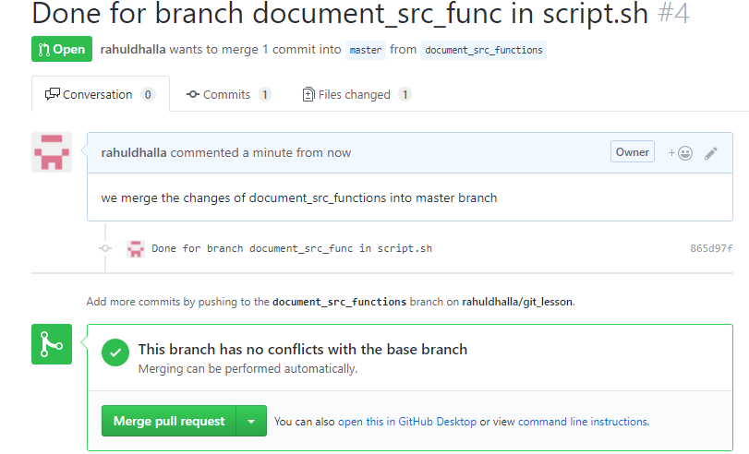

**Now you done pull request you have one more chance to review your changes**

**In the commit branch you will see all the commits on this branch.**

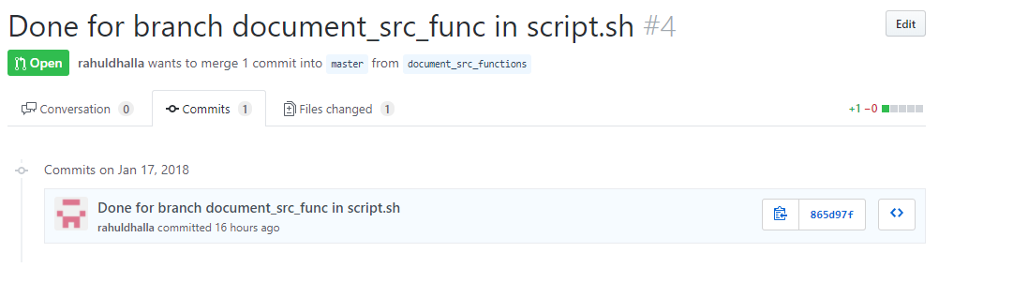

**In this case we made only one commit.**

**Additionally we can see the files changed**

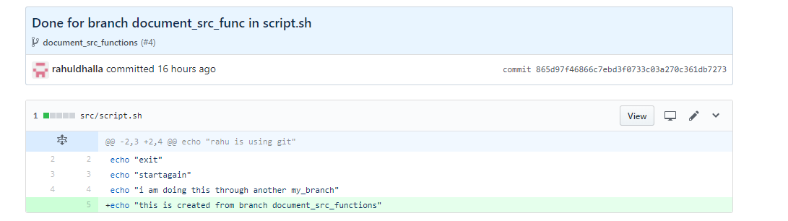

**And github will render all the changes that we have commt.**

**When your happy with your changes you can go back to conversation tab**

**And click**

**1.Merge Pull Request ist going to ask you confirm**

**2.And if you want you can delete the branch as well**

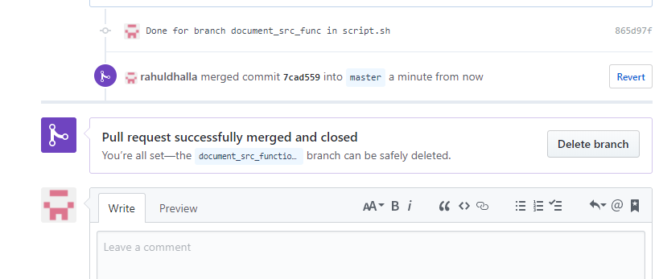

**We click on delete branch to delete it**

**Confusing technology is used here is the pull request**

**Essentially why it is called pull request**

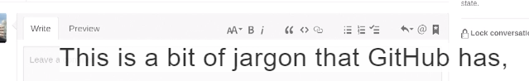

**Your cannot push your code into someone else .**

**someone else able to needs to look at your code and pull them in themselves.**

**This is why its called pull request.**

**On systems like gitlab instead of pull request there is another thing is having another name called merge request.**

**If you want you can also edit the changes to the messages**

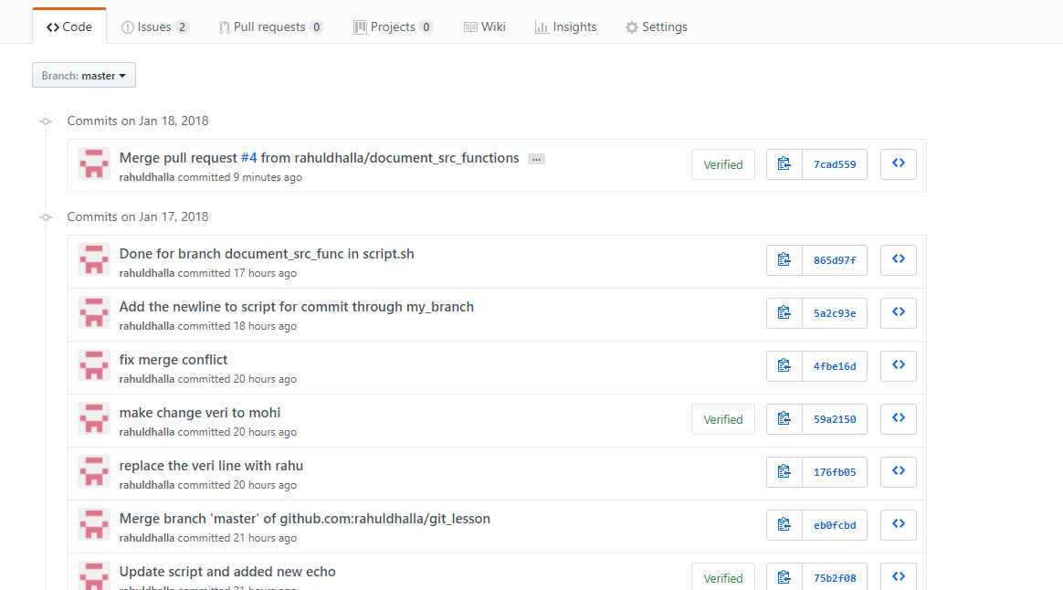

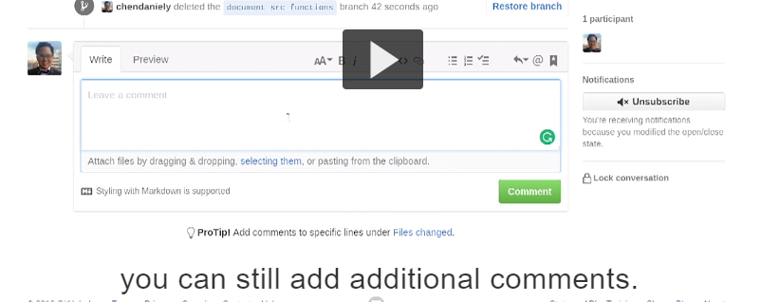

**Just as message to myself I can either edit the original message or leave an additional comment saying that this addresses has that issue**

**Since github automatically number the issues.**

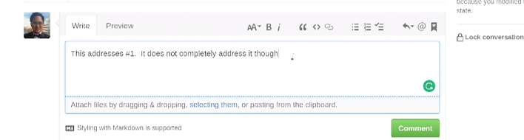**after deleting branch or merge we can address the issue jis number naal main comment kitta si so krskde aa usnu refer**

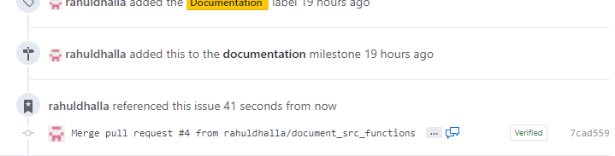

**Assi ki kitta us commit te ek reference pass kitta si ki #1 da hega va then ass I issues tab te jake us issue te click krage jive ki 1 then used naal saare comment miljange okay keep in mind.**

**Reverse reference back.**

**Just now local to remote we can pull down the changes from github to local.**

**Git pull origin points to github and master means master branch on github.**

**Data leke aayo**

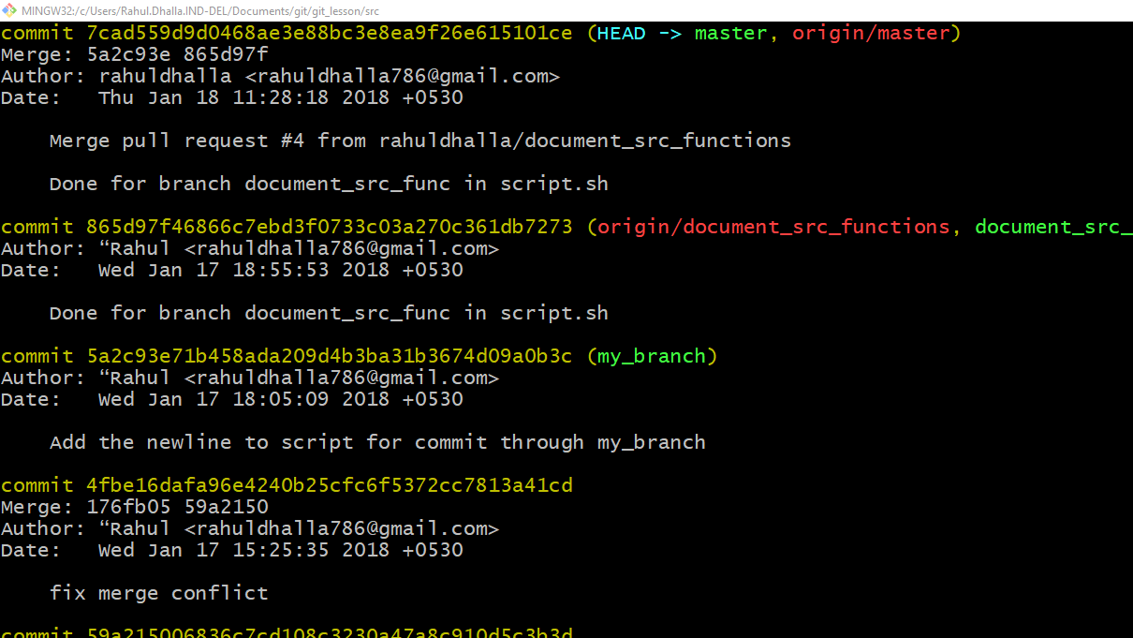

**One way is clean everything is just using a command called git fetch.**

**Git fetch is related to git pull what git pull does under the hood is really a fetch and merge.**

**Meaning its getting all the information and updating yur local computer**

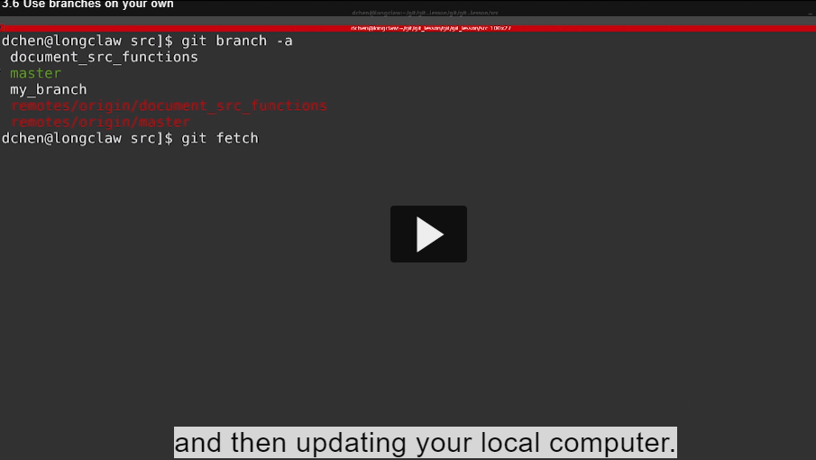**.**

**In our case we just want all the getting information and without updating local information.we can use git**

**Fetch**

**And there is flag called prune what it does is if there are any branches on the remote that does not exist on your computer it will delete it .**



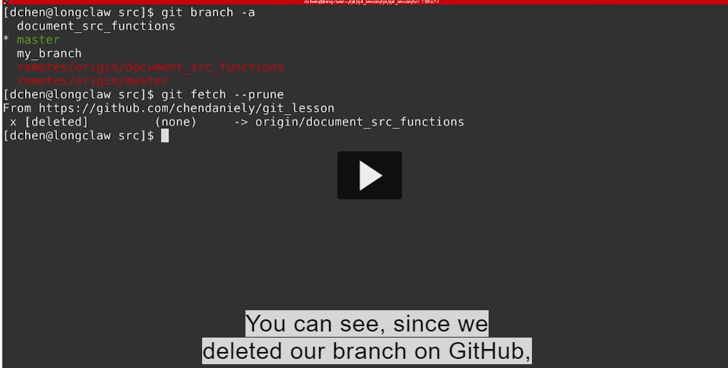

**Actually ki krda git remotes vale section on github nu update krdinda va jehri branch nahi hegi oh delete hojandi va**

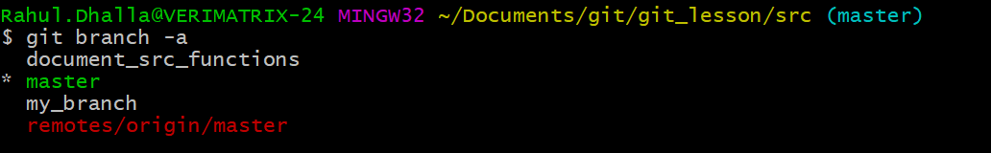

**Now looking on our branches you will see that remote branches has been deleted.**

**Now whats look up is to clean up the branches on your local computer.**

**We can use –d flag to delete the branches.**

**That the branch that contains work and you can delete it**

**With d flag and git might yell at you.**

**………………………..**

**If you force want to delete a branch instead of lowercase d you can use UPPERCASE D**



**I am showing as your example look at our branches everything is clean and tidy…………………………………………………………………………………………………………**

**Understanding Gitworkflows:**

## Transcript

- I just showed how you can incorporate

branches into your own Git workflow.

The workflow involved creating a new branch

that contains prototype work,

and then you eventually merge it back into Master.

So you end up with a graph similar to,

you start with your original Master branch,

you make a series of commits on your new branch,

and that series of commits gets merged back into Master.

**There's another type of workflow called Gitflow.**

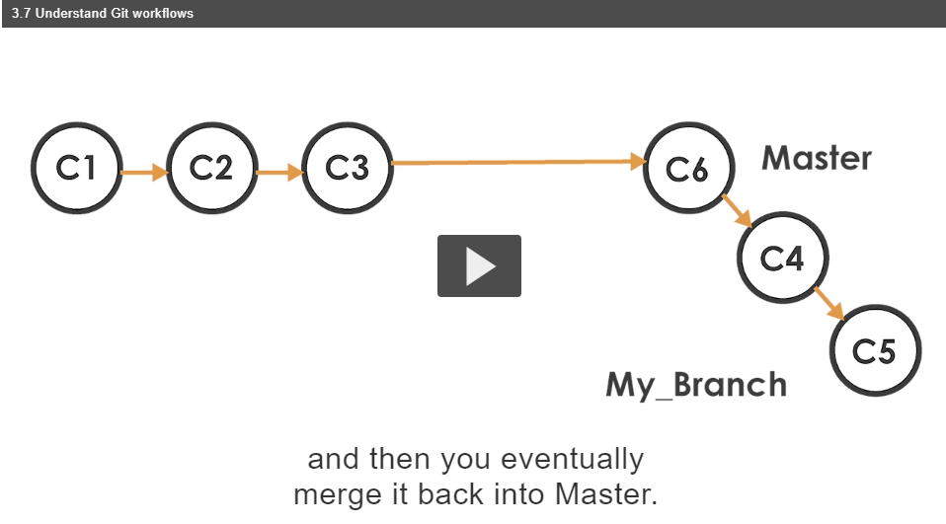

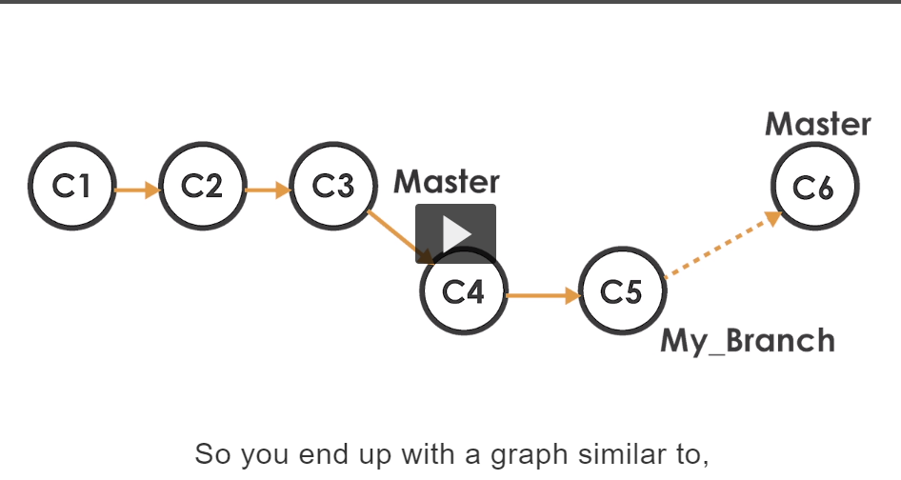

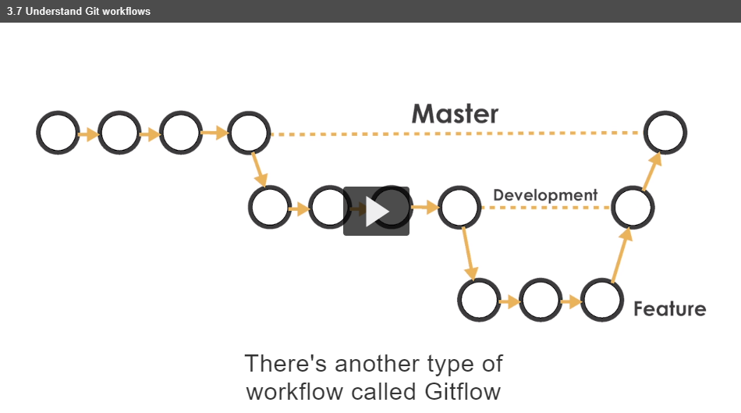

That extending the branching model.

1. start with master branch

2. create a new branch called development this is where prototype work or code that isn’t production ready go

**.**

**You have a development branch** 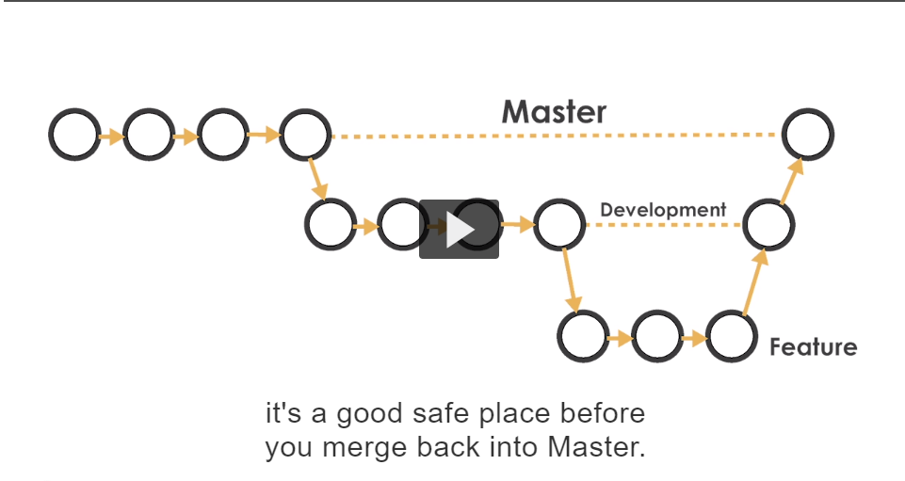 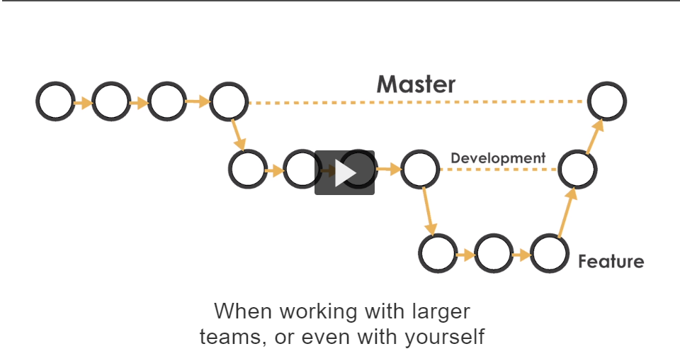

You can create smaller feature branches. Another way you can think of branches are there just a simple nickname that you can give a series of commits.

In this example I am going to create a series of feature branches that address the issues that we have.

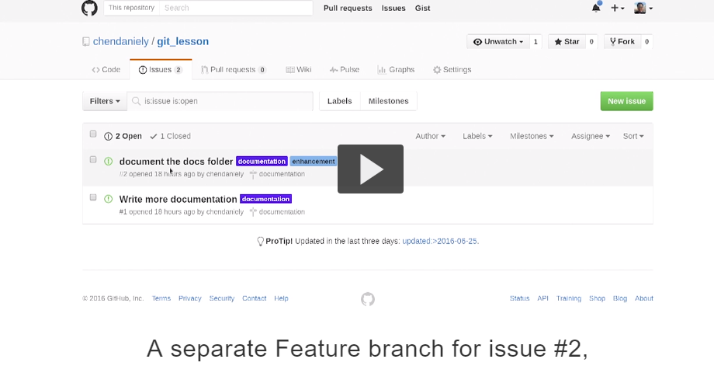

**Document the docs folder**

**When I have ready code for that jido mera code ready hogiya I merge back into devevlopement**

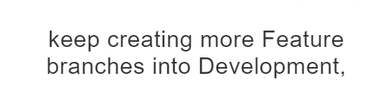



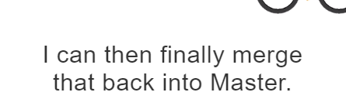



**.**

**If you look at our current state**

**See master and origin remote and now we create our development branch.**

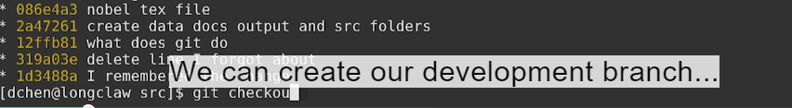

**Look at git graph decorate wali command**

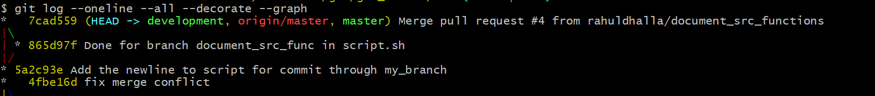**development branch is same on master.**



**When we were working wih gitflow the branches development,master and future they are all keywords that used to name branches**

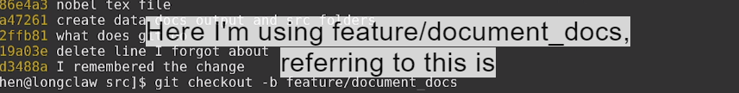

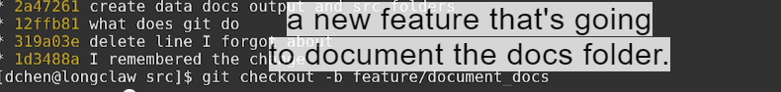

**Look at my git graph**



**Are all pointed to same location**

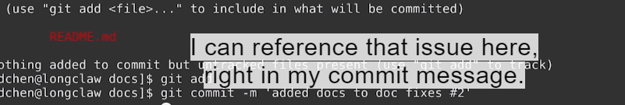

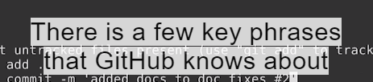

**That if I use github will automatically close issues when they get merged**

**So here fix # 2 no when this branch merged with master branch**

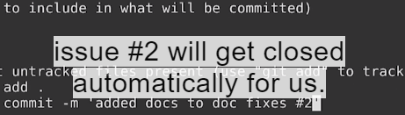

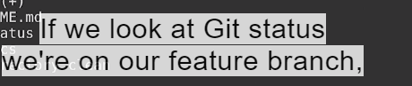

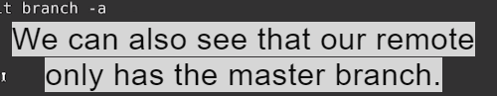

**Sarriya brnahces remote te move karo development and feature**

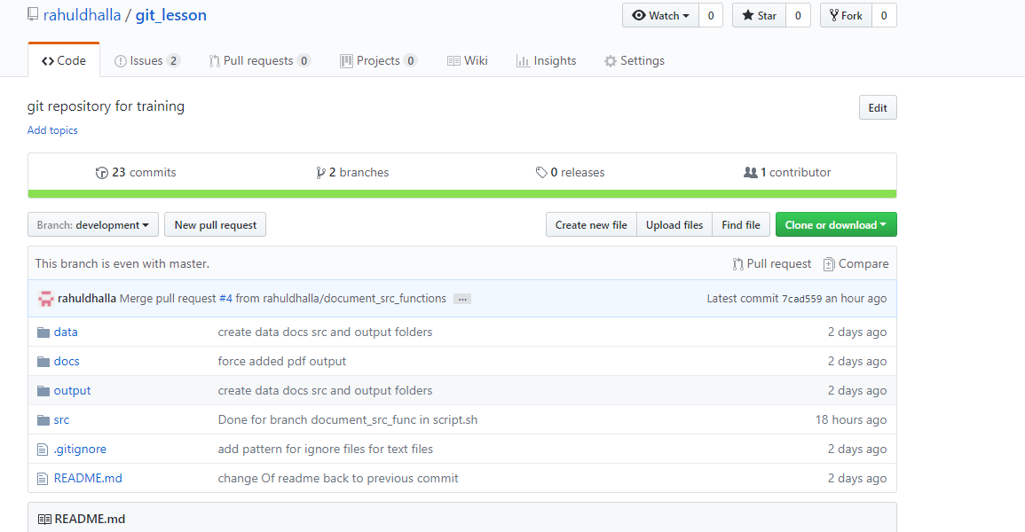

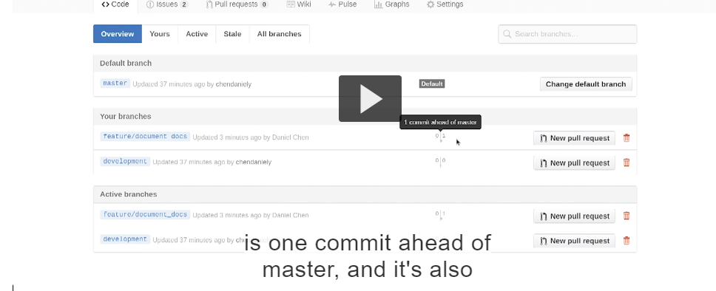

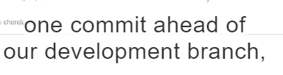



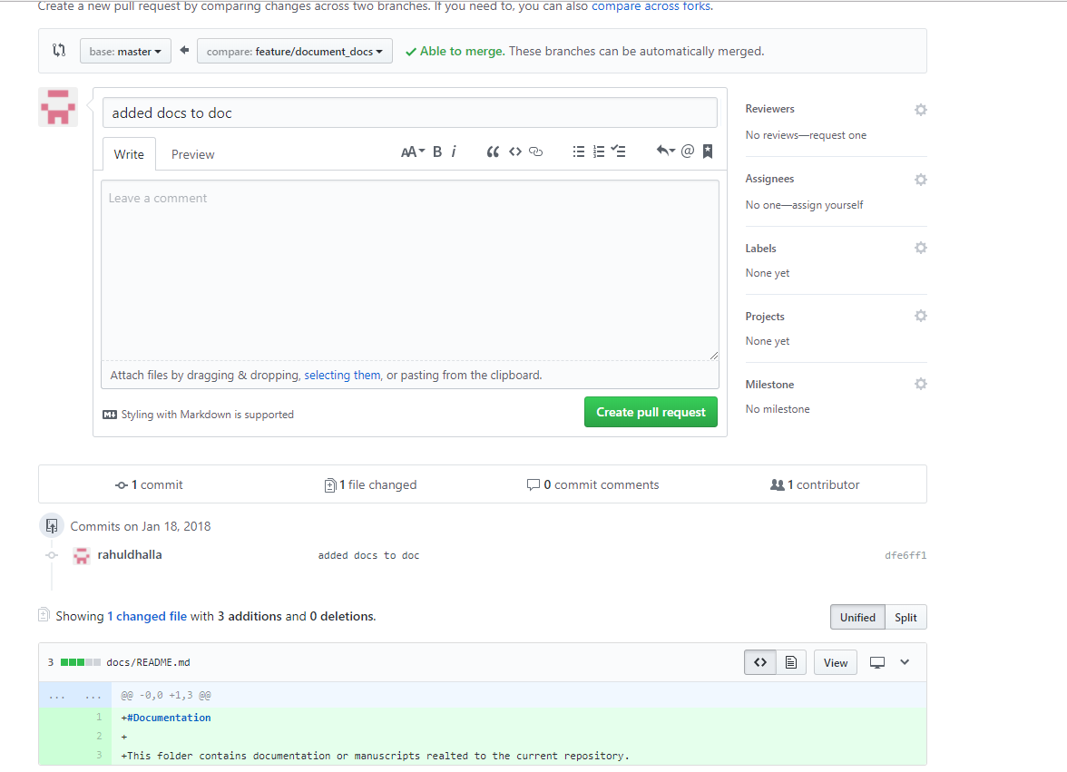

**We generally pull in the master branch but using the gitflows we don’t pull feature branches into master branches.**

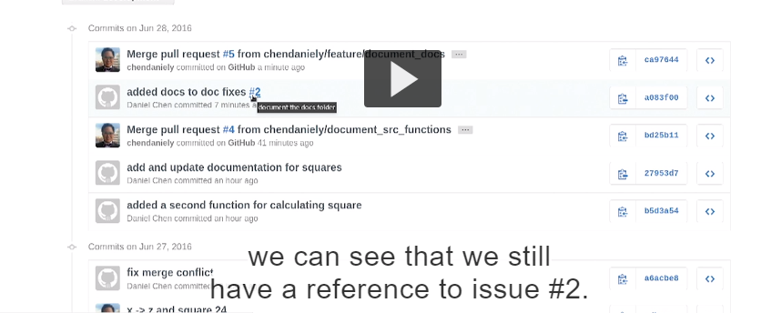

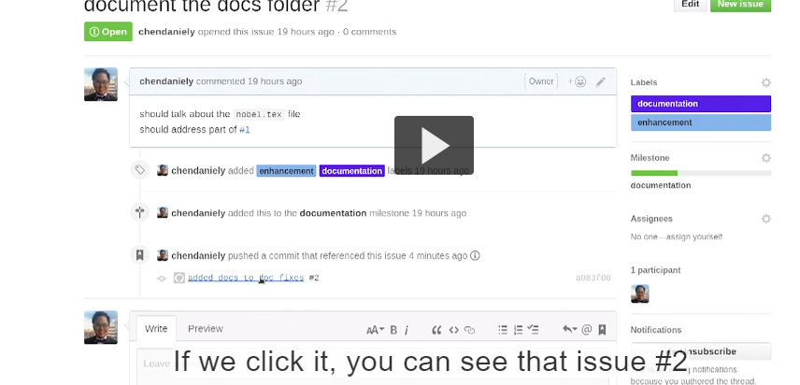

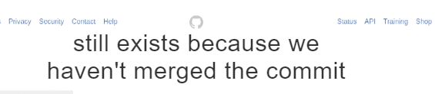**.**

**So write more feature branches.**

**Basically branch de commit te hash dedeine jisnall assi issue close karskde aa**

**Hamesha ek gal yaad rkho jis branch te assi hege ussi branch da name davvo pull karn waqt**

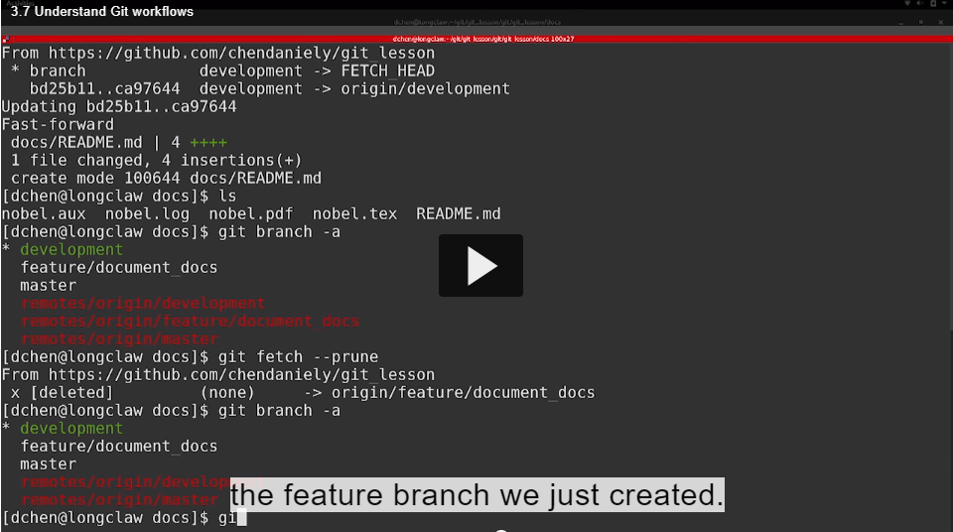

**Now lets create the another feature branch that complete the rest of the**

**documentation of the folders.**

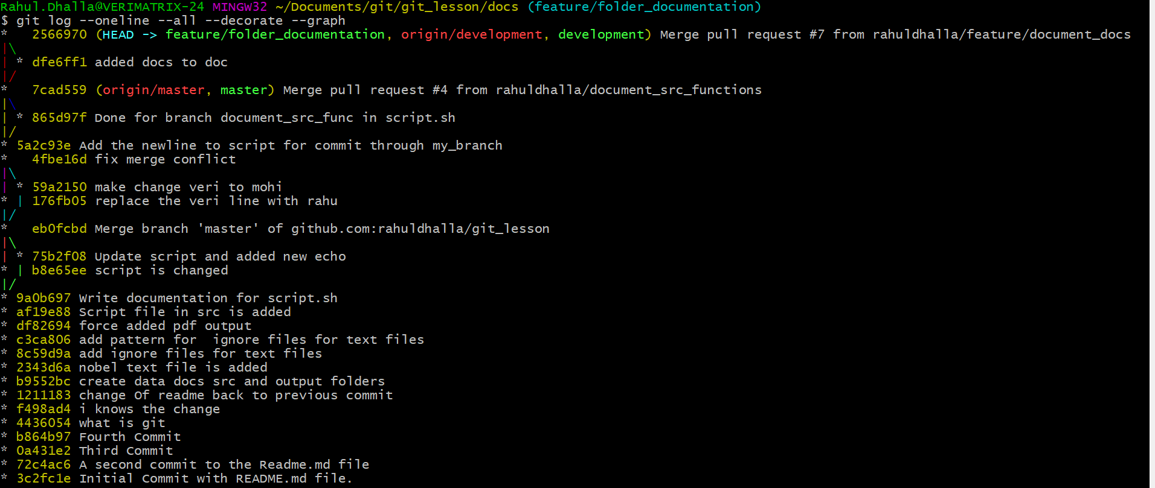

**1.Ek feature bnake assi merge kitti dev ch then delete krti**

**2.THEN ASSI AFTER MERGE DEV BRANCH TOH ek new feature bnayi**

**3. Files created and git realise that they are untracked.**

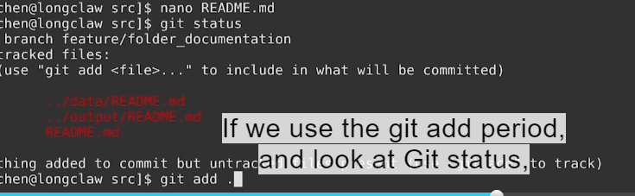

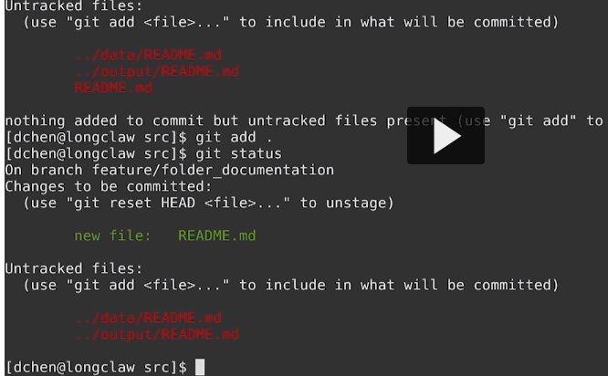

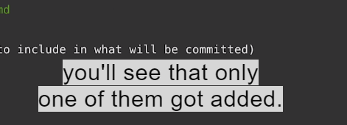

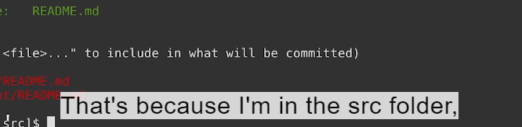

**Git period reallY adds where I currently am down the file tree**



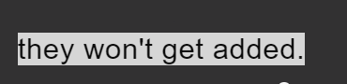

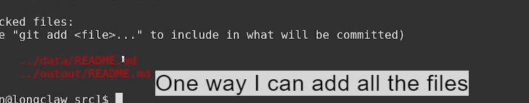

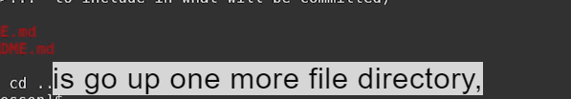

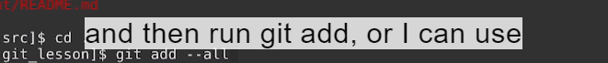

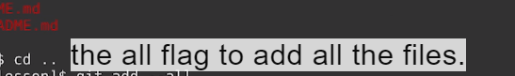

**Git add –all**

**I found jehri directory di file us ch jake add karega then staging area ch aajayegi**

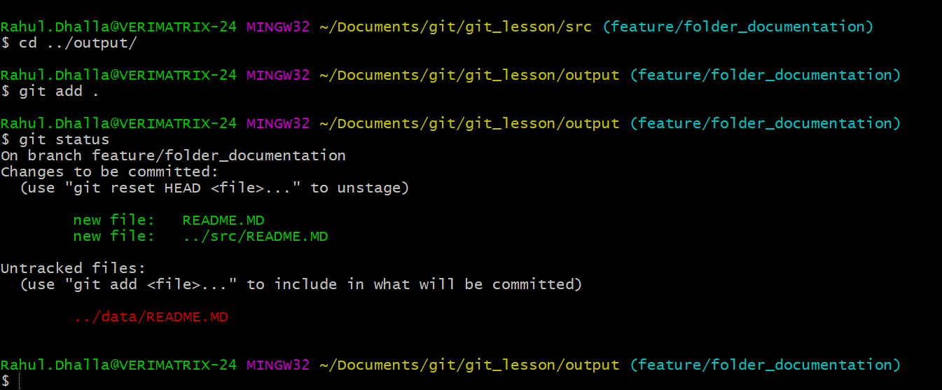

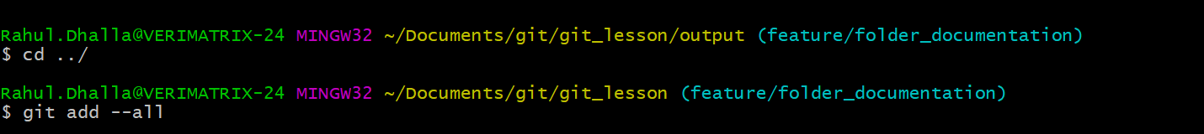

**Repo ch aake vekho**

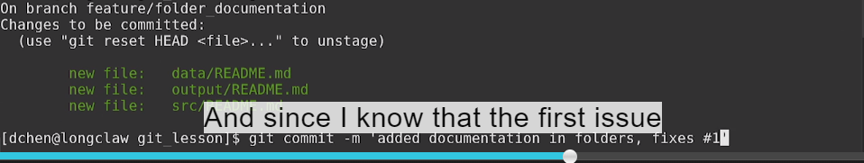

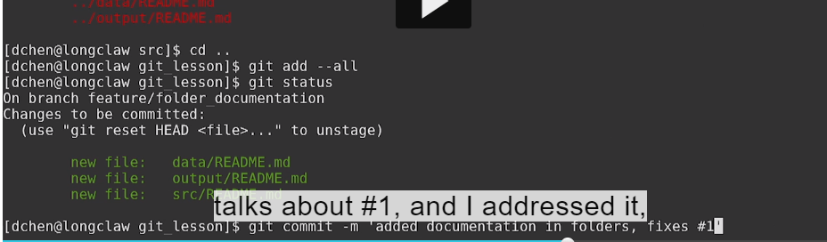

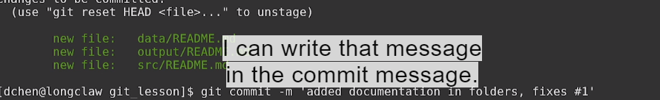

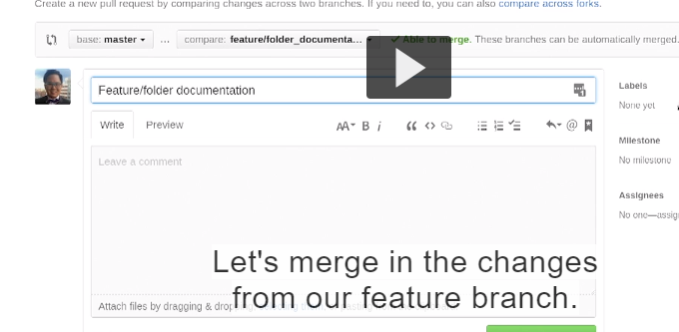

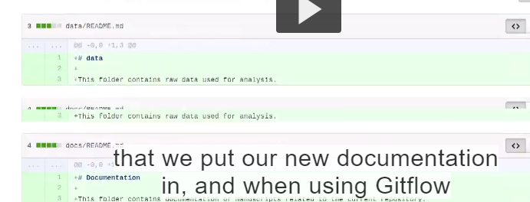

**Jido assi gitflow use krde assi kdi vi master branch nahi paunde pehle development then aago**

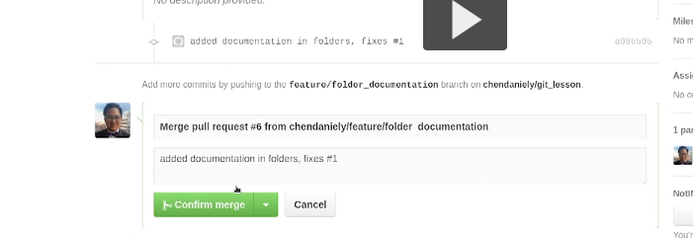

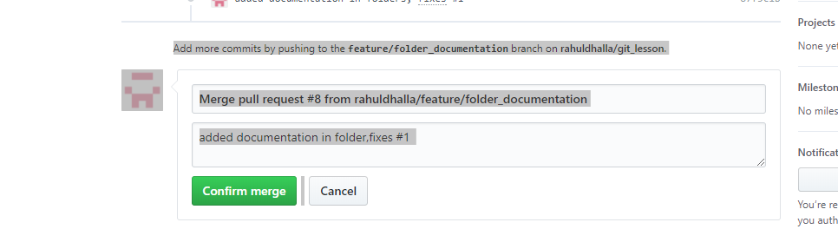



**Happy with development branch and this seems like is production ready**

**Code**

**We can now merge development branch into master**

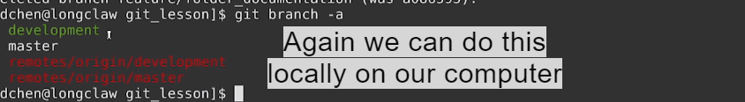

**Merge command is run by terminal and pull request(merge is issued through github interface)**

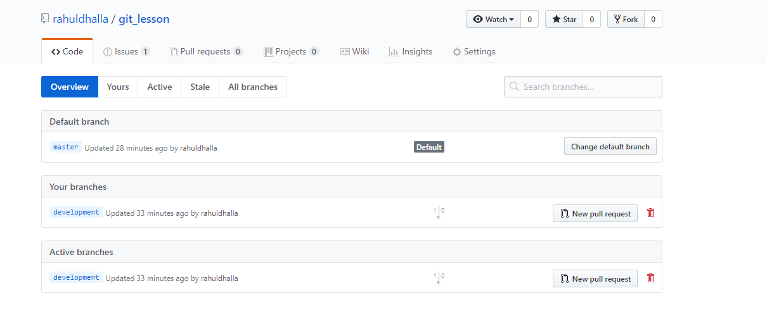

**This will show in branches tab**

**We can now click new pull request**

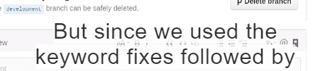

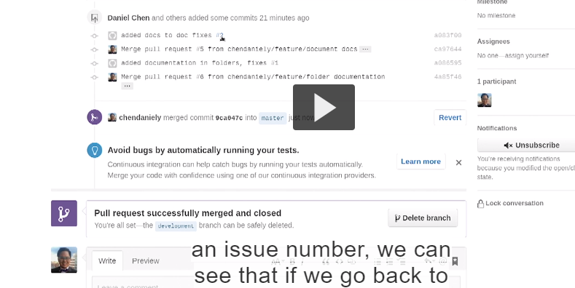

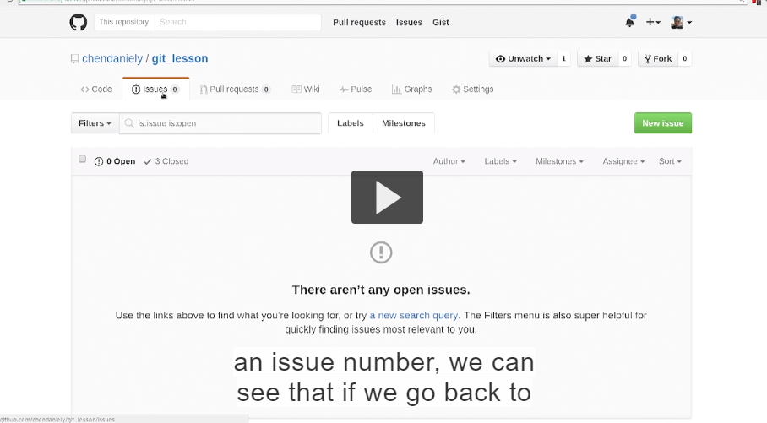

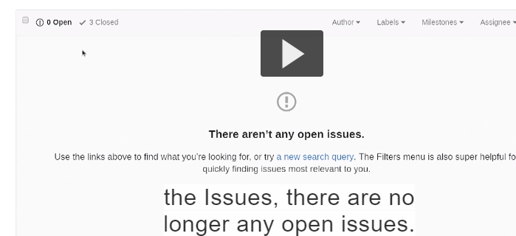

**They are now under the close tab**

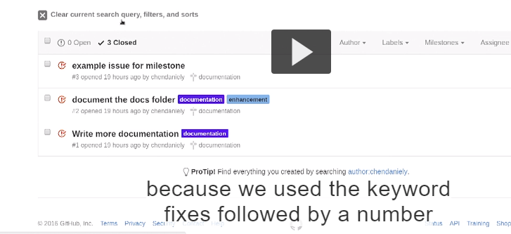

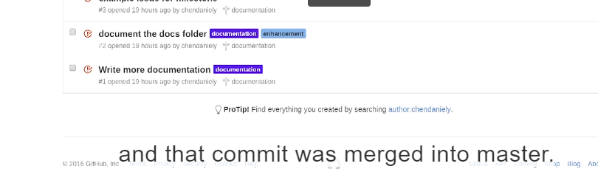

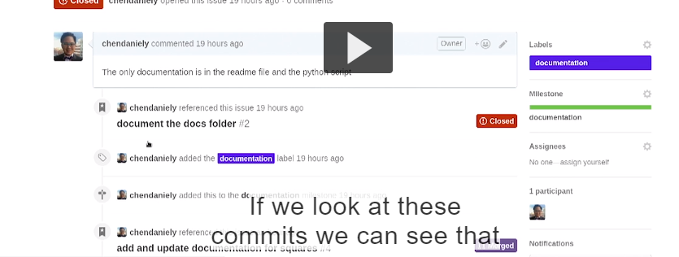

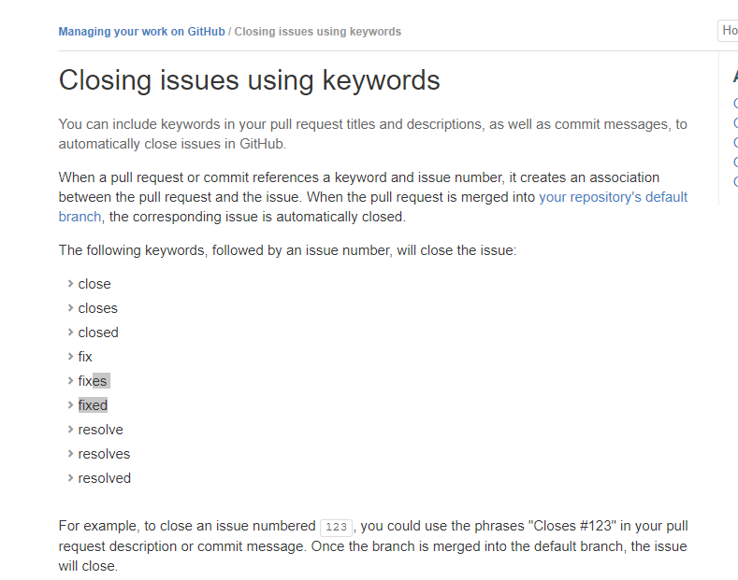

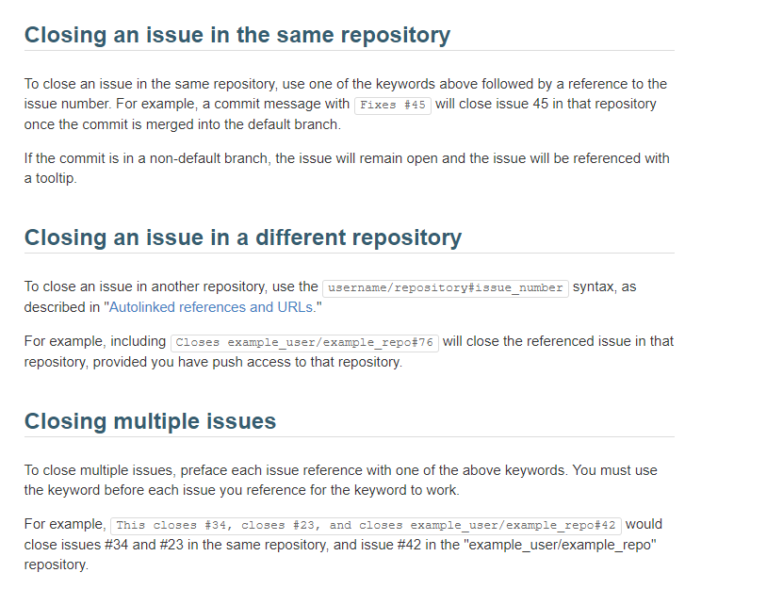

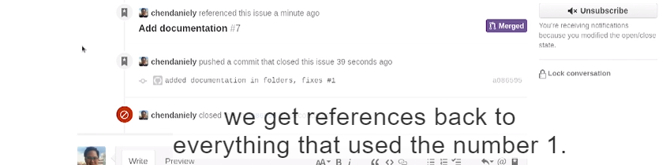

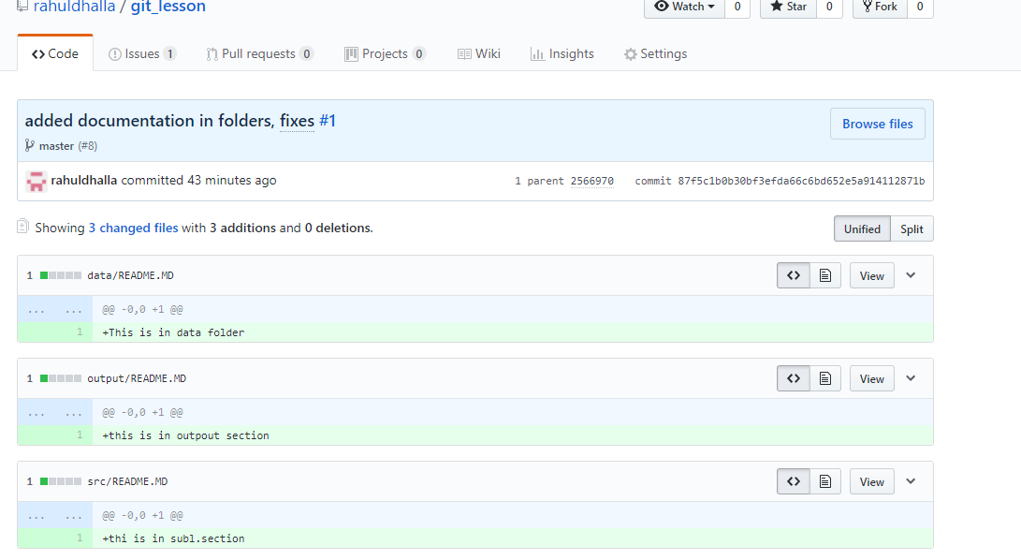

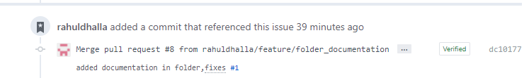





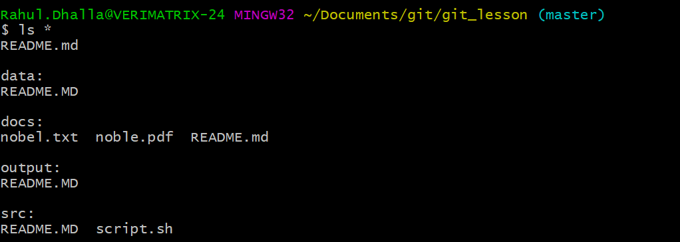

**Incorporated**

**And development branch is not below us because we actually took the development branch and merged into master branch.**

**We sort of problem is that why development is behind one master branch and we can see on our git branch two branches are not on same level.**

**One way is going to fix it by going to the development branch.**

**Now that we are on development branch**

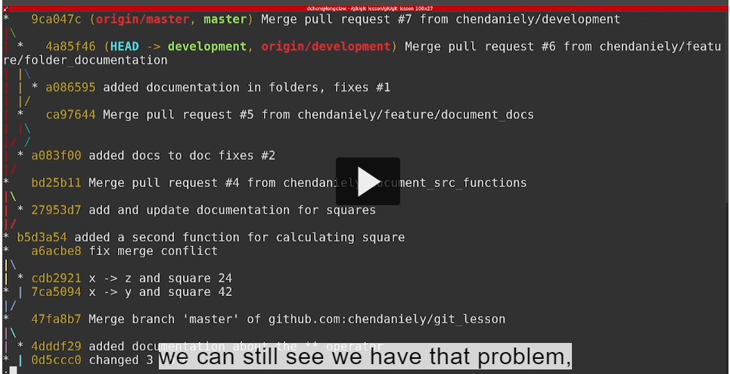

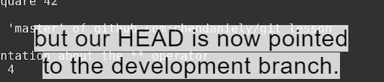

**Kistra development branch and master branch nu same level te leke aava**

**Is running a command called rebase.**

**Rebase like checkout can do a lot of things but in this case what we were doing is bringing the development branch into the same level as master branch.**

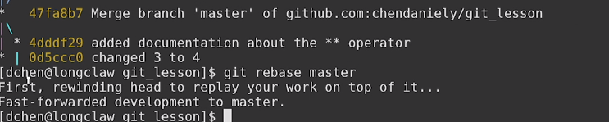

**Git rebase master**



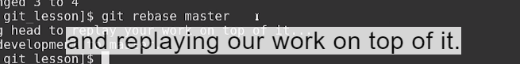

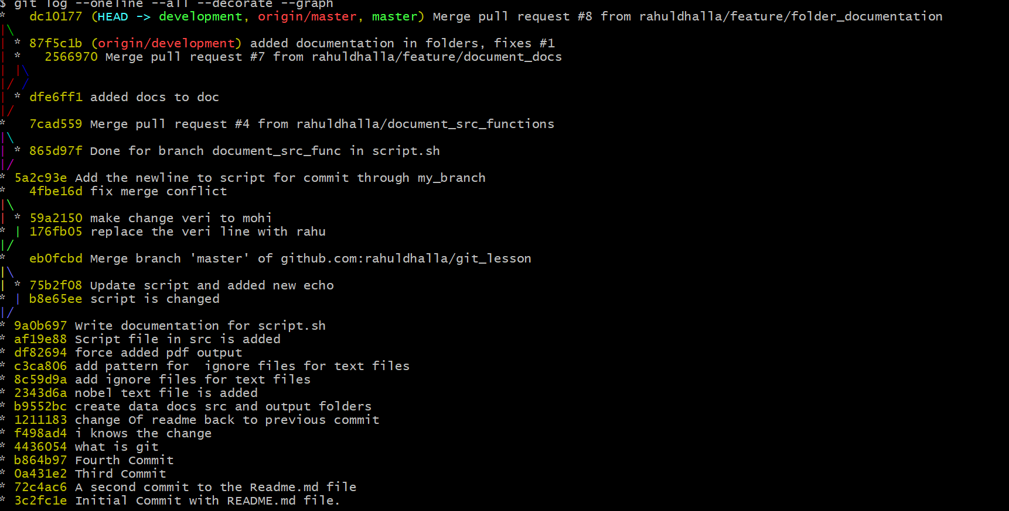

**Our development is on same level as master branch**

**To get back everything into sync**

**Then dev branch on local computer and sync back to github.**

**Only to sync github repos.**

**Note : Through github interface we get extra commit of merge pull request**

**But in case of terminal we never get .and we don’t get last commit message of merge branch.**

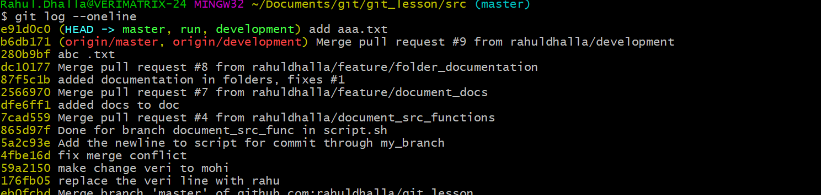

**#Incorporated changes after your branch:**

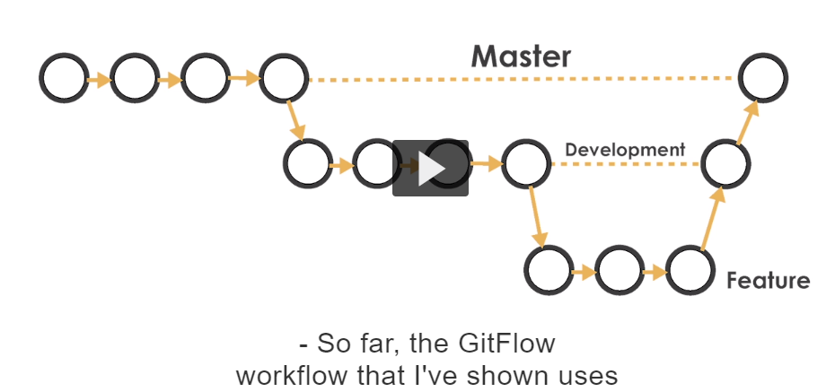

**Remember the Note:**

Generally karna ki aa meri 3 branches hegiya ne (master,dev,feature branch)

1.Hoya ki ek bug fix hega jehra assi master ch reflect krna siddha instead of dev or feature eskrke assi ek branch bnali after master ch 3 files add krke locally.jido navvi branch bnnigi us track status ch same 3 files aangiya so we have to add and commit and merge into master.After master hun assi dev and feature toh lene but fix ta ,master ch hega va je dev ch master de fixes laange then we have to rebase in dev (master toh) and then same dev rebase krega feature taki baad ch master d bug fix changes na chale jange.so baad ch assi feature nu merge karda ge dev then merge kardange master ch .So rebase plays important role.

Technically merge

## Transcript

- So far, the Git Flow work flow that I've shown uses

the Master, Development and Feature branches.

Since we know code, or pieces of writing

aren't going to be perfect,

there's going to be a time

when you have to make an immediate change

that gets incorporated **by Master right away.**

GitFlow uses a branch called **a Bugfix or a Hotfix branch**

to incorporate really important changes

1.Creating new folder for binary files.(bin) so I create an new feature branch.

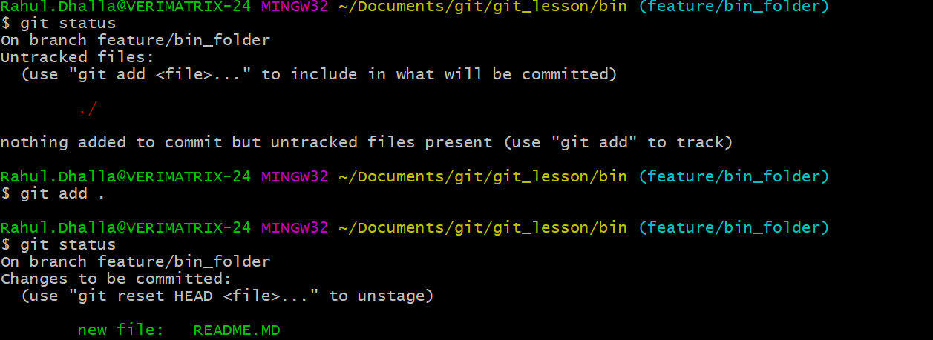

A new branch feature branch is created and we add bin dir with readme file and commit it .

Merge the changes into development branch.

If we look at github and see the doucmentation that we created earlier.

You can see not all of the spelling is consistent in the header.

This is a trival example now but this could also be a bug that should be fixed right way.if we want we can fix the bug by creating a bugfix or hotfix branch. I am on dev branch but since fixes are extremly important they should happen directly to the master branch.so I am going to move over master branch now I am on master branch I am going to fix the capitilization on the files.

Since I have made changes to the master but that are not commited yet

Since they are not commited its not late to create a branch.

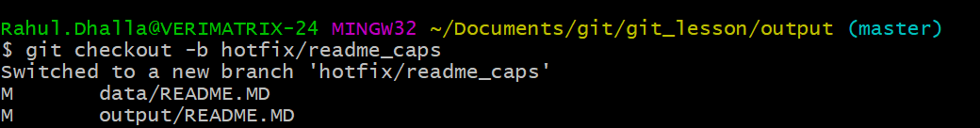

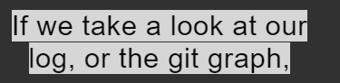

He uses reverse search



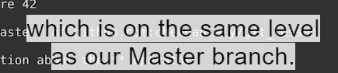

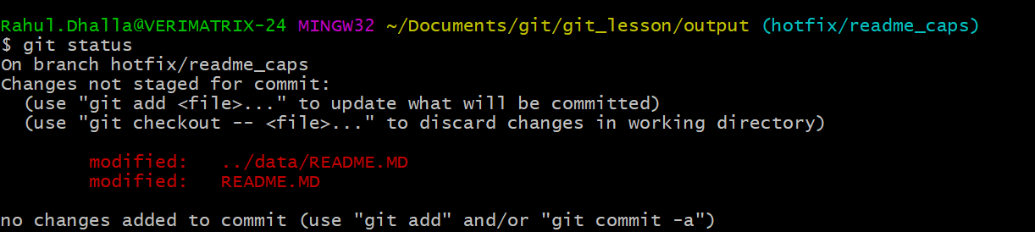

.

We can commit these changes and mere them straight into master.

Now we commited changes for the bugs and we can merge into master branch.

Two systems

1.Git mere command on terminal

2.Github.

Right now all now I show you on github

Now we pull the changes into master and which is generally bug fix with our change

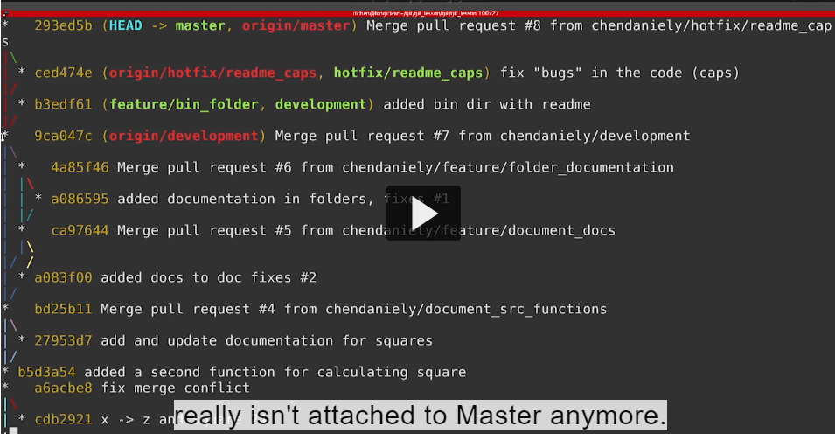

Dev is in really different state start off a common point but they got diverged.So before our merge changes from development to master branch. development has to contain all the changes that master does

1. Now I moved to dev branch and create new branch feature/cube

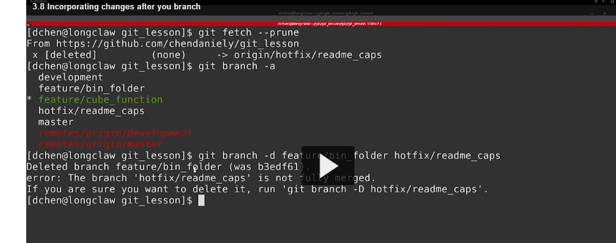

You can see when I try to delete the branch the bin folder

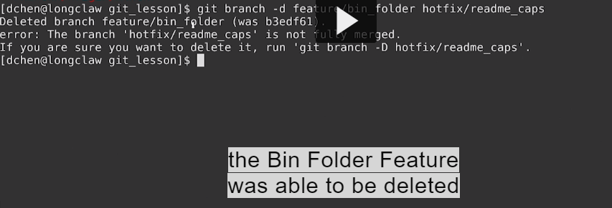



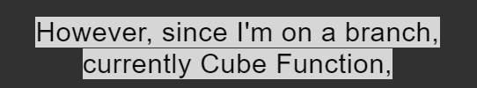

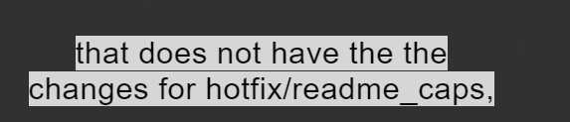

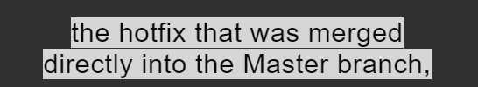

**It wont let me delete it**

**Since I know I make change in github interface I can force to delete it.**

**Using the capital D flag**

**.**

**Successfly cleaned my branches**

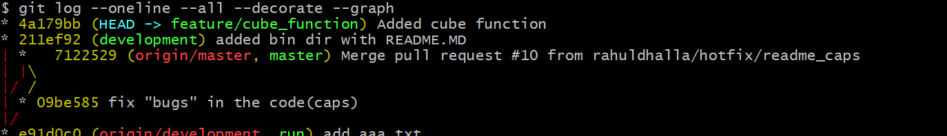

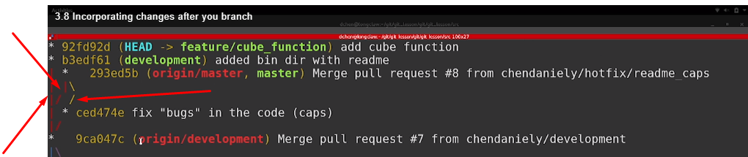

**Development di extension feature plus eh dekho master diverge hogyi si**

**Now you see our development branches all into sync**

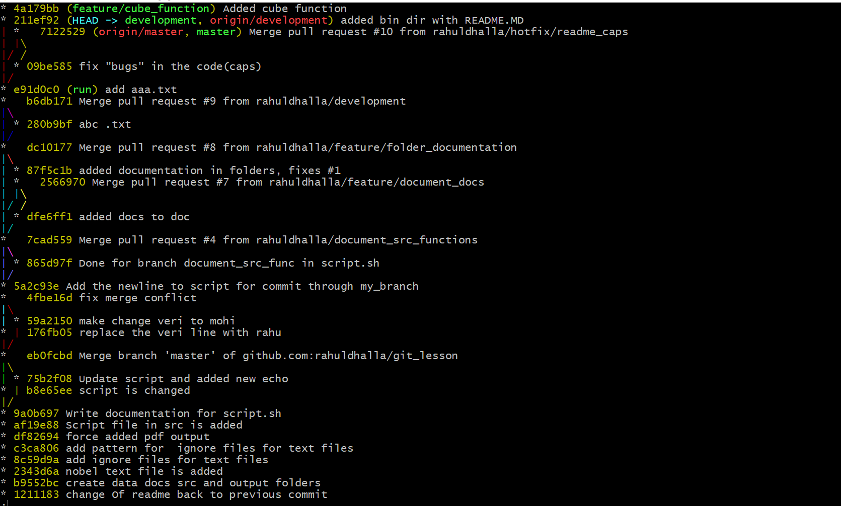

**To get the development branch replay its commits**

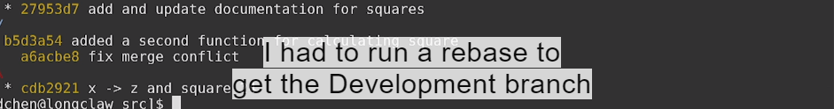

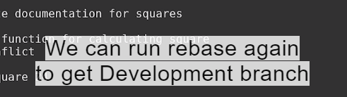

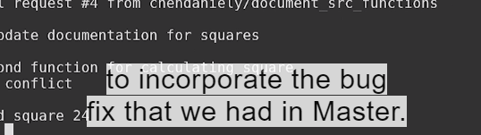**.**

**We can see that development branch doesnot have the fix that it is in master so main development branch ch master de changes liyana chanhuhnda va**

**If we rebase this change**

**We can rebase development branch into master**

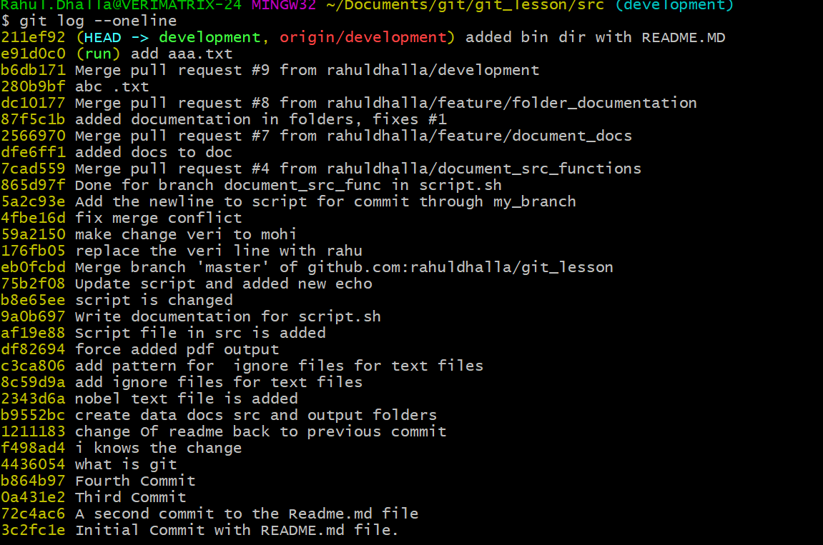



**In this case it will apply the commit**

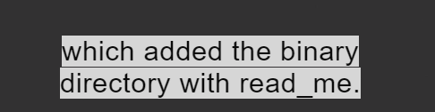

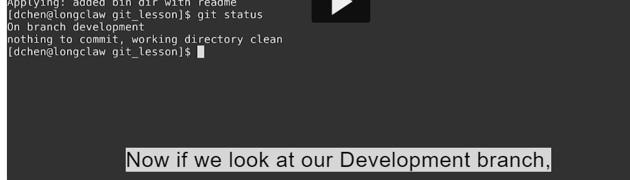

**And bug vi development ch aagya fixed bug**

**Development sync ch nahi remote vali bcuze we rebase our changes onto master.**

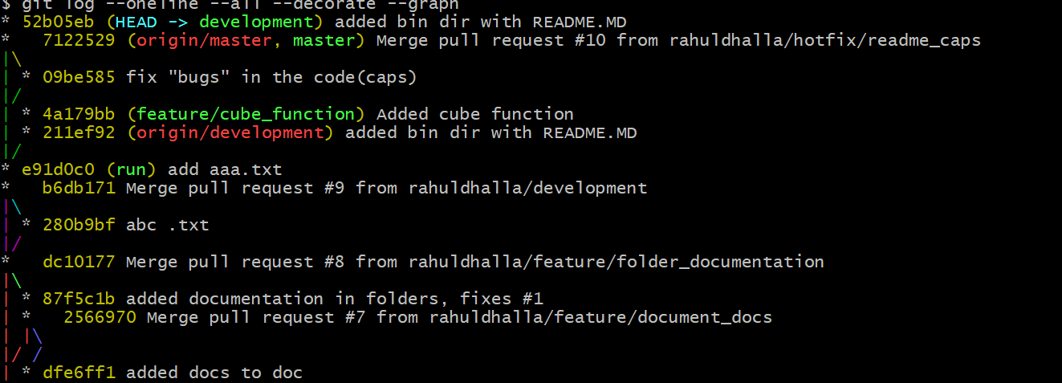

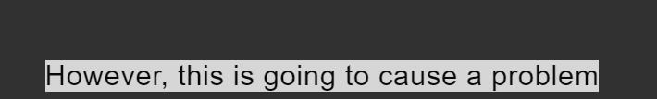

**Bcoz dev branch on remote doesn’t haVe the changes that I have made**

**When we ran rebase**

**It tells us rerun pull and run git push again.bcoz we ran the rebase there is another we can fix this problem**

**So we can use the –f flag to force the push**

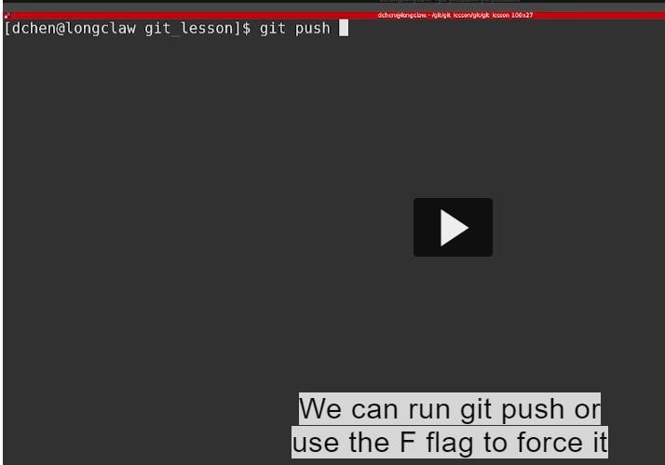

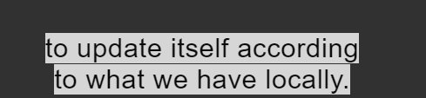

**This way we update the remote forcefully with our local changes**

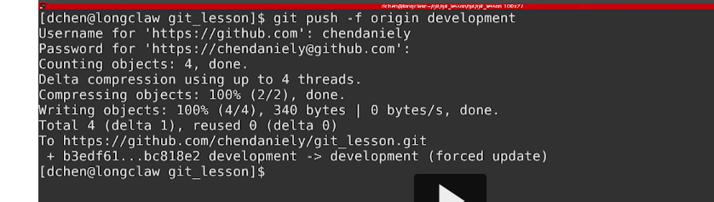

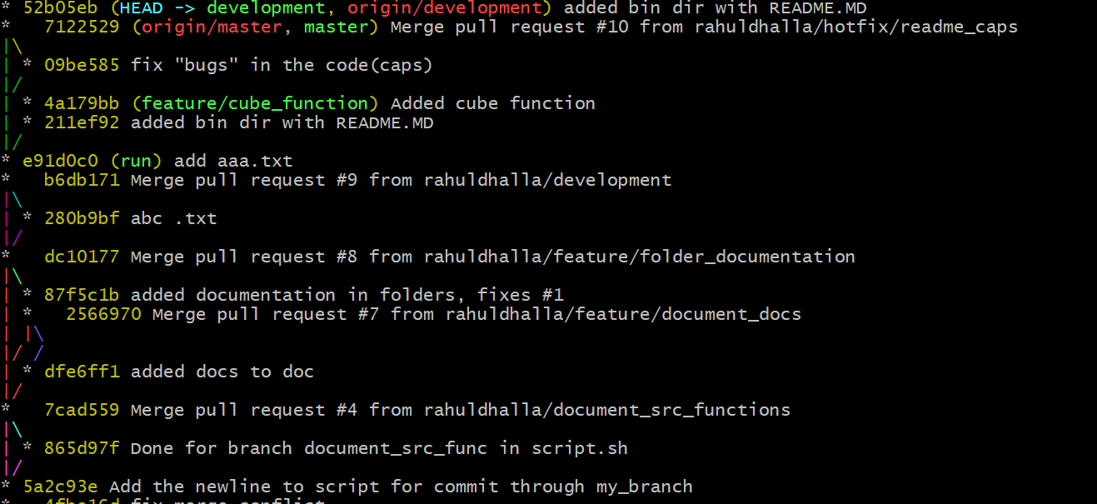**.**

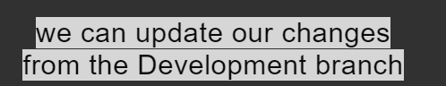



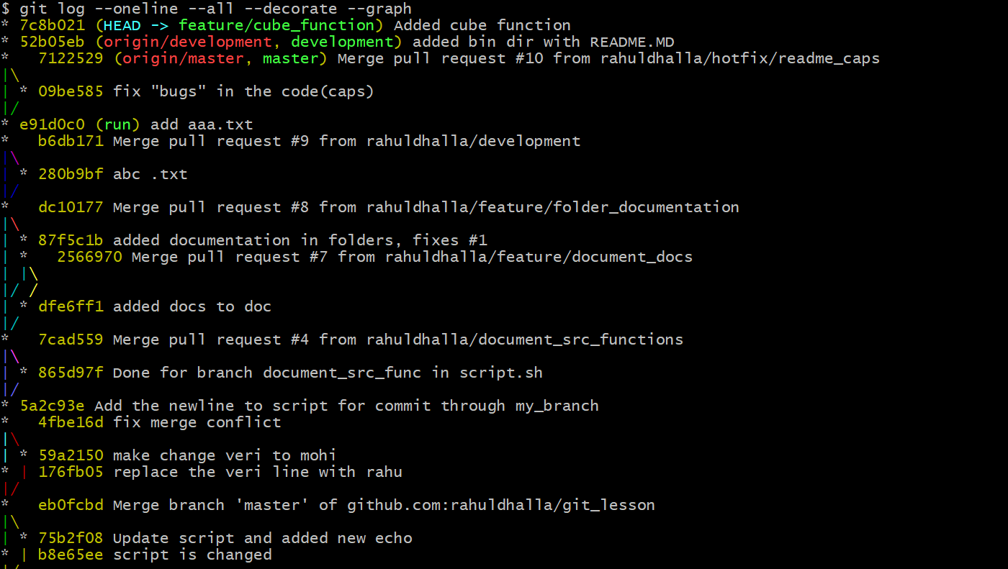

**Ustoh baad feature dev ch merge kitti then dev phir master ch merge krti and baaki branches delete krtiya okay.**

**Using Git Gui’s:How to use Gui to make certain things easier**

**1.Lets change the Readme File on branch master**

**By default when you install git you come with program called gitk,gitg or git gui depending upon your operating system.**

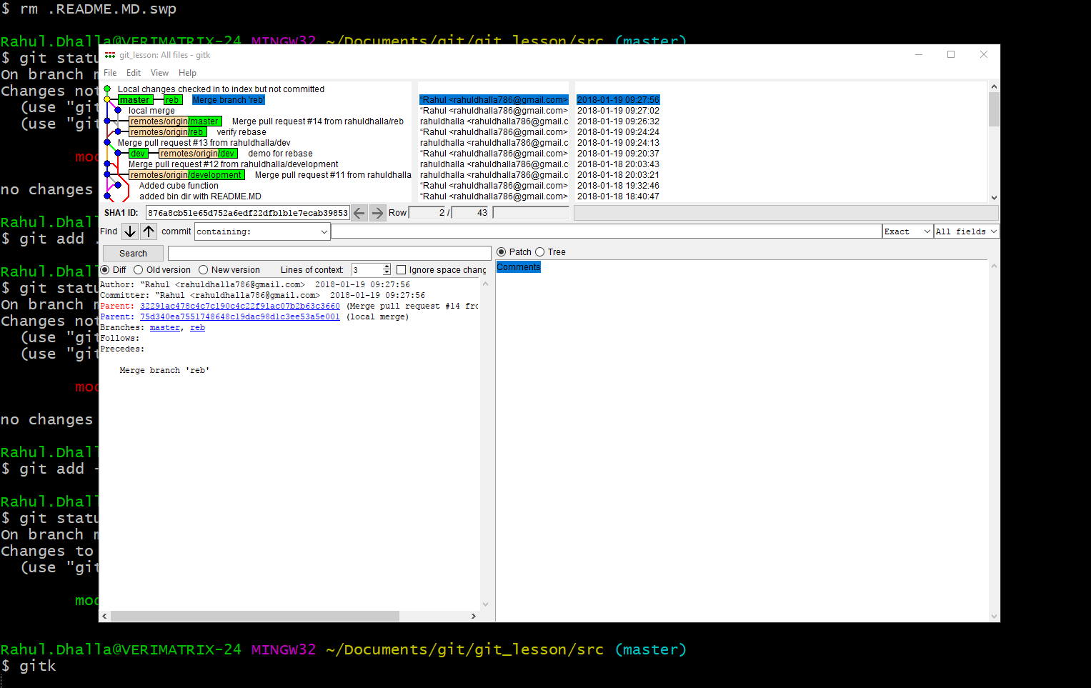**.**

**From gitk we can go to file and start the gui**

**When we launched the gui you can see there are few**

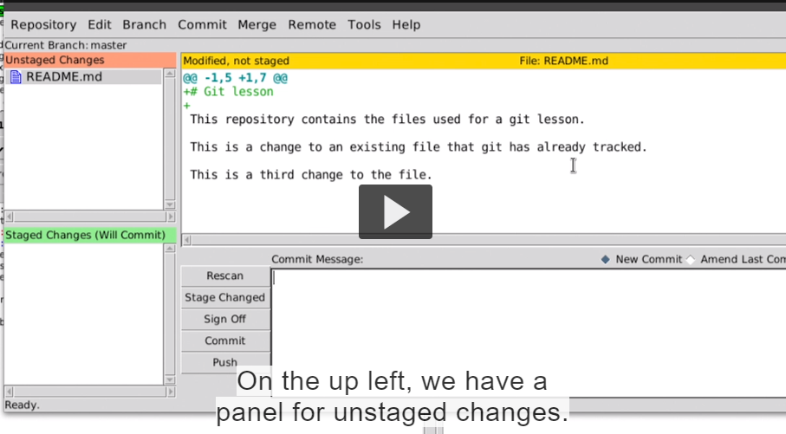

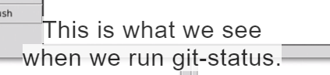

**On the upper right we have diff of the file I selected**

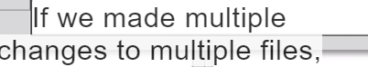

**That unstages changes will have panel that we will click**

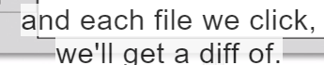

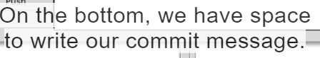



**To the staging area**

**We can click Readme file then go to commit and select stage to commit**

**1.File agar red hove or green sanu gui ch dikhegi green hi but jido tussi comit karoge oh aape dekhlega kina task apps background ch do itslef sanu pta nahi lagda**

**You can see after we do that**

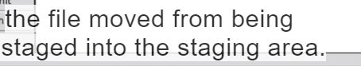

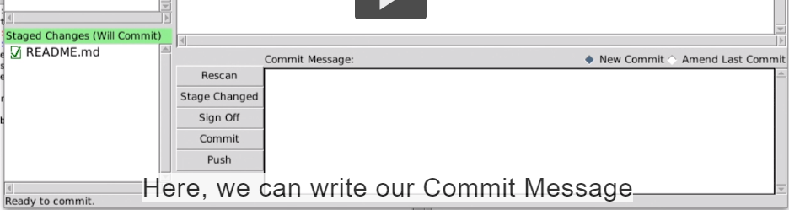

**And click commit to make actual commit**

**Another feature from the default git gui:**



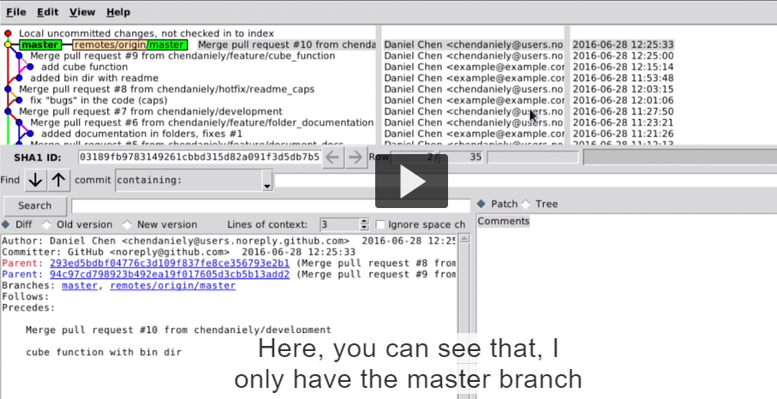

**And link to the master branch on my remote**

**We can also scroll down the commits and also see the difference in each commit.**

**Another cross platform that gui can use is called gitkraken**

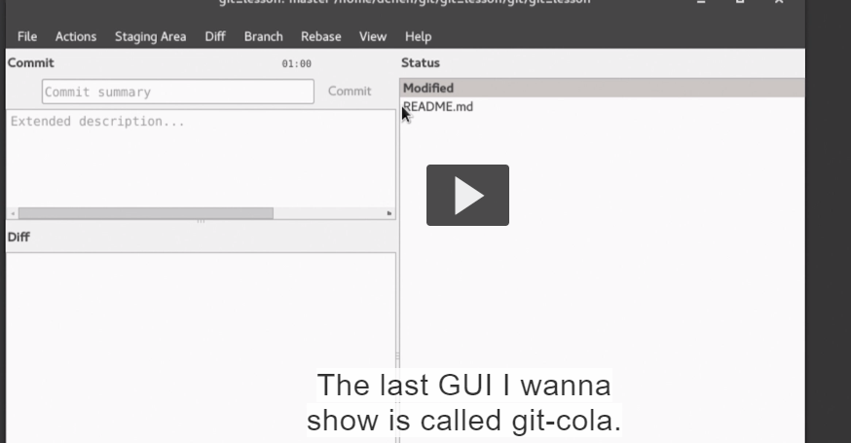

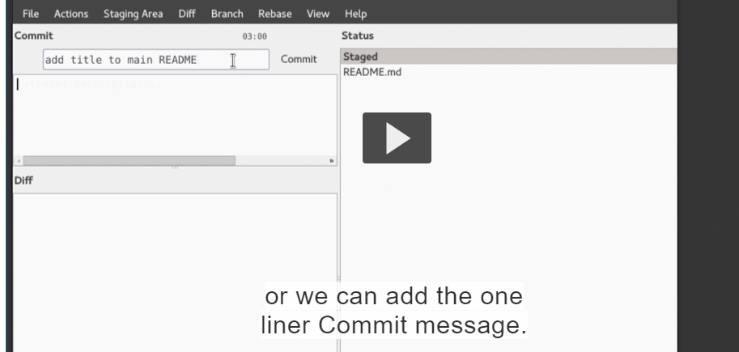

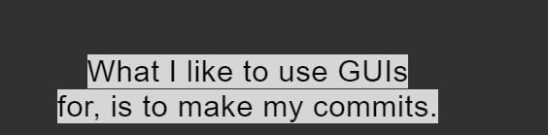



**And commit individual files**

**Typical when I work with remotes made a commits on gui and make the git push pull commands straights on the terminals**

**Here we look at our log tree one more time**

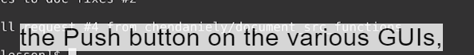

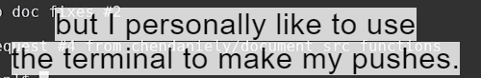

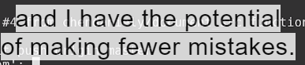

**Commits made through gui are fully sync with our remotes.**

Introduction to Part II:

## Transcript

- Welcome to part two,

Collaborating with Git.

In these lessons, I extend your knowledge

on working with remotes and branches,

and show you how you can use

the same concepts for collaboration.

I will cover three ways for collaboration.

First, by adding users directly to your project repository,

then, by having collaborators fork a repository,

and lastly, how we can combine everything together.

1.Collaborating with git:

Into the workflow collaboration

## Transcript

- Welcome to Lesson 4:Adding a Collaborator.

Here, I show you how you can add a collaborator

to your project and begin pushing and pulling code.

Next, I show you how you can work with branches

and pull requests, to reduce the number

of potential conflicts.

Finally, when multiple people are collaborating,

I show you how you can incorporate changes

in existing branches.

Bu the end of collaborator you will know how to start a collaborating by adding a user.directly to project.

## Transcript

- So far, I've showed you how you can use git

and GitHub by yourself.

I've alluded to the fact that you can use it

for collaboration with other people,

so now I'm gonna show you

how it can add other collaborators.

The first form of collaboration I'm gonna show you is

to add another person to a collaborator on your project.

So far, I've gone over your local computer,

and using pushing and pulling to your remote named Origin.

[4.1 Add a collaborator and push and pull down changes (06:51 mins)](https://www.safaribooksonline.com/library/view/git-essentials-livelessons/9780134655284/gell_04_01.html)

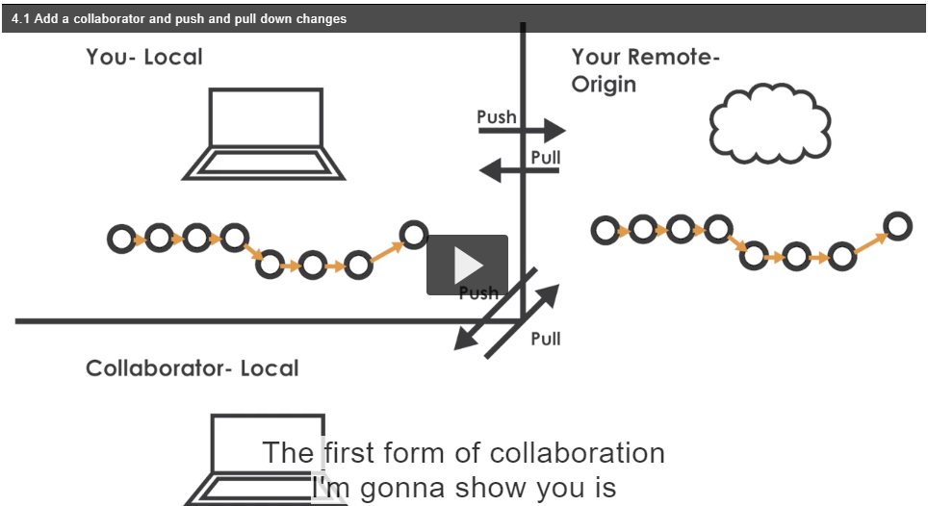

When we add the collaborator do the same thing you can



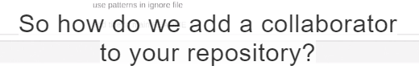.

First in github we can go to settings and click collaborators

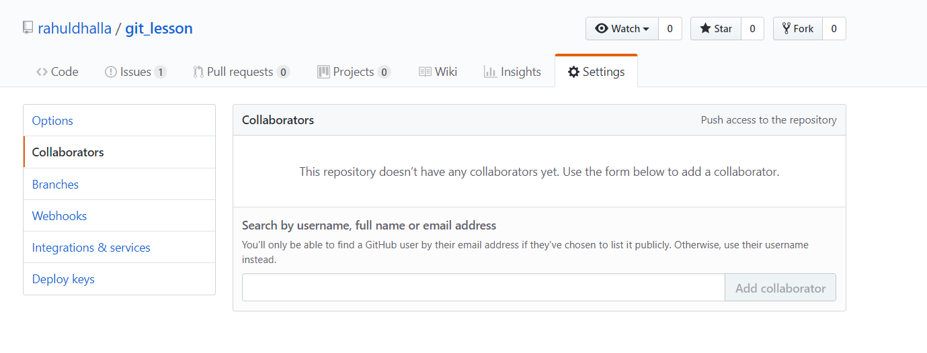

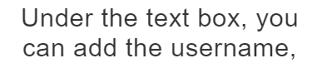in this case ‘github username’ of the person as a collaborator

Here I am adding teaching account as gitihub repository as collaborator



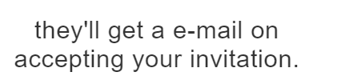

Right now I am in teaching account

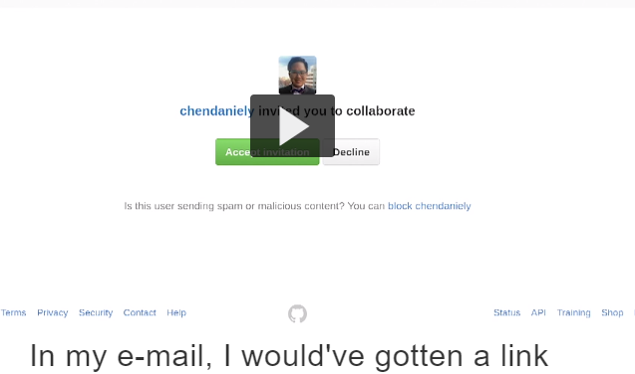

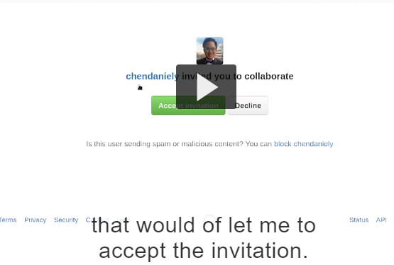

I am added in repo through click on gmail for invitation I make folder called collaboration to create file

Its ok if it is public but the main think is collaborator can do the pushing and pulling directly into the repo..

If you want to find it again we can click the clone or download button for https or ssh)

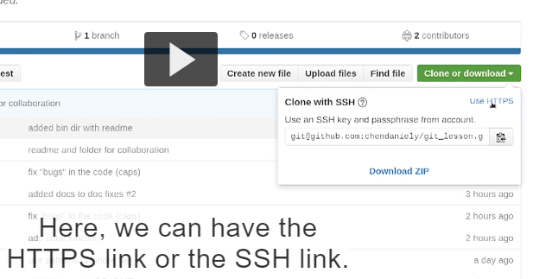

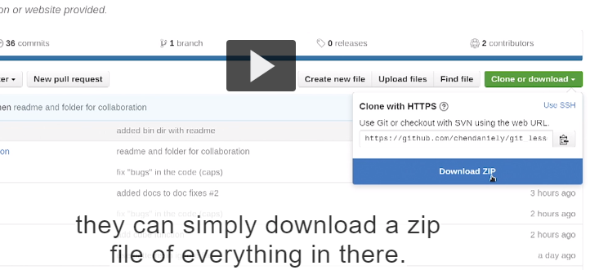

Now we have https link we can select and copy it.

Depends upon on you how you can do this

Now what we have to do with https link is clone it down.

First I have to sure I am not in directory or any subdirectoy where I havn’t typed git init.

When you sure you are not in git directory .you can safely do git clone

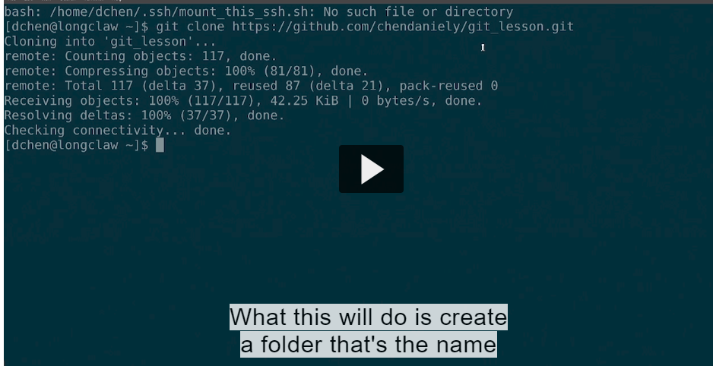

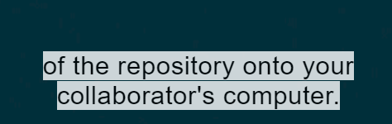

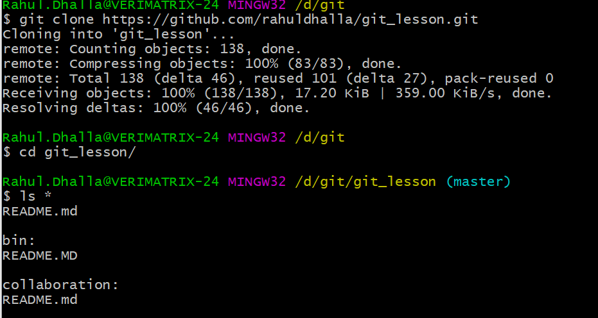.

So collaborator pushing and pulling kar skda.

After that they can push the commit to origin and master

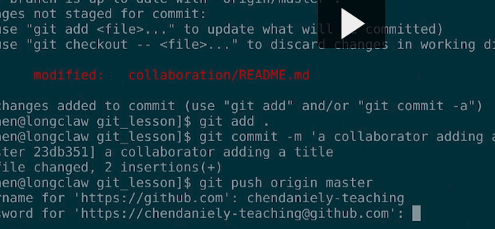

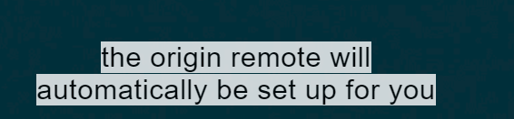

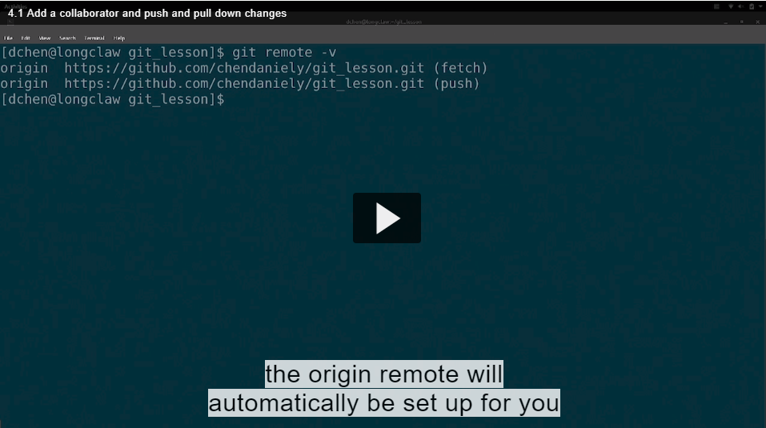



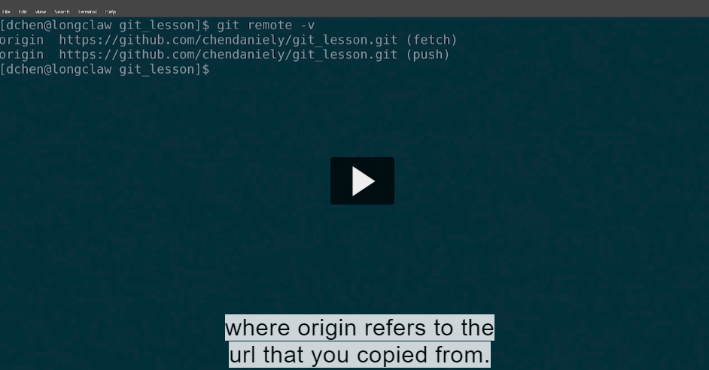

You can also add it as manually.through remote..

## Transcript

- So you can see working with a collaborator is almost like

working with yourself, where your collaborator is

just someone directly making changes on the Git Hub page.

I showed you in a previous example where

when you start making changes in multiple places,

you can have the same change to the same file

and you have the potential to have merge conflicts.

The same thing can happen when you add a collaborator.

Push pull with branches and request a pull.

Your collaboratory can make a change into repository but when you try to push or pull down.

You are going to have conflict.

One way is to reduce the conflicts is to introduce branches which I have talked about earlier.

Here I am show you and your collaborators can work with branches

1.collaborator de pc te file change kitti and branch bnake commit kitta fix/caps and merge kitti master naal

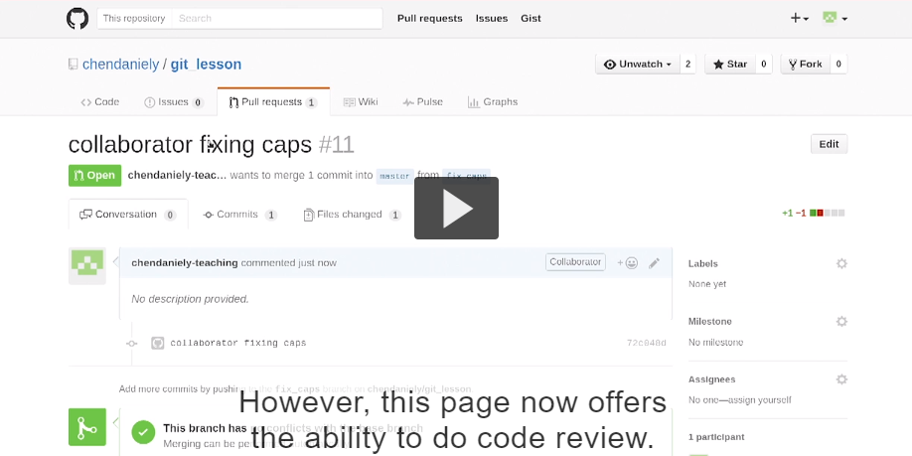

Since it is typical bad practice for you to do merge and push merge and accept your own pull request.

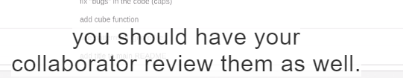

Pull reuest odo aundi jido collaborator bus ek vari merge pull request te krke shad de je naal hi dubara click kitta phir changes hojange but krna ki ek vari click taki owner code review krle

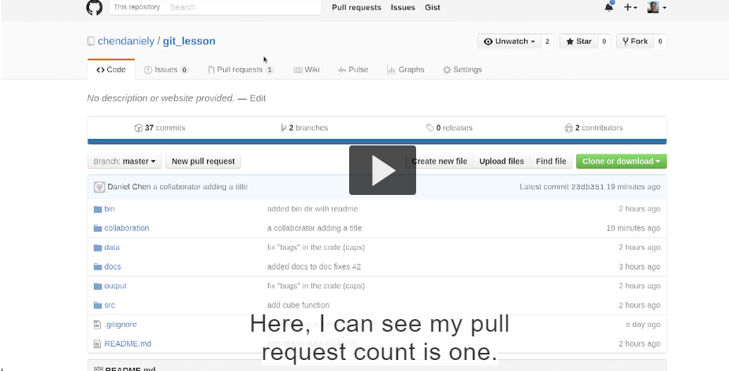

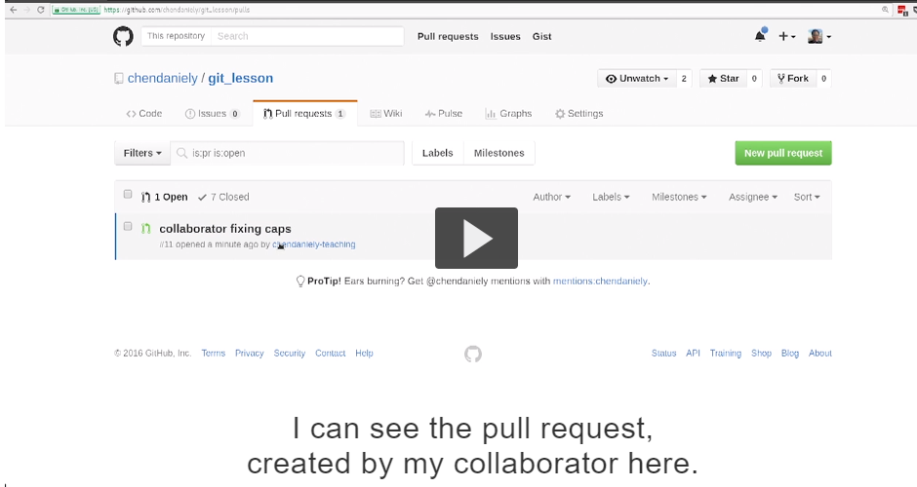

Jido assi create pull request krde but merge pull request te click nahi karde then ek dum pull request val dekho you will see pull request ch option aandi hovegi for code review

Collaborator ne apne github toh create krke shad ta and dusre bande ne github login krke vekhiya ki hega he will see pull requests.

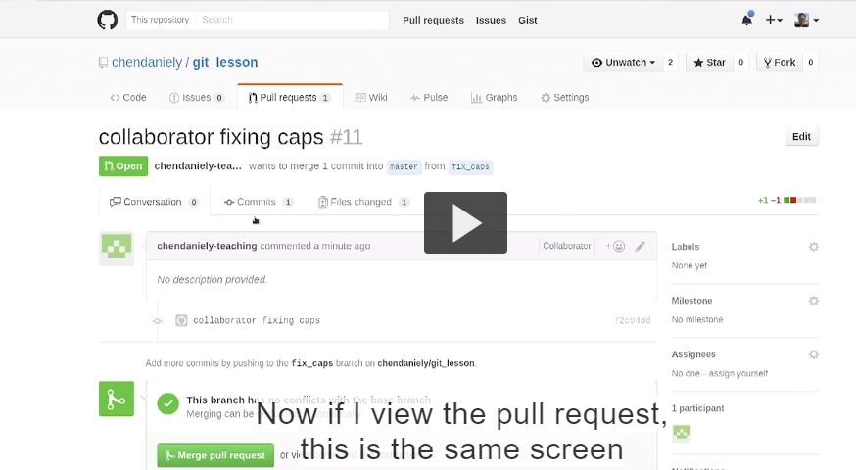

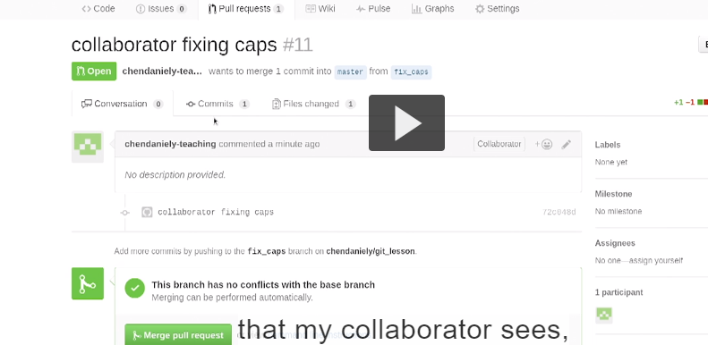

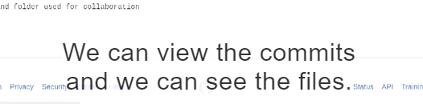

File te click krke jayo and see you can add comment on it

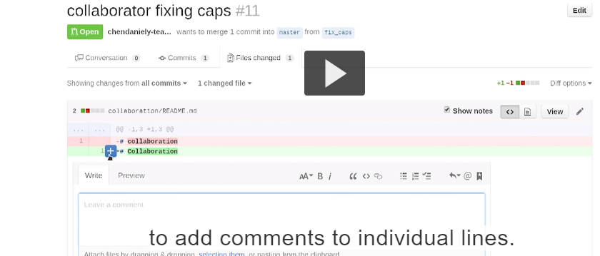

Comment mardo and done

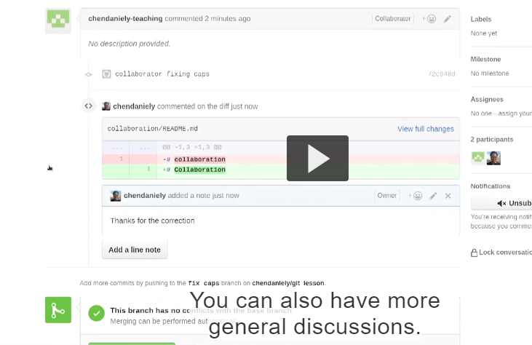

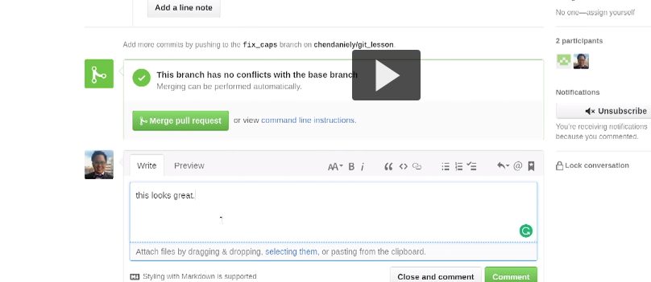

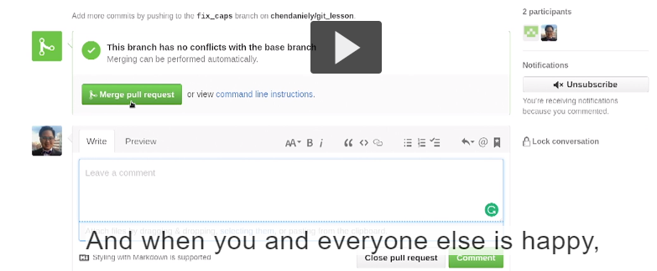

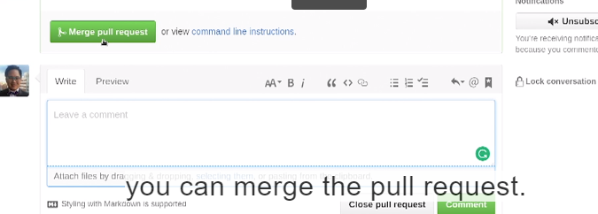

…………………………………………………………………………………………………………………

## Transcript

- [Instructor] I just showed you how your collaborator

can create a branch and submit their own pull requests

that you or your collaborator can accept.

Now you run into a similar problem that we had before,

when working with branches,in that sometimes,

you're going to have a branch that contains information

that you don't have.

Just now, I accepted a pull request from my collaborator.

But before running git pull to pull down the changes,

Incorporate changes in existing branches:

Before I gonna go I am commit my changes on branch

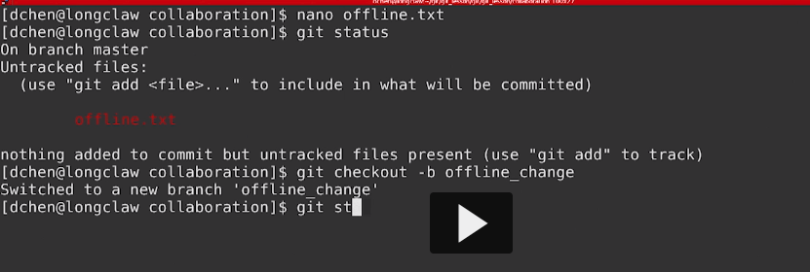

Commit and see I have no internet.

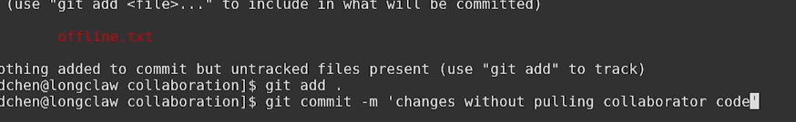

I pretend I keep working until I have internet connection again or

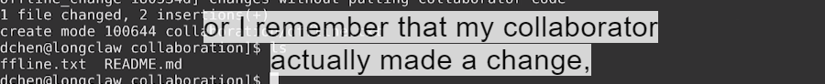

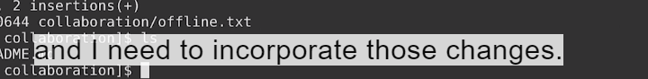

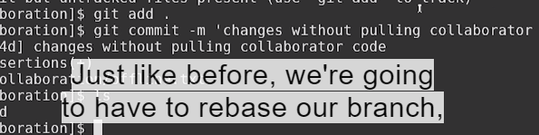

But before even we do that



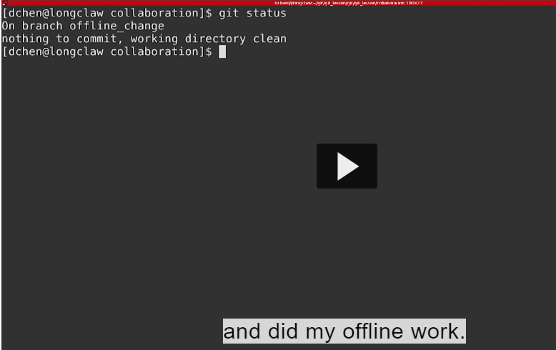

Again the master branch still has the file

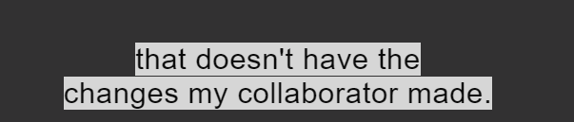

So I can pull the changes down to github

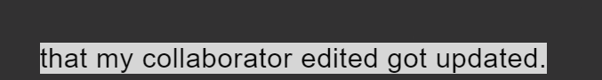

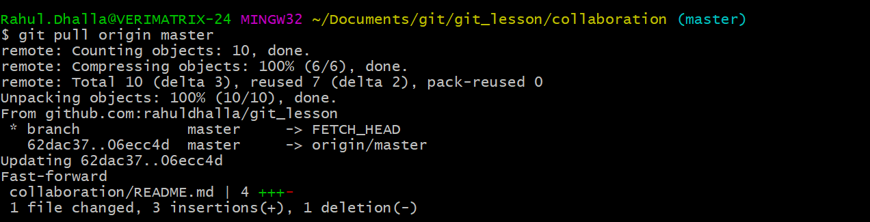

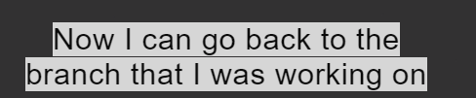

And rebase my changes.

After I finish rebasing I can see still have changes .i have the offline text file that I create on my branch

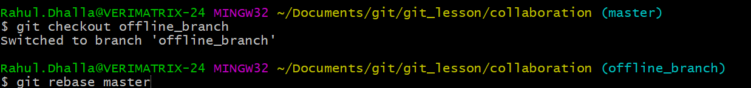

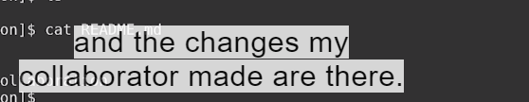

What can I do now either merge my branch onto the master branch and push the master branch or I can push offline mybranch to github and create the pull request there

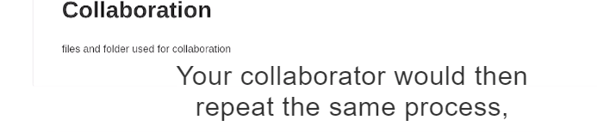

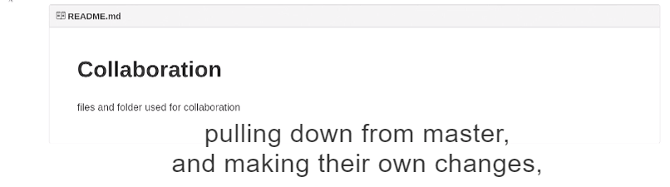

Basically ki hega master side te means owner side te kuj hega then assi change kitta and collaboration sid ete kuj te assi offline_branch bnayi si so par master ta update nahi owner ne apna kam kitta pehle master nu pull karo in collaboration vali side and then rebase karo master in collaboraton side te in offline ch taki master vale changes rehn okay .So master branhch ch change kat karo .

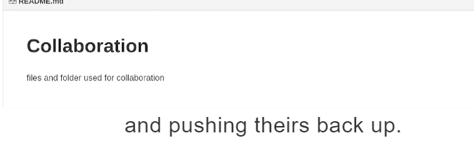

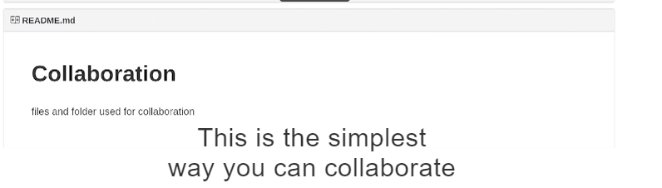

With other people on github

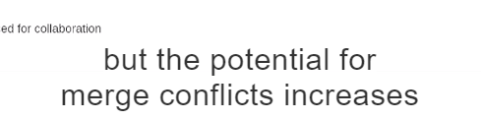



In other we go for another workflows that reduce the number of merge conflicts and scale

